2015 City of Mississauga’s Report on the Accessibility Plan___________________________________________

Mississauga is becoming a more accessible city.

An accessible city ensures everyone feels they belong.

The City released its 13th Annual Accessibility Plan in 2015. That’s important because one in seven people in Ontario has a disability. In Mississauga that means over 100,000 people have some kind of disability. The number will rise to one in five as the population ages.

Mississauga’s Accessibility Vision Statement, “A Great Place to live, work, travel and play for everyone!” complements the City’s vision of “a place where people choose to be” as outlined in the City’s Strategic Plan.

The Accessibility Vision is an inclusive one that will be realized by:

- Meeting or exceeding legislative timelines
- Providing mobility for everyone
- Retrofitting older buildings, parks and trails
- Making accessibility a design priority
- Providing accessible information
- Creating awareness
- Securing dedicated funding
- Representing persons with disabilities
These strategies help realize our vision:
  - Give accessibility a voice everywhere
  - Do what we know is right through our practices and policies
  - Partner with other jurisdictions (i.e., government) for synergies and efficiency
  - Reach out and collaborate to improve education and awareness
  - Encourage private sector contributions to accessibility

Legislation____________________________________________________________________________________

The Ontario Human Rights Code recognizes the dignity and worth of every person in Ontario. It provides for equal rights and opportunities and freedom from discrimination.

Customers, clients and tenants with disabilities have the right to equal treatment and equal access to facilities and services. This includes restaurants, shops, hotels and movie theatres, as well as apartment buildings, transit and other public places.

At work, employees with disabilities are entitled to the same opportunities and benefits as people without disabilities. In some cases, they may need special arrangements or “accommodations” to help them do their job.

The Accessibility for Ontarians with Disabilities Act (AODA, 2005) was put into place to develop, implement and enforce accessibility standards.

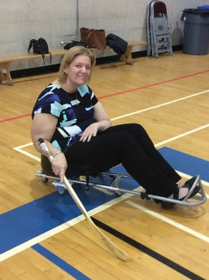
Vice Chairperson of the Mississauga Accessibility Advisory Committee, Melanie Taddeo trying out sledge hockey on wheels

Customer Service, Information and Communication, Employment, Transportation and Built Environment Standards

A number of accessibility standards are laid out in regulations made under the AODA. They set out measures, policies, practices and other steps needed to improve and prevent barriers for people with disabilities. The standards apply to both the public and private sectors.

The Accessibility Standard for Customer Service was the first standard to become law as a regulation. The City of Mississauga complied with this regulation in 2009.

The Integrated Accessibility Standards Regulation (IASR) combines the next four standards that include information and communications, employment, transportation and built environment.

This regulation also includes additional ‘general requirements’ such as ensuring that we purchase accessible goods and services. The City of Mississauga complies with the AODA requirements (Accessible Customer Service, IASR) and has submitted the AODA Self-Certified Accessibility Report to the Accessibility Directorate of Ontario.

We are currently working on implementing the new built environment requirements.

Mississauga’s Multi-Year Accessibility Plan________________________________________________________

The City’s Multi-Year Accessibility Plan (2012-2017) and yearly reports demonstrate the City’s commitment to making accessibility a part of everyday business.

The plan was approved by City Council in March 2012 and identifies accessibility standards and projects that ensure the City meets the requirements laid out in the standards.

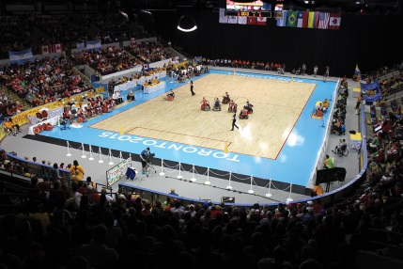
Wheelchair Rugby at the Para Pan Am Games at Mississauga Sports Centre

Achievements_________________________________________________________________________________
The achievements identified in the 2015 Annual Report presented to Council include:

Customer Service______________________________________________________________________________
The 2015 Exceptional Accessible Customer Service Awards were presented to:
- Ingrid Humphreys, Fitness Instructor, who designs programs for people with COPD, Osteoarthritis, Osteoporosis and Arthritis

- Bill Montague, Project Manager, Park Development, who transforms playgrounds into accessible playgrounds

- Amanda Watters, Transit Enforcement Officer, who on two occasions assisted residents with disabilities who encountered personal challenges while using MiWay

The City also launched a new Inclusion Resource Team in partnership with Community Living Mississauga to support adults with developmental disabilities.

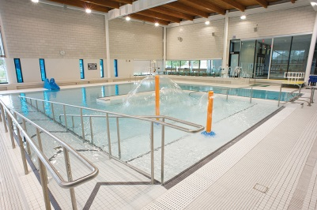
Clarkson Therapeutic Pool

Information and Communications________________________________________________________________

- The City revised its Documentation Standards Policy to include an Accessibility section that provides standards to be applied to all City documents.

Employment__________________________________________________________________________________
- Twenty-six (26) adult volunteers with developmental disabilities participated in the Summer Work Experience Program (SWEP) and Secondary School Volunteer Project. One of these volunteers went on to become a paid part-time building operations staff at Frank McKechnie Community Centre.

Transportation________________________________________________________________________________
- MiWay installed 200 new bus pads throughout Mississauga to make transit more convenient and accessible
- MiWay improved its alert system by issuing real-time alerts to customers about service disruptions.

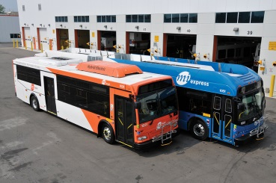
MiWay Accessible Buses

Built Environment_____________________________________________________________________________

Buildings_____________________________________________________________________________________
Facilities with improved accessibility in 2015 include:
- City Centre Transit Terminal washrooms – colour contrasting, lighting, signage
- Civic Centre stairways – colour contrasting, lighting, signage, images of persons with disabilities
- South Common Parks Depot - accessible kitchen cabinetry, washroom, signage
- Central Library – accessible counters and book drop off
- Frank McKechnie Community Centre – improved accessible parking closer to the entrance,
- Huron Park Recreation Centre – ramp access to arena dressing rooms,
- Mississauga Valley Community Centre – installed an additional grab bar in pool change area, emergency exterior stair was upgraded with colour contrast and non-slip surface
- The Mississauga Accessibility Design Handbook was revised to reflect new accessibility standards. Council approved the City of Mississauga 2015 Facility Accessibility Facility Accessibility Design Standards
- Fifteen (15) automatic door operators were installed at City facilities

Outdoor Spaces_______________________________________________________________________________

- Over 79 parks received accessible seating and benches

- The amended Accessible Parking By-Law with new AODA requirements (i.e., more spaces) was approved by Council and is effective March 1, 2016 on a go forward basis

- Malton Village Park was redeveloped with accessible seating, an accessible picnic table, wide paved pathways, tactile warning plates at curb cuts and accessible parking

- Six (6) trails received paving construction and reconstruction
- Two accessible swings and two transfer platforms were installed at Jack Darling Memorial Park playground

Other Successes_______________________________________________________________________________
- Mississauga hosted the Toronto 2015 Para Pan Am Games goalball, powerlifting and wheelchair rugby events
- The City hosted a ParaSport Try It Event as part of National Access Awareness Week
- An Accessibility video was produced that highlights City of Mississauga accessibility successes, and includes features such as closed captioning and descriptive narration to accommodate those with visual and hearing disabilities.
- Four members of the Mississauga community were presented with the AODA 10th Anniversary Champion Award

The Accessibility Advisory Committee and the Accessibility Policy_____________________________________
Mississauga’s Accessibility Advisory Committee (AAC) advises, recommends and assists the City in promoting and facilitating a barrier-free Mississauga for citizens of all abilities (universal accessibility) including persons with disabilities.

The committee reviews municipal policies, programs, services and facilities and assists with the identification, removal and prevention of barriers faced by persons with disabilities.

The City’s Accessibility Policy ensures that the City continues its progress towards improving accessibility in Mississauga. The policy requires all City corporate policies and procedures, bylaws, standards and guidelines must comply with the AODA’s accessibility standards.

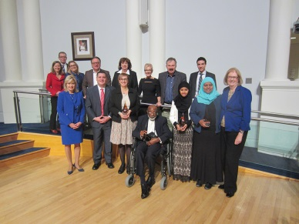
AODA 10th Anniversary Champion Award Winners

For more information:__________________________________________________________________________

To find out more about the City’s Accessibility Advisory Committee or Accessibility Plan visit mississauga.ca/accessibility or contact Diana Simpson, Supervisor, Accessibility Planning at 905-615-3608, TTY: 905-615-3411, diana.simpson@mississauga.ca or accessibility.info@mississauga.ca

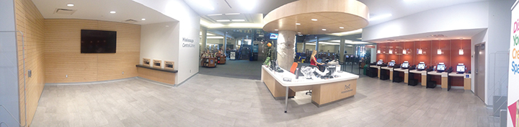
Mississauga Central Library - accessible counters, desks and book drop-off area

