
Office of the City Manager

City of Mississauga
Leading today for tomorrow
300 City Centre Drive
MISSISSAUGA ON L5B 3C1

Tel: 905-896-5000
FAX: 905-615-3376
www.mississauga.ca

Message from the City Manager and Chief Administrative Officer

I am pleased to introduce the second edition of the City of Mississauga Accessibility Design Handbook. This updated resource can be used as a reference tool as we work towards making Mississauga a universally-designed accessible community. Based on the human rights principles of respect, dignity and inclusion, these guidelines are a key component of the City’s Accessibility Plan and reflect our corporate values of Trust, Quality and Excellence.

The revised handbook reflects the following updates:

- Barrier-free design requirements from the 2006 Ontario Building Code (OBC);
- New sections and enhancements to existing sections i.e. inclusion of new diagrams; new sections such as emergency exists, theatre facilities, assistive listening systems and more;
- Consistent language to align with the new OBC.

The Accessibility Advisory Committee formed a subcommittee to assist in the development and revisions to the accessibility design guidelines for the City. This committee consists of representatives from Development & Design, Building, and Facilities & Property Management divisions and select members of the Accessibility Advisory Committee. The guidelines in this handbook will assist project designers to incorporate accessibility criteria into their designs before they are built, furthering the goals in the City’s Accessibility Plan.

The Accessibility Design Handbook is the result of the collaborative effort among community and professional experts working with City staff and Members of Council. My appreciation to everyone involved in this project!



Janice Baker
City Manager and Chief Administrative Officer


Acknowledgments
The City of Mississauga thanks those who contributed to the production of this valuable resource.

The Accessibility Advisory Committee

City of Mississauga Accessibility Staff Working Group
Facilities & Property Management Division, Corporate Services Department
Development Section – Planning, Development and Business Services, Community Services Department
Development & Design Division– Planning and Building Department
Building Division – Planning and Building Department
Engineering & Works Division – Transportation and Works Department


We would like to thank and recognize the contributions of the Corporation of the City of London for their generous permission to utilize the Facility Accessibility Design Standard (FADS) document as the basis for the creation of this standard.

City of Mississauga Accessibility Contact:

Diana Simpson Accessibility Coordinator
905-615-3608, TTY 905-615-3411
diana.simpson@mississauga.ca
Facilities & Property Management Division
300 City Centre Dr.
Mississauga, Ontario
L5B 3C1
Fax: 905-896-5939

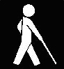
DRAFT
Accessibility
Design Handbook
Revised:
December 7, 2007
City of Mississauga

1 Introduction 1-0
1.1 Mandate 1-1
1.2 Structure and Format of the Accessibility Design
Handbook 1-2
1.3 Definitions and General Requirements 1-3
1.3.1 Space and Reach Requirements 1-4
1.3.2 Signage 1-8
1.3.3 Universal Symbols of Accessibility 1-10
1.3.4 Braille and Tactile Signage 1-12
2 Exterior Design 2-0
2.1 Accessible Parking and Passenger Drop-Off Zones 2-1
2.1.1 Accessible Parking Spaces 2-2
2.1.2 Accessible Passenger Drop-Off Zones 2-4
2.1.3 Accessible Parking Signage 2-5
2.2 Pedestrian Linkage 2-7
2.2.1 Accessible Routes 2-8
2.2.2 Protruding Objects 2-10
2.2.3 Surface Treatments 2-12
2.3 Entranceways 2-14
2.3.1 Barrier-free Entrances 2-15
2.3.2 Gates, Turnstiles, and Openings 2-16
2.4 Ramps, Staircases and Other Changes in Level 2-17
2.4.1 Curb Ramps/Cuts 2-18
2.4.2 Ramps 2-20
2.4.3 Steps and Stairs 2-23
2.4.4 Handrails 2-25

2.5 Recreational Areas 2-27
2.5.1 Accessible Playgrounds 2-28
2.5.2 Accessible Swimming Pools and Splash Pads 2-30
2.5.3 Accessible Picnic Areas 2-32
2.5.4 Accessible Pathways and Trails 2-33
2.5.5 Benches and Street Furniture 2-35
2.5.6 Landscaped Areas 2-37
2.5.7 Balconies, Porches, Terraces and Patios 2-38
3 Interior Design 3-0
3.1 Interior Circulation 3-1
3.1.1 Doors 3-2
3.1.2 Corridors 3-6
3.1.3 Emergency Exits 3-7
3.2 Interior Changes in Level 3-9
3.2.1 Stairs and Escalators 3-10
3.2.2 Ramps and Lifts 3-11
3.2.3 Elevators 3-13
3.3 Interior Areas 3-16
3.3.1 Reception Areas 3-17
3.3.2 Waiting and Queuing Areas 3-18
3.3.3 Offices, Work Areas and Meeting Rooms 3-19
3.3.4 Restrooms 3-21
3.3.5 Changing Rooms 3-28
3.3.6 Bathing Facilities and Shower Rooms 3-30
3.3.7 Saunas and Steam Rooms 3-33
3.3.8 Kitchens 3-34

3.4 Interior Amenities and Features 3-37
3.4.1 Drinking Fountains and Eyewash Stations 3-38
3.4.2 Public Telephones 3-40
3.4.3 Lockers, Storage, Shelving and Display Units 3-42
3.4.4 Windows, Glazed Screens and Sidelights 3-43
3.5 Other Facilities 3-44
3.5.1 Cafeterias 3-45
3.5.2 Libraries 3-46
3.5.3 Places of Worship 3-48
3.5.4 Retail Facilities 3-49
3.5.5 Medical Care Facilities 3-50
3.5.6 Transportation Facilities 3-51
3.5.7 Theatre Facilities 3-53
3.5.8 Arenas, Halls, and Other Indoor Recreational Facilities 3-55
4 Systems and Controls 4-0
4.1 Visual and Audible Alarms 4-1
4.2 Vending and Ticketing Machines 4-2
4.3 Controls and Operating Mechanisms 4-3
4.4 Detectable Warning Surfaces 4-4
4.5 Card Access, Safety and Security Systems 4-6
4.6 Glare and Light Sources 4-7
4.7 Lighting 4-8
4.8 Texture and Colour 4-10
4.9 Materials and Finishes 4-12
4.10 Acoustics 4-14
4.11 Assistive Listening Systems 4-15
5 Appendices 5-0
5.1 Universal Design Principles 5-1
Principle One: Equitable Use 5-2
Principle Two: Flexibility in Use 5-2
Principle Three: Simple and Intuitive 5-3
Principle Four: Perceptible Information 5-3
Principle Five: Tolerance for Error 5-4
Principle Six: Low Physical Effort 5-4
Principle Seven: Size and Space for Approach and Use 5-5
5.2 Definitions 5-6
5.3 Bibliography and Web Resources 5-11

1

Introduction

1.1 Mandate
In September 2003, Mississauga City Council adopted our first annual Accessibility Plan. A Strategic Planning Process was followed in preparation for the Plan and as a result the City of Mississauga Accessibility Advisory Committee (AAC) developed the following vision statement:

To create a fully accessible community utilizing universal design principles resulting in improved attitudes and full inclusion.

The Mississauga Accessibility Plan outlines several initiatives to move Mississauga toward becoming an accessible city. One of the initiatives is to develop accessibility design criteria for the City.

The Mississauga Accessibility Design Handbook outlines design criteria in which the City demonstrates to other sectors that we, as a city, are committed to the removal of barriers. Various departments within the corporation and external stakeholders will benefit from having access to the Accessibility Design Handbook. Internal staff, external agencies and our customers will benefit from this consistent approach.
In recognition of the diverse needs of residents of and visitors to the City of Mississauga, the mandate of the Accessibility Design Handbook is to generate built environments that are more inclusive.

The Accessibility Design Handbook is based on the premise that often simple design decisions can make the difference between a path, area or facility being accessible or inaccessible to individuals with varying levels of ability. Furthermore, consideration of a diverse range of needs during the design process can produce an environment that facilitates greater safety, comfort and ease for its users – a benefit to all.

Although the Accessibility Design Handbook outlines design criteria which are intended to generate built environments that are more inclusive, the application of the criteria is dependent on the ability of the City to apply the criteria under various legislation, such as the Ontario Building Code and the Planning Act, enacted by the provincial government.

1.2 Structure and Format of the Accessibility Design Handbook
The Accessibility Design Handbook is organized in a manner corresponding to how both the design and use of an accessible space or facility is likely to occur.

The process begins with consideration for the general space and reach requirements of individuals with disabilities, followed by criteria for signage. Primary consideration is given to both signage and space and reach provisions for a variety of users since every accessible area and design feature of a facility or site is determined by or connected with these requirements.

Next, external design criteria outline the requirements for accessible arrival and departure areas, including parking spaces and drop-off zones, followed by design considerations for other exterior spaces and pathways.

Moving within the building, various recommendations are presented for interior elements and facilities, including doors, corridors and restrooms.

Near the end of the handbook, but applicable to all sections, criteria for systems and controls, such as alarms, lighting, materials and finishes are provided.

The Accessibility Design Handbook includes both Metric and Imperial units. For the purpose of this document all Metric units are the standard for implementation. Imperial units are approximate and included exclusively for ease of readership.

The Ontario Building Code (OBC) contains legislated minimum requirements for the design and construction of all projects. The latest version of the OBC must be followed.

1.3 Definitions and General Requirements
People with disabilities face unnecessary barriers almost everywhere. They confront difficulty with accessibility almost everyday at home, at work, at school, in parks, in auditoriums, in stores and restaurants and on streets and sidewalks.

A “barrier” signifies anything that prevents an individual with a disability from participating in all aspects of society because of his or her disability. A barrier may be physical, architectural, informational, communicational, attitudinal, or technological, or found in a policy or practice.

To comprehend the scope of the following Accessibility Design Handbook, the word disability must be defined. The Ontario Human Rights Code defines disability as follows:

- Any degree of physical disability, infirmity, malformation or disfigurement that is caused by bodily injury, birth defect or illness and, without limiting the generality of the foregoing, includes diabetes mellitus, epilepsy, a brain injury, any degree of paralysis, amputation, lack of physical co-ordination, blindness or visual impediment, deafness or hearing impediment, muteness or speech impediment, or physical reliance on a service dog or other animal or on a wheelchair or other remedial appliance or device.

- A condition of mental impairment or a developmental disability;

- A learning disability, or a dysfunction in one or more of the processes involved in understanding or using symbols or spoken language, a mental disorder, or

- An injury or disability for which benefits were claimed or received under the insurance plan established under the Workplace Safety and Insurance Act, 1997.

It is important to note that designing for greater accessibility encompasses not only the reduction of physical barriers for persons using wheelchairs and other mobility aids, but also the creation of an environment that is accessible for people who have vision concerns and/or have hearing loss, as well as individuals with cognitive disabilities, persons of short stature, children and the elderly.

While the range of users and requirements for accessibility often vary widely, the remainder of this section outlines general requirements for space, reach and signage, which serve as the foundation for the Accessibility Design Handbook.

1.3.1 Space and Reach Requirements
In order to design an accessible environment one of the most important considerations is the space and reach requirements of the intended users of the site or facility. The dimensions and manoeuvring requirements of a wheelchair or other mobility equipment, as well as the range of cane detection should serve as the basis for the design and construction of accessible elements within a site.
Criteria
The following figures illustrate average space and reach requirements for individuals using mobility devices,
canes and service dogs.
Mobility Devices
a) Mobility devices, such as wheelchairs and scooters, require clear space to turn and manoeuvre and to approach features throughout a site or facility.

Wheelchair Clear Floor Space

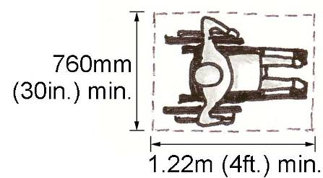

Wheelchair Turning Radius

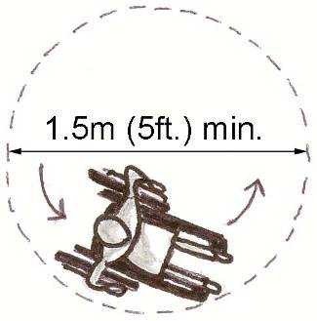

Scooter Clear Floor Space

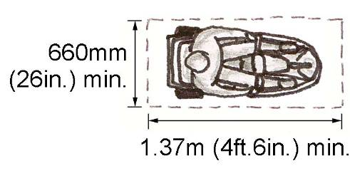

Scooter Turning Radius

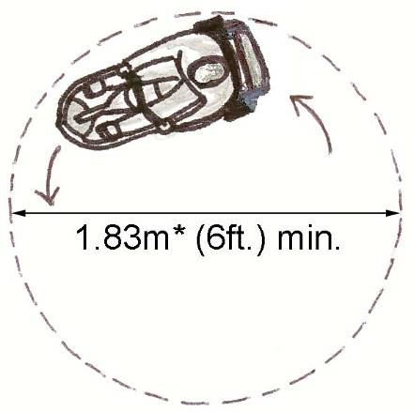

*The turning radius of a scooter varies widely depending on the size and wheel configuration. A 1.83m (6ft.) diameter was selected to accommodate the majority of scooters. Larger scooters may still manoeuvre within this clearance, but not in one continuous circle (i.e. must make a three-point turn).

Three-Point Turn

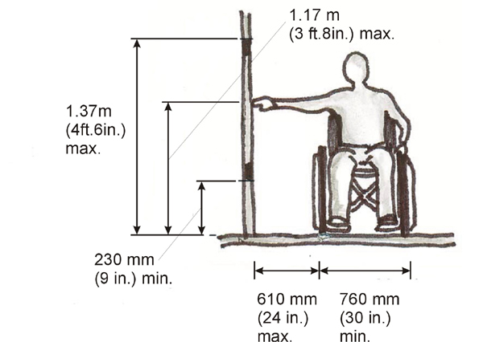
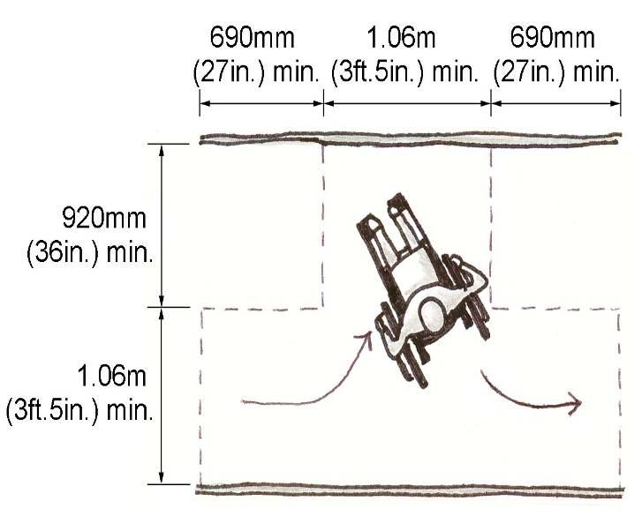

Forward Reach

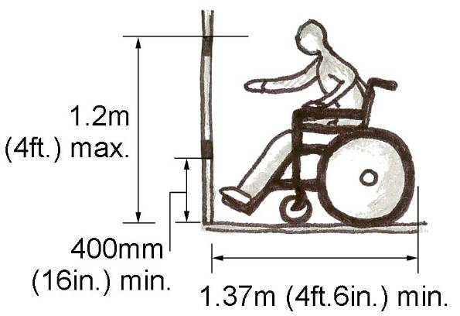

Side Reach

Front or Side Approach

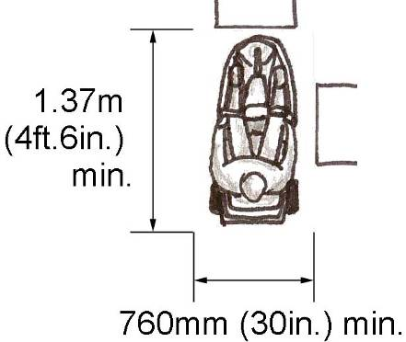

Front Approach under a Horizontal Surface

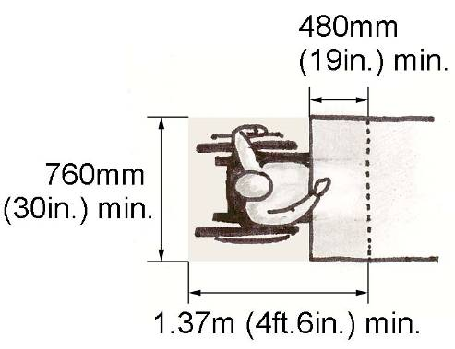

Clear Toe, Knee and Arm Rest Space

Folded Wheelchair

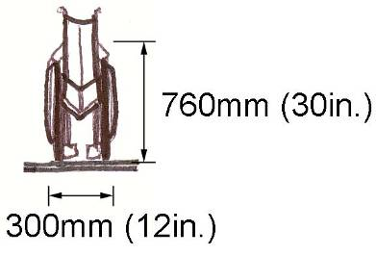

Persons using other mobility aids, such as canes or crutches, also require space clearances to move throughout a facility or site.
Canes and Service Dogs
b) Individuals with vision disabilities who use canes or service dogs also have space requirements which should be considered when designing a site or facility.

Cane and Crutch Clear Widths
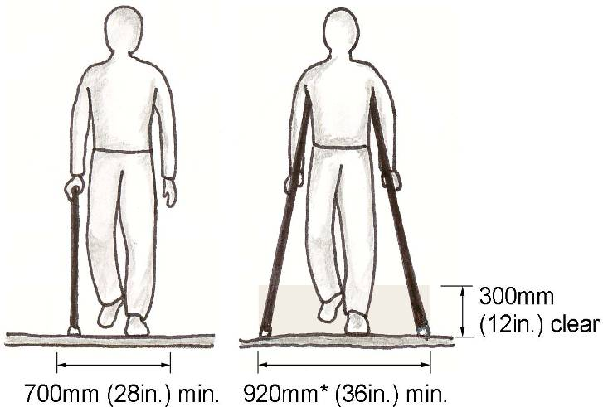

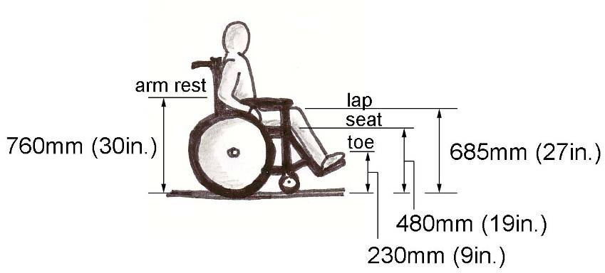

*Crutch tips require a clear width of 920mm (36in.) for a comfortable gait. Persons using walking aids can manoeuvre through a clear opening of 810mm (32in.) wide.

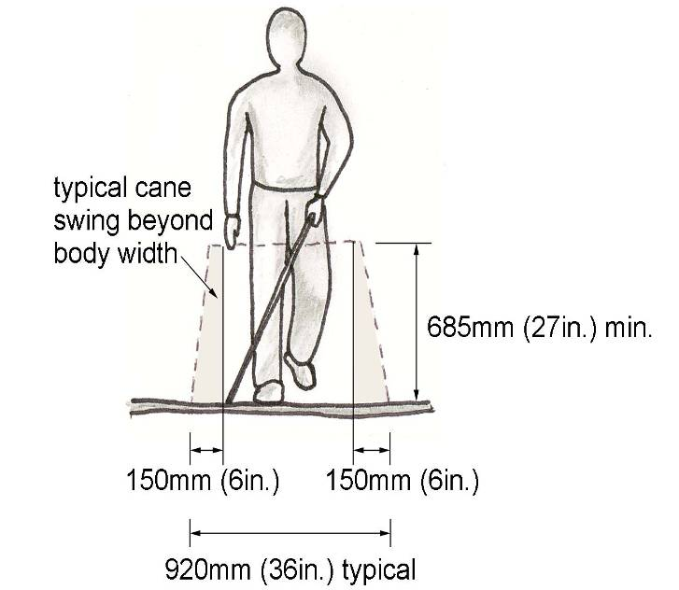
Cane Detectable Range

Cane Detectable Range

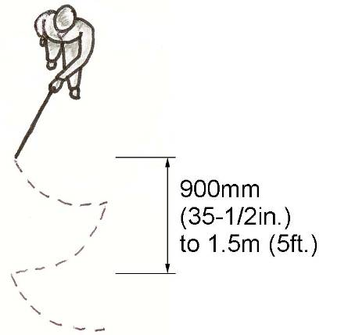

Clear Width for Person with Service Dog
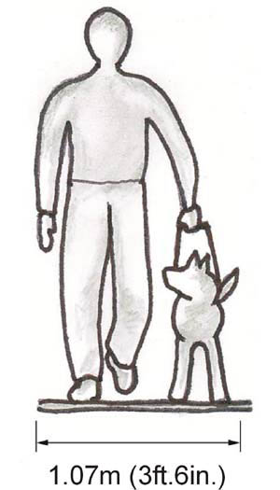

1.3.2 Signage
Clear signage is beneficial to all users of a facility. Appropriately positioned and universally recognizable signage plays an important role in assisting disabled individuals locate accessible areas and paths. Graphic symbols are helpful for individuals with literacy or vision concerns, while electronic signs are useful for people with low vision and/or people who are deaf, deafened or hard of hearing.
Location
Appropriate signage should be included for all significant site and facility areas, routes and features. In addition to each feature, route and area being signed, signage should also be considered as part of a system with logical connections provided throughout the site or facility.

The signage standards are not applicable to municipal roads.
Criteria
a) In general, signs should be explicit, concisely worded and contain easily understood symbols and diagrams (i.e. clear and sharp, not stylized).

b) While sufficient signage is important for way finding, a proliferation of signs should be avoided since this may create visual noise resulting in confusion for vision or cognitively disabled persons.

c) Letters and numbers on signs should be sans-serif, e.g. helvetica, univers 55 and arial with a recommended width-to-height ratio between 3:5 and 1:1 and a stroke-width-to-height ratio between 1:5 and 1:10.

d) Characters on signs should be clear and visible from an appropriate distance based on the function and location of the sign. Height dimensions for characters are recommended to comply with the viewing distances displayed in the following table.

Character Heights on Signs

Minimum Character Height | Maximum Viewing Distance
25mm (1in.) | 750mm (29 1/2in.)
50mm (2in.) | 1.5m (5ft.)
75mm (3in.) | 2.3m (8ft.)
100mm (4in.) | 2.5m (8ft.2in.)
150mm (6in.) | 4.6m (15ft.)
200mm (8in.) | 6.0m (19ft.8in.)

e) Signs with numbers should use Arabic numerals.

f) Characters, symbols and backgrounds on signs should have a matte or satin (non-glare) finish.

g) Characters and symbols should contrast (70% or greater) with their background. White lettering or symbols set on a dark background is generally more easily read by people who have low vision.

Contrasting Signage

h) Use upper and lower case letters. Avoid using all capital letters as they provide less visual information to differentiate letters and give words shape.

i) Avoid very fine type and very thick type. Choose a type face that is in regular range.

j) The minimum level of illumination over directional or informational signage should be 200 lux (20 ft. candles) Emergency lighting is 10 lux (1.09 ft. candles) in exits. (See also Section 4.7 – Lighting).

- Signage should avoid using the colour combinations yellow/grey, yellow/white, blue/green, red/green, black/violet, or red/black, since these combinations are unreadable for most people with various visual conditions.

l) Colour contrast on signage should be effective against the background to the sign.

CNIB Guide to Effective Colour Contrast
Background Surface | Sign Background | Colour of Lettering
Light brick or light stone | Dark (black preferred) | White/yellow
Whitewashed wall | Dark (black preferred) | White/yellow
Red brick or dark stone | White | Black, dark green or dark blue
Green Vegetation | White | Black, dark green or dark blue

1.3.3 Universal Symbols of Accessibility
International Symbols of Accessibility (ISAs) indicate to persons with disabilities reasonable freedom of movement within and around the site or facility to which the symbol is attached.

- The ISA for people with physical disabilities, hearing loss and vision loss should be positioned to indicate respectively accessible areas and features.

The ISA for persons who are hard of hearing will be used to identify areas that have permanently installed assistive listening systems (Section 4.11- Assistive Listening Systems).

International Symbols of Accessibility (ISA)
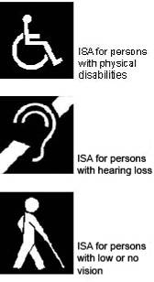

ISAs typically use a blue background, with white lettering, borders and pictographs.

Where lighting conditions or surfaces require an alternative to the blue background, a white background, with blue lettering, borders and pictographs may serve as a substitute.

b) Other signage, such as that for restrooms, parking or telephones, should incorporate the appropriate ISAs.

Signage with International Symbols

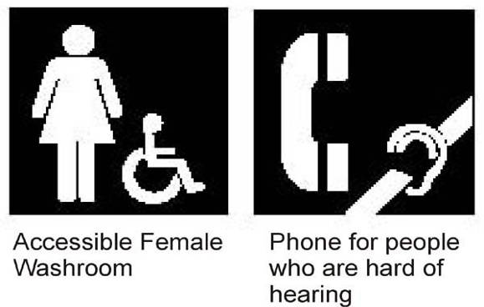

c) Where suitable, directional arrows should be incorporated into signage for accessible routes, features and areas.

Signage with Directional Arrows


Pedestrian directional signage should be wall or post-mounted at eye-level, between 1.37m (4ft.6in.) and 1.5m (5ft.) above the finished floor or ground.

d) Directional and identification signage for a site or facility should establish a standardized program for sign height and location, e.g. always to the left or right of a door at a height of “x”, etc.

Signs and symbols for sites and facilities should follow the CSA Standard CAN/CSA-Z321 “Signs and Symbols for the Workplace”.

1.3.4 Braille and Tactile Signage
a) Braille signage should be used frequently and appropriate to identify important site and building features.

b) Grade 1 Braille should be used on signage with 10 words or less.

Grade 2 Braille, which uses contractions of words and phrases, should be used on signage with more than 10 words.

c) Braille type should be in the same place as other type on all signs, e.g. place the Braille type below or to the left of the corresponding tactile sign.

d) Signs with Braille should be positioned so that the reader does not have to bend over to touch the Braille type.

e) Braille should be separated from other raised characters or symbols.

f) Where Braille is provided, the immediate surrounding surface should be void of sharp edges or points.

g) Tactile signage should be included in public areas, particularly at key access points, restroom entrances and along emergency routes.

h) Tactile signs should be mounted between 1.2m (4ft.) and 1.5m (5ft.) above the finished floor/ground.
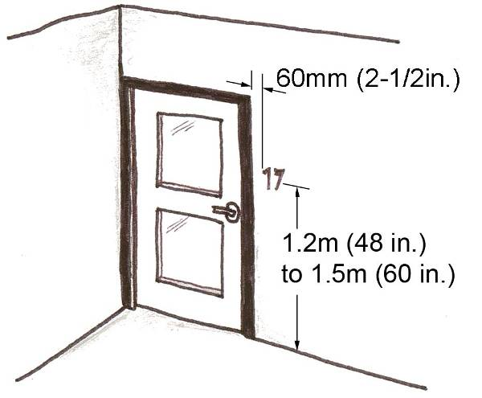

i) Tactile signage at public entranceways and doorways should be placed on the latch side of the door, no more than 150mm (6in.) from the door jamb. For restroom doors tactile signage should be placed on the door itself.

j) Tactile letters, numerals and symbols should be raised at least 0.8mm (1/32in.).
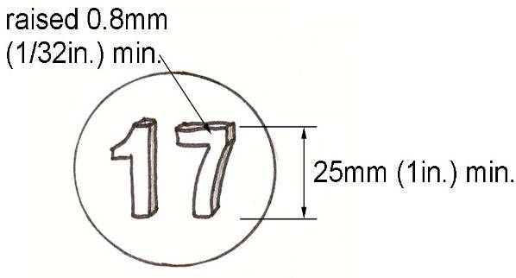

k) The edges of tactile characters should be gently rounded. Half-rounded characters should not be used.

l) Tactile characters should measure between 16mm (5/8in.) and 50mm (2in.) in height. A minimum height of 25mm (1in.) is recommended for raised characters on identification signs.

m) Enclosed stairwells should have tactile signage consisting of Arabic numerals designating the floor number, permanently mounted on both sides of the door, 60mm (2in.) inside the stairwell.

n) Raised characters are preferable to indented characters since they are less susceptible to maintenance problems such as filling up with dirt or cleaning compounds.

o) Raised borders can make raised characters difficult to read and should be placed away from the characters.

- A clear path of travel should be provided in front of all Braille and tactile signage.
Electronic Signage and Signals
a) Light emitting diode (LED) signage should be white, yellow or light blue on a black background. Red LEDs on a black background are unreadable for most people with poor vision, particularly those who are colour blind.

b) To be heard clearly, audible exterior signals, such as a pedestrian crossing signal, should be at least 15 decibels louder than ambient noise.

See also Section 4.1 – Visual and Audible Alarms.

2

Exterior Design

2.1 Parking and Passenger Drop-Off Zones
Individuals arriving at a location by vehicle generally have two options: either park the vehicle or be dropped off. Although well-organized parking and drop-off areas benefit all users, the location and design of these components are particularly important for the arrival and departure of persons with disabilities.

To better facilitate safety and ease, consideration should be given for the proximity of accessible parking spaces and drop-off zones to barrier-free paths of travel, as well as, main entrance and exit points. Clear signage, proper lighting and appropriate surface materials also contribute to the overall accessibility of parking areas and drop-off zones.

2.1.1 Accessible Parking Spaces
Provide accessible parking spaces in close proximity to barrier-free entrances and exits to facilitate the ease and safety of arrival and departure for individuals with disabilities.
LOCATION
Accessible parking spaces serving a particular facility should connect to the shortest barrier-free path of travel from the parking area, lot or structure to the main accessible entrance.
CRITERIA
a) Accessible parking spaces should be located within 30m (98ft.5in.) of the main barrier-free entrance and exit.

b) For facilities with multiple barrier-free entrances and exits, accessible parking spaces should be dispersed and located within 30m (98ft.5in.) of each barrier-free entrance and exit.

c) A barrier-free path of travel should connect each accessible parking area, lot or structure to each barrier-free entrance and exit.

d) The path of travel from an accessible parking space should avoid vehicle traffic crossing and movement behind or between vehicles.

e) Each parking area, lot or structure should have accessible parking spaces in compliance with the following table.

Accessible Parking Space Requirements

Total Parking Spaces | Minimum Accessible Spaces
1 to 25 | 1
26 to 50 | 2
51 to 75 | 3
76 to 100 | 4
101 to 150 | 5
151 to 200 | 6
201 to 300 | 7
301 to 400 | 8
401 to 500 | 9
501 to 1000 | 2% of total
1001 and over | 20 plus 1 for each additional 100

f) To accommodate people in wheelchairs and those with other mobility equipment, accessible parking spaces (parking stalls) should be at least 4.6m (15ft.) wide and 5.2m (17ft.) deep.

Accessible Parking Space Dimensions

g) Accessible parallel parking stalls should be at least 7.25m (23ft.10in.) long and 4.6m (15ft.) deep.

Accessible Parallel Parking Dimensions

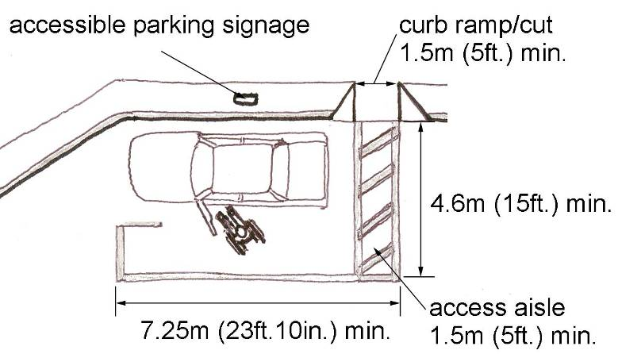
h) A clear path (no parking zone) to the adjacent curb ramp/cut should be demarcated by a painted, hatch-lined access aisle, at least 1.5m (5ft.) in width.

i) An accessible parking space should have a firm, level surface with a maximum slope of 2% (1:50) for drainage.
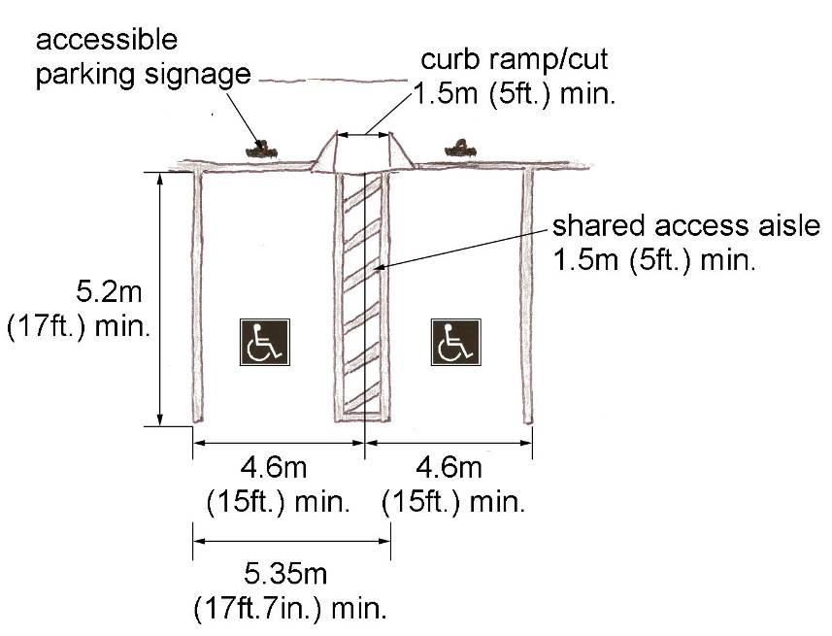
j) Curb ramps or other features mitigating changes in level from a parking space to a barrier-free path of travel should avoid encroachment upon the minimum dimensions of the accessible parking stall (refer to Accessible Parking Dimensions and Section 2.4.1 – Curb Ramps/Cuts).

k) While not recommended, if wheel stops are included they should be painted yellow for maximum visibility.

l) The instructions to operate a municipal parking meter should be no higher than 1.4m (4ft.7in.) with all operable components no higher than 1.2m (4ft.) above the ground. Where sufficient clear space is provided for a side approach, the operable components may be installed as high as 1.37m (4ft.6in.) (refer to Section 1.3.1 – Space and Reach Requirements).

m) For signage standards for accessible parking spaces refer to Section 2.1.3 – Parking Signage.

2.1.2 Accessible Passenger Drop-Off Zones
Accessible passenger drop-off zones are important for individuals who have difficulty traveling distances and those who use wheelchairs or other mobility equipment, particularly when entering or exiting side-loading vehicles.
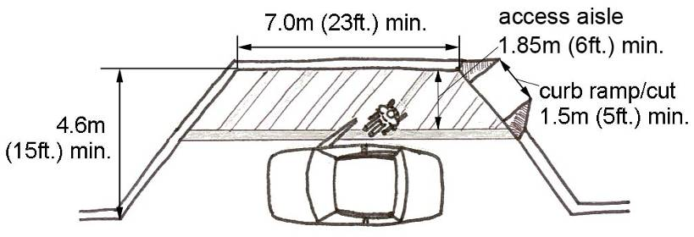
LOCATION
Generally, the drop-off zone should be located at the main barrier-free entrance of the building/site. At a minimum, the zone should be located in close proximity to the main entrance so that persons can see and be seen while waiting to be picked-up or dropped-off.
CRITERIA
a) Accessible drop-off zones should be located within 30m (98ft.5in.) of the main barrier-free entrance and exit.

b) A barrier-free path of travel should connect the accessible drop-off zone to the barrier-free entrance and exit.

c) Changes in level should be minimized, but if required should follow the standards set out in Section 2.4 Ramps, Staircases and Other Changes in Level.

d) If curbs are required, a curb ramp with a minimum width of 1.5m (5ft.) should be included (refer to Section 2.4.1 – Curb Ramps/Cuts).

e) The surface of the drop-off zone should be firm, non-slip and level.

f) An accessible passenger drop-off zone should be at minimum 7.0m (23ft.) in length and 4.6m (15ft.) in width.

Accessible Drop-Off Zone Dimensions

g) Signage indicating “drop-off zone only, no parking” should be positioned in a highly visible location.

h) Where possible, overhead canopies and awnings should be included to provide protection for disabled people unloading in the drop-off zone from the elements, but should have a vertical clearance of at least 2.9m (9ft.6in.) (3.35m (11ft.) preferred) to accommodate vehicle unloading devices.

Drop-Off Zone Vertical Clearance
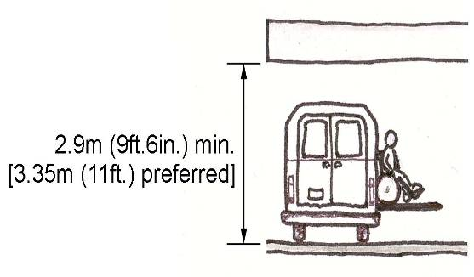

2.1.3 Accessible Parking Signage
Accessible parking spaces must be clearly marked with appropriately sized and positioned international symbols.
LOCATION
Accessible parking space signage must be located directly adjacent to an accessible parking stall.
CRITERIA
a) Accessible parking spaces must be designated with the International Symbol of Accessibility for persons with physical disabilities mounted both vertically on a sign and marked on the surface of the parking stall.

b) All barrier-free parking signage should be visible to vehicles approaching the parking stall.

c) Vertical signage for an accessible parking space must be designed in accordance with the following figure and be positioned in front of each barrier-free parking stall.

Accessible Parking Sign –
By-law 134-83
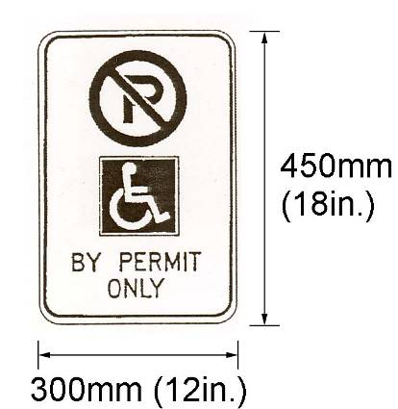

Colour Specifications:
White background
Black letter P, legend and border
Red annular band with interdictory stroke
Blue symbol background and outline
Entire sign face to be of reflective material

d) A second sign to deter illegal usage of the accessible parking space is recommended to be mounted below the regulated sign outlined in the following figure, noting the maximum fine $5000.

Second Accessible Parking Sign

MAXIMUM FINE
$5,000.00
150mm
(6in.)

300mm (12 in.)

e) Vertical accessible parking space signs (post or wall mounted) should be located 1.2m (4ft.) above grade, between 600mm (24in.) and 2m (6ft.6in.) from the curb edge or on a building face within 2m (6ft.6in.) of the curb. Refer to By-law 134-83.

Post-Mounted Accessible Parking Signage
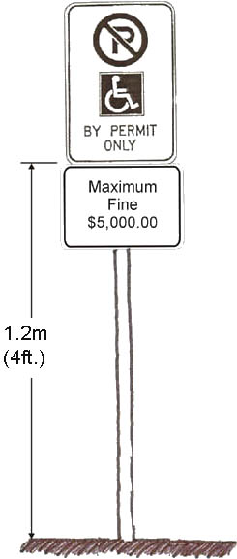

f) For surface signage, the International Symbol of Accessibility for Persons with Physical Disabilities should be painted with a blue background with white lettering onto the paved surface of the parking stall and be a minimum length and width of 1.0m (3ft.3in.).

Accessible Parking Surface Signage

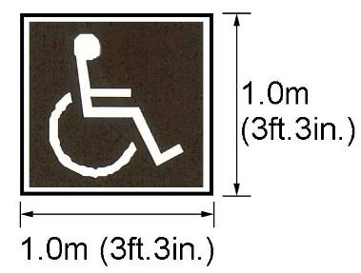

g) In addition to signage for individual parking spaces, signage directing vehicles and pedestrians to accessible parking areas should be located at changes in direction and appropriate intervals, e.g. 30m (98ft.5in.), along a continuous path of travel.

Accessible Parking Directional Signage
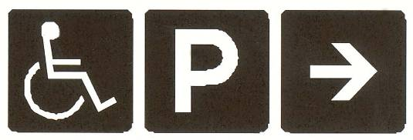

2.2 PEDESTRIAN LINKAGES
People with disabilities are better able to participate in the community if facilities include barrier-free paths of travel. Walkways and municipal sidewalks function as critical links for movement by providing pedestrians with a guided path to a particular destination.

Since municipal sidewalks and municipal walkways contribute such a fundamental function they should be designed to meet the needs of the widest possible range of users.

Walkways should be designed and constructed to provide a well-defined, barrier-free path of travel from parking areas, drop-off zones and streets to the main building entrance, as well as other accessible site features.

In addition to serving a variety of elements and areas on a site, walkways should be simple, logical and consistent in both layout and surface treatment. This enables individuals, particularly those with low or no vision, to predict and interpret new, as well as routine paths of travel.

Municipal sidewalks and municipal walkways should be designed as an accessible route in areas of significant pedestrian activity such as hospitals, medical centres, senior residences, schools, places of worship, community centres, arenas, libraries and civic buildings.

2.2.1 Accessible Routes
Accessible routes should provide a clear width for individuals using wheelchairs or other mobility equipment to not only travel in a straight line but also to turn and to manoeuvre around obstacles.
LOCATION
Walkways and municipal sidewalks should aim to meet the standards for accessible routes for areas of significant pedestrian activity.
CRITERIA
a) At a minimum, one accessible route should connect barrier-free parking spaces, drop-off zones and public streets or sidewalks to the main barrier-free entrance and exit of a facility. It is preferable for all routes to be accessible with the inclusion of ramps, curb cuts, lifts or other suitable measures to deal with changes in level.

b) An accessible route should be at least 1.83m (6ft.) wide. This width permits the comfortable passage of two wheelchairs/scooters/strollers, etc. as well as the piling of snow along the edges without obstructing pedestrian flow during the winter months.

Accessible Route Width
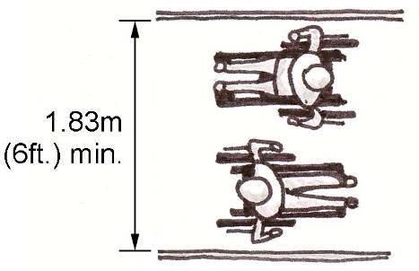

c) The slope of an accessible route should be less than 3% (1:33) to ensure ease of travel and manoeuvrability.

d) Where accessible routes have a slope between 3% (1:33) and 5% (1:20), level resting areas, at least 1.5m (5ft.) in length, should be provided every 30m (98ft.5in.).

e) Accessible routes with a slope greater than 5% (1:20) are considered ramps and should be designed according to Section 2.4.2 – Ramps.

f) To ensure proper drainage a
cross slope of 2% (1:50) is recommended for all accessible routes.

g) Surfaces of accessible routes should be constructed of a firm, smooth, stable, non-slip, non-glare material, including; concrete, asphalt or brick. Concrete with a level, brushed surface is preferable (refer to Section 2.2.3 – Sidewalk Surface Treatments).

h) An accessible route should have a continuous surface with no steps permitted unless accompanied by an accessible ramp (refer to Section 2.4.2 – Ramps).

i) Where an accessible route crosses or adjoins a vehicular route and the surface is not separated by curbs, railings or other protective measures, a detectable warning surface, at least 1100mm (43in.) in width, should define the boundary between the accessible route and the vehicular way (refer to Section 4.4 – Detectable Warning Surfaces).

j) Where maze gates or offset gates are installed, the clear width of the route may narrow provided that the offset of the maze gates does not restrict the ability of a person using a wheelchair, scooter or other mobility aid to pass through (refer to Section 1.3.1 – Space and Reach Requirements).

2.2.2 Protruding Objects
Accessible routes should provide a clear path of travel free from ground and aerial obstructions. Protruding objects, such as directional signs, tree branches, wires and street furniture, should be installed and maintained as to ensure they are outside the clear path of travel and are cane detectable.
LOCATION
While it is optimal for an accessible route to be completely free of obstructions, objects may protrude into accessible route under a variety of circumstances. Where objects do protrude into sidewalks and pathways they should be clearly marked, detectable and navigable.
CRITERIA
a) When designing an accessible route, particularly for persons who have low or no vision persons, projections into or over the path of travel should be avoided.

b) Aerial projections, including tree branches, awnings, lights etc., should have a vertical clearance of 2.03m (6ft.8in.).

Ground projections, such as the edge of a landscaped area or water feature, should be cane detectable. A curb at least 50mm (2in.) to 75mm (3in.) in height is recommended.

Aerial and Ground Projections
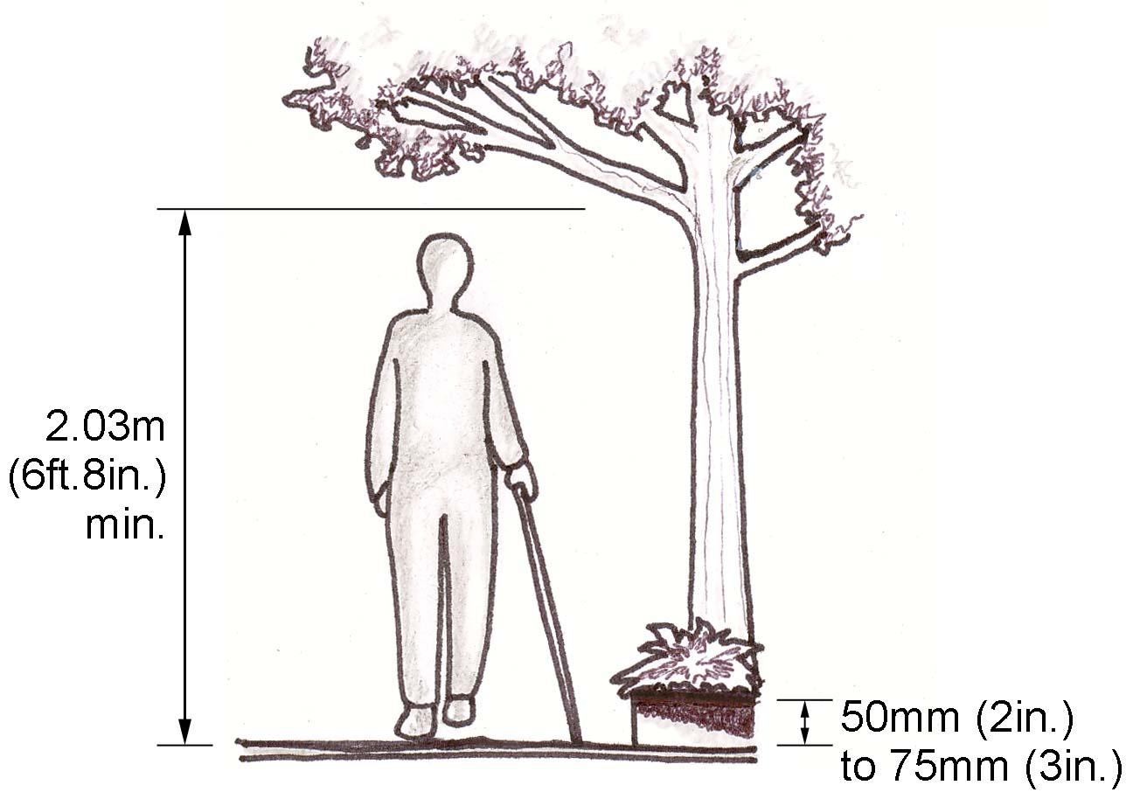

c) If a projection must occur below 2.03m (6ft.8in.) it should have a maximum projection of 100mm (4in.).

Projections Below Vertical Clearance
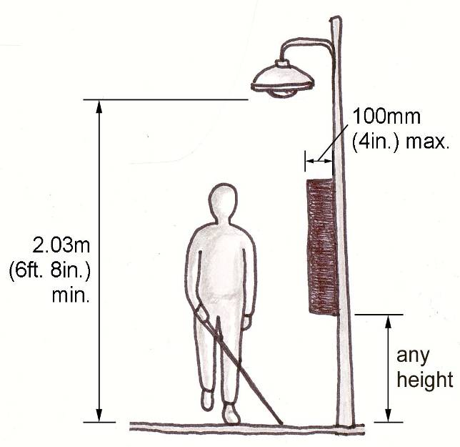

d) An object protruding more than 100mm (4in.) should be marked with a cane detectable guiderail if the leading edge of the object is between 685mm (27in.) and 2.03m (6ft.8in.) above grade.

Projection Outside Cane Detectable Range
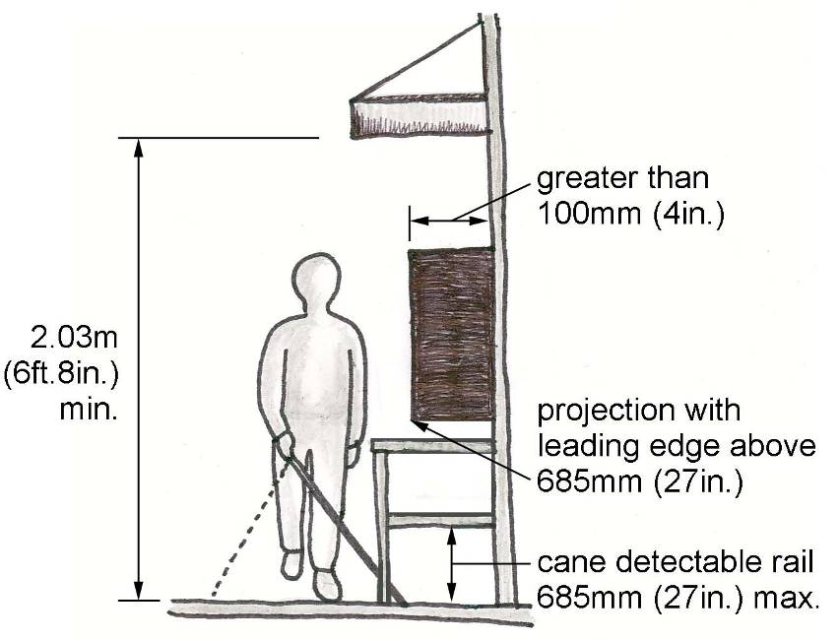

e) Protruding objects should not reduce the clear width of an accessible route or manoeuvring space.

f) See also Section 2.5.5 – Benches and Street Furniture.

2.2.3 Surface Treatments
Accessible routes should contain surface treatments, such as colour contrasted material or tactile features to assist individuals, especially those with low or no vision, to safely navigate the route.
LOCATION
While surface treatments are important to the entirety of an accessible route, several areas are particularly important, including; facility entrances, traffic crossings, stairs, ramps and other changes in level, as well as corners and junctions.
CRITERIA
a) Contrasting colours, materials or tactile surface treatments should be set into accessible routes to identify edges, key site features and correct paths of travel, particularly when the pedestrian route encounters vehicular traffic, a significant change in level or other potentially hazardous condition.

b) A change in surface texture should be used on accessible routes to provide clues to the location of edges, vehicular routes and intersections, curb cuts, or steps and stairs. Surface texture should minimize potential water and ice accumulation.

c) Contrasting colours and tones, achieved through the use of material variation or high-contrast paint, should be used to indicate key features, such as curb or stair edges and traffic crossings.

d) Surface treatments and materials should be used simply, logically and consistently throughout the site so individuals can predict and interpret the route layout. Tactile treatments should be used carefully, since too much tactile information may create a distracting or confusing condition.

e) Dot-type blocks should be used to provide a warning signal to screen-off obstacles, drop-offs or other hazards (refer to Section 4.4 – Detectable Warning Surfaces for design specifications).

f) Line-type blocks should be used to warn of hazardous conditions (e.g. traffic crossings), as well as indicate the correct direction of travel (refer to Section 4.4 – Detectable Warning Surfaces for design specifications).

Tactile Sidewalk Treatment
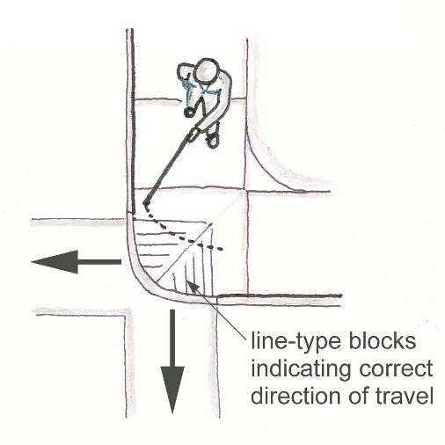

g) Where construction or repairs are required on an accessible route, the works should be well-marked with cane detectable barriers. Lights and audible warnings should be included where feasible.

h) See also Section 4.4 – Detectable Warning Surfaces.

2.3 Entranceways
Representing the transition between interior and exterior elements on a site entranceways are an integral part of barrier-free site design. An accessible entranceway to a building or facility should be available for the participation of people with different levels of ability.

Barrier-free entrances connecting to accessible routes and site features, such as parking, drop-off areas, public transportation stops, streets and sidewalks ensure that an individual with a disability can safely and conveniently access a facility.

2.3.1 Barrier-Free Entrances
Barrier-free entrances and exits must be included throughout a site, both reinforcing and integrating with accessible routes and other barrier-free site features.
Location
Barrier-free entrances should be positioned in prominent, sheltered and easily accessible locations.
CRITERIA
a) The main entrance of a building or facility must be barrier-free.
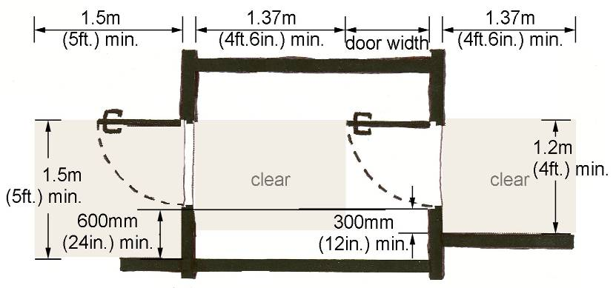
b) Where a building or facility has only
one entrance, that entrance must be barrier-free.

c) Where there is more than one entrance, at least 50% of entrances should be barrier-free.

d) Barrier-free entrances should be located within 30m (98ft.5in.) of accessible parking spaces and drop-off zones.

e) Universal signage should indicate the location of all barrier-free entrances.

f) Entrances which are not accessible should have directional signage indicating the location of the nearest barrier-free entrance.

g) Barrier-free entrances should have a clear, level, non-slip landing outside the entrance at least 2.44m (8ft.) in width and 2.44m (8ft.) in length.

h) The opening of a barrier-free entrance, measured between the edge of the door in the 90 degree open position and the door stop, should be at least 860mm (34in.) wide, excluding door hardware, to accommodate people using all mobility aids.

i) Where an accessible entrance
has an adjoining vestibule, the vestibule should have at least 1.37m (4ft.6in.) of clear space beyond the swing pattern of the entrance door.

Clear Space for Doors in Sequence

j) Where possible barrier-free entrances should include overhead canopies and awnings to provide protection from the elements (refer to Sections 2.1.2 – Passenger Drop-Off Zones and 2.2.2 Objects Protruding into Sidewalks and Pathways for acceptable vertical clearances).

k) To reduce a potential tripping hazard door mats should be no higher than 6mm (1/4in.) from grade.

l) See also Section 3.1.1 – Doors.

2.3.2 Gates, Turnstiles and Openings
Gates and turnstiles should address the full range of users that may pass through them. Single-bar gates designed to be at a convenient waist height for ambulatory persons are at neck and face height for children and chest height for persons who use wheelchairs and scooters.
Location
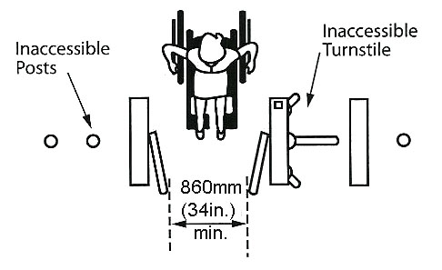
Revolving turnstiles are a physical impossibility for a person in a wheelchair to negotiate. Therefore, where gates and turnstiles are incorporated in an opening consideration must be taken to allow passage for wheelchair users, persons with poor balance and persons using other mobility devices, strollers, walkers or delivery carts.
CRITERIA
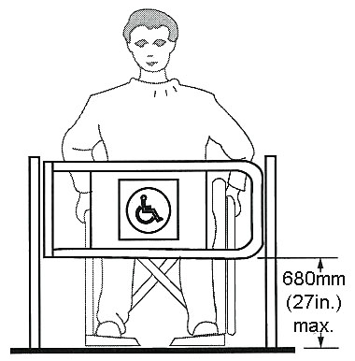
a) Where gates or openings are provided through fences or screens to public use areas, such openings shall be accessible (i.e., a minimum of 860mm (34in.) wide, to allow free passage for persons who use a wheelchair or scooter. (Note: Hardware should be suitable for autonomous use, and any closing device should not be spring loaded).

b) Where turnstiles or other ticketing control devices are utilized which are not accessible, a gate or opening which is accessible shall be provided in the same location and shall incorporate the International Symbol of Accessibility for Persons with Disabilities.

c) Turnstiles shall incorporate a pronounced colour contrast to differentiate them from the surrounding environment.

d) Where gates are incorporated into a chain-link fencing system, the poles at either side of the gate shall incorporate a pronounced colour contrast from the fence and the surrounding environment.

2.4 Ramps, Staircases and Other Changes in Level
While variations in grade are often unavoidable, the design of barrier-free paths of travel should aim to minimize the degree and frequency of changes in level. Where changes in level do occur, properly designed ramps, steps and stairs greatly improve the likelihood of safe and unimpeded access to buildings and other site features.

2.4.1 Curb Ramps/Cuts
While a smooth transition and minimal slope are ideal for users of wheelchairs and other mobility equipment, they are potentially hazardous to people who have low or no vision who may not notice the transition from sidewalk to street or driveway. With this in mind, curb ramps should be designed to provide maximum utility to wheelchair and mobility equipment users, without creating additional hazards for people who have low or no vision.
Location
Curb ramps/cuts should be located wherever barrier-free routes cross a raised curb.
CRITERIA
- A curb ramp should have a minimum width of 1.5m (5ft.) with the ramp not exceeding 2.0m (6ft.6in.) in length.

Curb Ramp Requirements
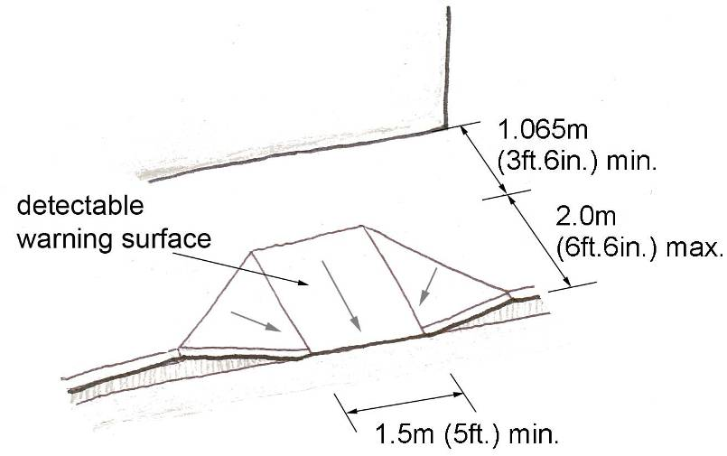
If a curb ramp cuts into an accessible sidewalk or pathway a level resting area, at least 1.5m (5ft.) wide and 1.07m (3ft.6in.) deep should be provided at the top of the curb ramp to accommodate the turning of a wheelchair or other mobility aid.

b) A curb ramp should have a maximum slope of 8% (1:12) with a recommended slope of 6% (1:15). Each flared side should have a recommended slope of 10% (1:10).

c) The counter slope of surfaces immediately adjacent to curb ramps should not exceed 5% (1:20).

d) Curb ramps which provide access to vehicular way crossings shall include a detectable warning surface (refer to Section 4.4 – Detectable Warning Surfaces).

e) The lower edge of a curb ramp should be finished with a rounded or sloped edge between 6mm (1/4in.) and 13mm (1/2in.) in height. An edge greater than 13mm (1/2in.) impedes the safe operation of a wheelchair, while an edge less than 6mm (1/4in.) is a potential hazard to individuals with low or no vision.

Lower Edge of a Curb Ramp
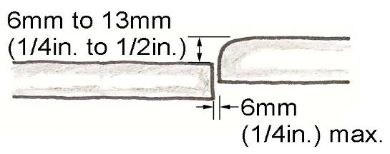

- Handrails are not required adjacent to curb ramps.

- Storm gratings, manhole covers and other obstacles should not be located on or near curb ramps and connecting paths of travel.

- Where catch basins are necessary, they should be located clear of the curb ramp and upstream –from the accessible route.
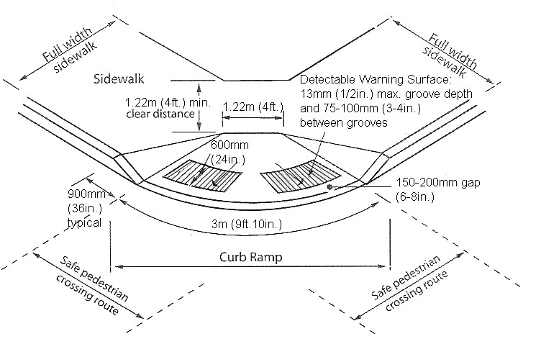
- A curb ramp should be slip-resistant and provide a smooth transition from the ramp to adjacent surfaces.

- See also Sections 2.2.3 – Sidewalk Surface Treatments and 4.4 – Detectable Warning Surfaces.

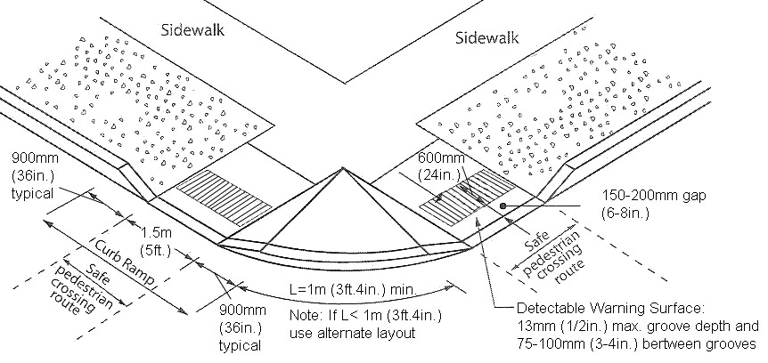

2.4.2 Ramps
Ramps assist wheelchair users and those who have mobility difficulties, as well as provide a general benefit to persons experiencing difficulty negotiating changes in level. Where a change of level already exists or cannot be avoided, a properly designed ramp should be constructed to provide access for those using wheelchairs, scooters, crutches or canes, pushing strollers or moving packages on a trolley.
LOCATION
Ramps with handrails should be integrated into an accessible route wherever significant changes in level necessitate the inclusion of a ramp.
CRITERIA
- Location of ramps shall be indicated with signage that incorporates the International Symbol of Accessibility.

- The recommended width for an accessible ramp is 1.22m (4ft.).

- The minimum slope of a ramp is 5% (1:20). Where the recommended slope is technically infeasible the running slope must never exceed 8% (1:12).

- The cross slope of a ramp should be a maximum of 2% (1:50) to facilitate drainage.

- Ramps with a slope between 5% (1:20) and 8% (1:12) and/or a rise greater than 1.5m (5ft.) or width greater than 1.83m (6ft.) should have handrails on both sides (refer to Section 2.4.4 – Handrails for detailed requirements).

- The clear width between ramp handrails should be between 1.1m (3ft.7in.) and 1.2m (4ft.). These widths permit both the passage of a mobility aid and the opportunity to grasp both handrails.

Ramp Width between Handrails

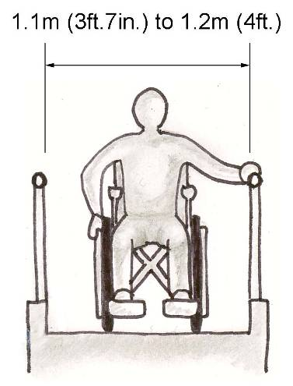

- Intermediate landings or level resting areas should be provided on a ramp every 9.0m (29ft.6in.) and where there is a significant change in direction.

- Intermediate landings on a straight ramp should have a minimum length of 1.67m (5ft.6in.).

Landing Dimensions for Straight Ramps

- Where an intermediate landing is at the corner of an L-shaped ramp, the landing should have a minimum width and length of 1.67m (5ft.6in.).

Landing Dimensions for
L-shaped Ramps

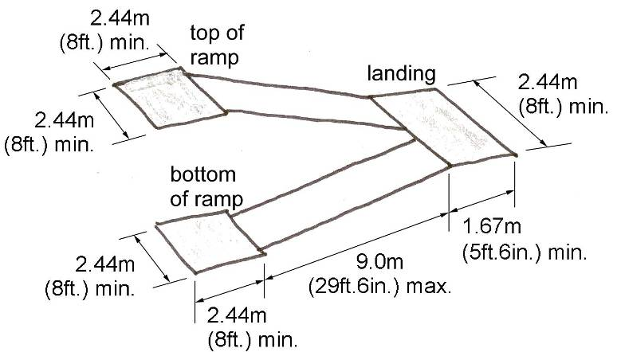
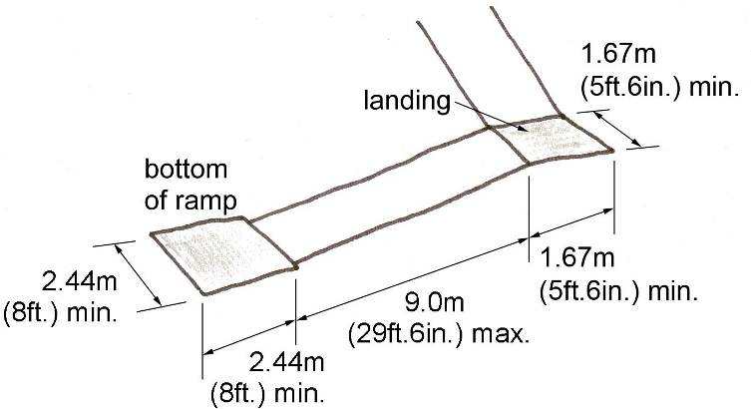

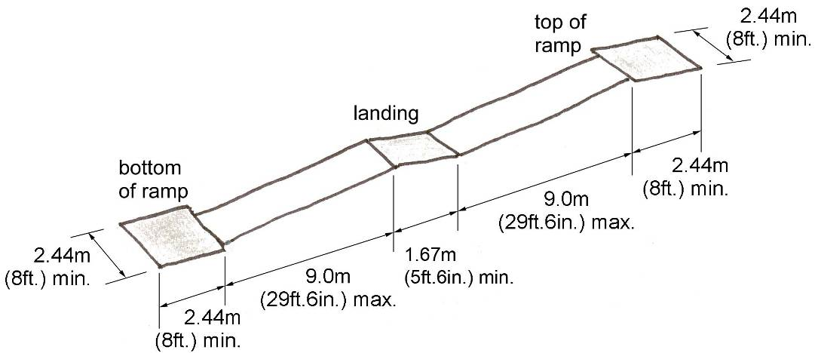

- Where an intermediate landing is at the switchback of a U-shaped ramp, the landing should have a minimum width of 2.44m (8ft.) and length of 1.67m (5ft.6in.).

Landing Dimensions for
U-shaped Ramps

- Landings located at directional changes at the top or bottom of a ramp and/or if served by a doorway should be at least 2.44m (8ft.) wide and 2.44m (8ft.) long.

- A curb with a minimum height of 50mm (2in.) or a solid barrier or pipe rail located no higher than 50mm (2in.) from the ramp surface should be included to act as safety stops for wheeled equipment.

Height of Safety Barriers on Ramp Edges
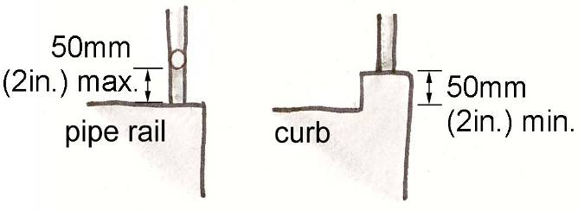

- Surfaces of ramps and landings should be non-slip, non-glare and free of ridges or aggregates that may promote the accumulation of water, ice or snow. Concrete, with a brushed finish perpendicular to the path of travel, is recommended.

- Colour and texture contrasts should denote the top and bottom of a ramp, as well as any intermediate landings (refer to Section 4.4 – Detectable Warning Surfaces).

- See also Section 2.4.4. – Handrails.

2.4.3 Steps and Stairs
Steps and stairs should be designed and constructed to ensure maximum ease and safety especially for those with mobility difficulties and/or low vision. Of particular importance is the inclusion of safety features, such as detectable warning surfaces, to assist individuals who have low or no vision locate entry and exit points, as well as step edges.
LOCATION
Accessible steps and stairs should be integrated into a barrier-free path of travel. Furthermore, stairs should be located perpendicular to the pedestrian direction of travel.
criteria
- All stairs and steps should be uniform in riser height and tread depth.

- Stair risers should be a minimum of 125mm (5in.) and a maximum of 180mm (7in.) in height.

Stair treads, measured from riser to riser, should be a minimum of 280mm (11in.) in depth.

Where stair treads without nosing project forward they should be sloped to the riser at an angle not less than 60 degrees to the horizontal.

Stair Riser and Tread Dimensions
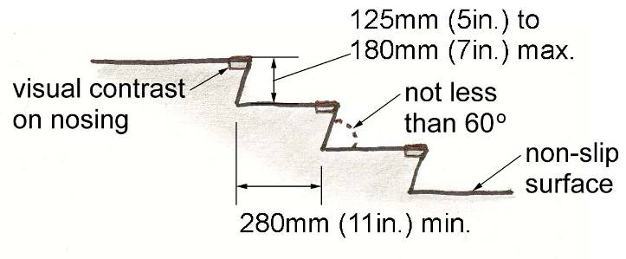

- An open riser with nosing presents a tripping hazard and should be avoided. Stairs with open risers are hazardous to individuals who need a solid riser to guide the foot up or who place crutches or canes against the riser of the next step.

Unacceptable Stair Tread Design

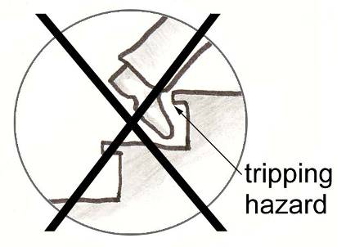

- Openings in riser or tread surfaces should not permit the passage of a sphere 13mm (1/2in.) in diameter.

- Steps or stairs which rise more than 1.5m (5ft.) and/or are more than 1.1m (43in.) wide must include handrails on both sides (refer to Section 2.4.4 – Handrails for detailed requirements).

- Steps or stairs that are 2.2m (7ft.2in.) or greater in width should include an intermediate (middle) handrail to assist individuals with limited mobility or low vision.

- Surfaces of steps and stairs should be non-slip, non-glare and free of ridges or aggregates that may promote the accumulation of water, ice or snow. Concrete, with a brushed finish perpendicular to the path of travel, is recommended (see also Sections 4.4 – Detectable Warning Surfaces and 4.1.8 – Materials and Finishes).

- To warn of impending level changes detectable warning surfaces should be installed one stair width from the top and flush to the bottom of steps or flights of stairs and extend at least 915mm (36in.) into the adjoining path of travel.

Detectable Warnings on Stairs

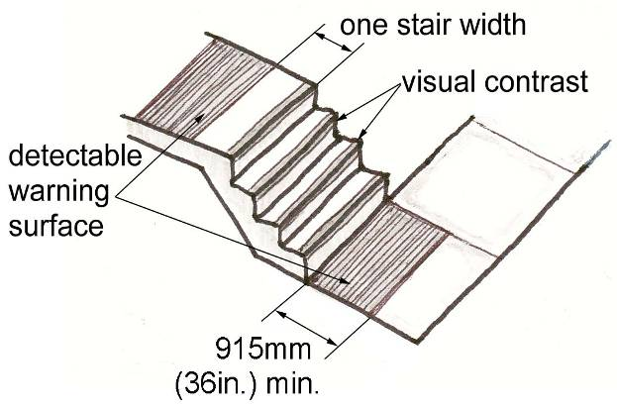

- Colour or texture contrasted tread nosing should be included to provide a visual and/or tactile warning indicating stair edges (refer to Section 4.4 – Detectable Warning Surfaces for detailed requirements).

- Where a pedestrian route passes a flight of stairs at least 2.03m (6ft.8in.) of clear headroom should be maintained underneath the stairs. Where the underside of a flight of stairs is less than 2.03m (6ft.8in.), a cane detectable rail should be installed for the length and width of the portion below the required clear height.

Detectable Rail under Open Staircase

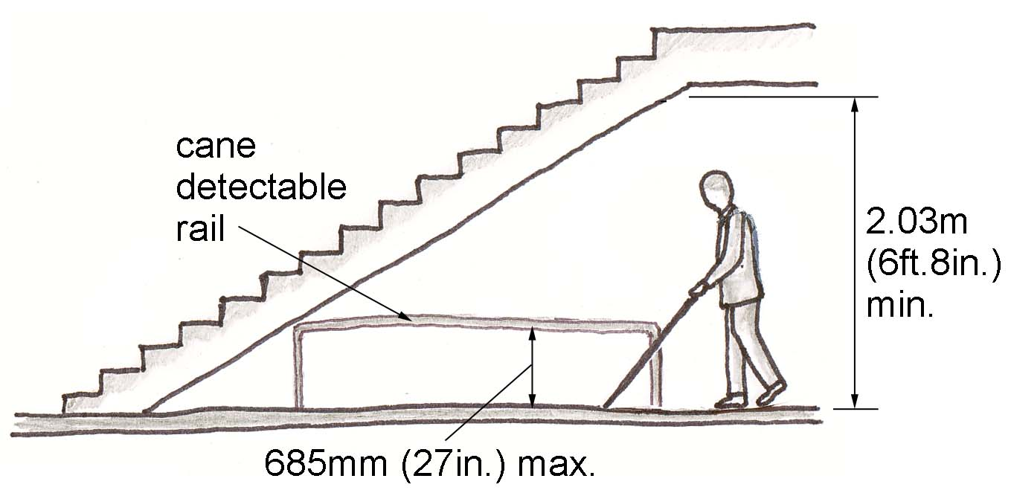

`

2.4.4 Handrails
Handrails included on ramps and stairs should be of correct height, size and configuration to accommodate the widest range of users and provide maximum utility to individuals with limited mobility or other disabilities.
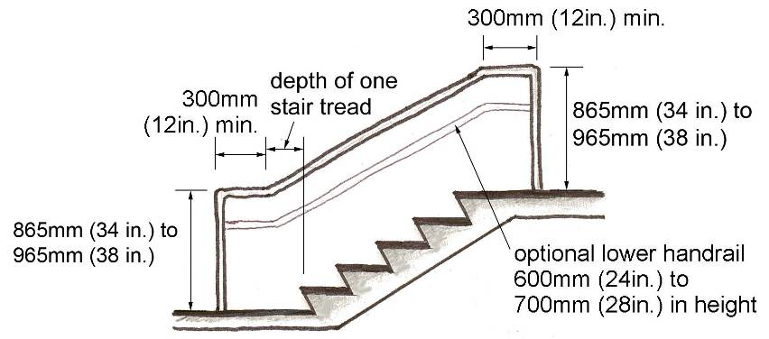
Location
Handrails should be included on all ramps, steps and stairs particularly along barrier-free paths of travel.
criteria
a) All ramps, steps and stairs should include handrails with a continuous gripping surface to help individuals negotiate changes in level.

b) Ramps with a slope between 5% (1:20) and 8% (1:12) should have handrails on both sides.

c) Ramps, steps or stairs which rise more than 1.5m (5ft.) and/or are more than 1.83m (6ft.) wide should include handrails on both sides, except where the ramp serves as an aisle for fixed seats.

d) Ramps, steps or stairs that are 2.2m (7ft.2in.) or greater in width should include an intermediate (middle) handrail to assist individuals with limited mobility or low vision.

e) Handrails must not be less than 865mm (34in.) and not more than 965mm (38in.) in height, measured from the surface of the ramp or stair nosing to the top of the handrail.

Barrier-Free Handrail Design

f) Handrails designed for use by children should be between 600mm (24in.) and 700mm (28in.) in height.

g) Where both adults and children use handrails extensively a double set of handrails should be included to accommodate all users.

h) The clearance between a smooth wall surface and adjacent handrail should be 50mm (2 in.). The clearance between a rough wall surface and handrail should be 60mm (2-1/2 in.).

Barrier-Free Handrail Design Detail
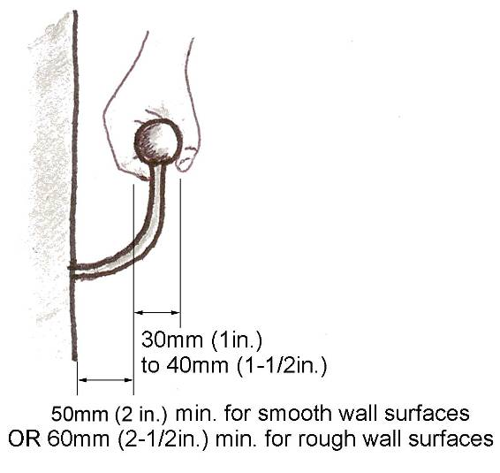

Handrails should be, smooth in texture, firmly mounted and easy to grasp, measuring between 30mm (1in.) and 40mm (1-1/2in.) in diameter.

Handrails should extend, parallel to the floor or ground surface at least 300mm (12in.) beyond the beginning and end of a ramp or stair segment.

i) Handrails should be round (preferred) or oval in shape. Square or rectangular rails are not acceptable.

Accessible Handrail Shapes
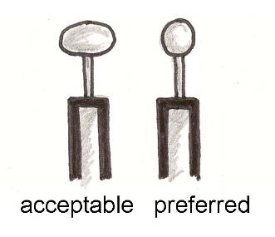

j) To reduce the potential for injury, handrail extensions should avoid using butt-ends. Instead handrail extensions should return in a continuous manner to the floor or wall.

Gripping surfaces of handrails should be smooth and continuous without supporting posts or other obstructions interrupting the handhold.

Handrail Extension Options
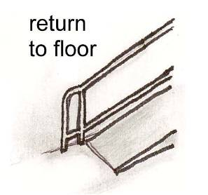

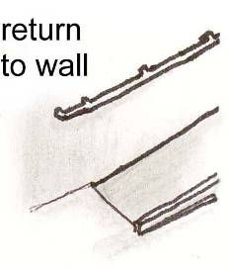

2.5 RECREATIONAL AREAS
Recreational areas should include components that are designated and designed to be accessible. Playgrounds, swimming pools, splash pads, picnic areas, pathway and trails are a few examples of recreational areas that can be designed to be accessible depending on the challenges and constraints with existing conditions.

In addition to designing individual outdoor components to be accessible, consideration should be given for the proximity to and connections between all accessible elements. For instance, a barrier-free swimming pool requires universal toilet rooms, changing areas, parking, seating etc. all in close proximity and connected by barrier-free paths of travel.

2.5.1 Accessible Playgrounds
Accessible playgrounds are designed to generate specific opportunities for play and learning. They also provide an opportunity for socialization between a child and other children or caregivers (any of whom may have a disability). In addition an accessible route, adequate accessible parking should also be provided. “Accessible” playgrounds should be designed to accommodate and include children and caregivers of various abilities.
Location
Accessible playgrounds and accessible play components must be located along an accessible route.
criteria
- A playground must be accessible from a firm, level and non-slip surface, sidewalk or pathway.

- Accessible Playgrounds should be designed with reference to the Playability Toolkit published by the Ontario Parks Association with the Province of Ontario (current version) as well as the National Standard of Canada CAN/CSA-Z614 for “Children’s Playspaces and Equipment” (current version).

- All entry and exit points for barrier-free play components must connect to an accessible route (see Accessible Route Section 2.2.1).

- Small playgrounds, measuring less than 304.8m² (1000 sq ft), may have accessible routes with a clear width of 1.12m (3ft.7in.). Where such routes exceed 9.14m (30ft.) in length, a wheelchair turning space should be provided (see Section 1.3.1 – Space and Reach Requirements).

- To provide flexibility around existing site features such as trees, ground-accessible routes may narrow to a clear width of 915mm (36in.) for a maximum distance of 1.53m (5ft.).

- Non-encroachment safety zones required around play components and manoeuvring space can overlap onto the accessible route.

- A vertical clearance of at least 2.03m (6ft.8in.) should be provided along the entire ground-level accessible route. Vertical clearance for the remainder of the play area may vary to permit the inclusion of protective roofs and other play components.

- Raised play structures designated as accessible should be designed with transfer points, ramps, platforms and railings leading to play components allowing children in wheelchairs or with limited mobility to participate.

Accessible Play Equipment
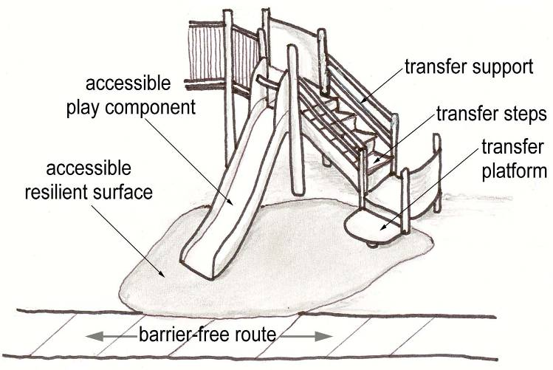

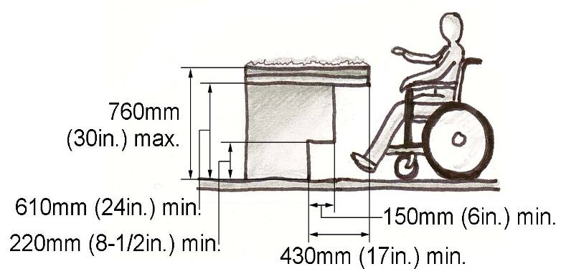
- Tire nets, ramps and slides should be designed to allow children with mobility limitations to crawl and slide on them as well as easily transfer to and from the component.

- Barrier-free play equipment should be surrounded by an accessible resilient surface. Refer to the current Canadian Safety Association Standards and the American Society for Testing and Materials: Specifications for Impact Attenuation of Surface Systems Under and Around Playground Equipment (ASTM 1292) and Determination of Accessibility to Surface Systems Under and Around Playground Equipment (ASTM 1951).

- Accessible surfaces and play components should be designed to complement and enhance the theme of the play area.

- Where an accessible resilient surface is not feasible for the whole playground, accessible and non-accessible surfaces can be combined.

- The transition between adjacent surfaces should be smooth, with a rounded or sloped edge no greater than 6mm (1/4in.) to 13mm (1/2in.) in height.

- Raised sand and water tables, where installed, should be designed in accordance with the following figure.

Accessible Sand or Water Table

- Additional circulation space should be provided around high-use play components.

- Accessible routes, seating areas and other accessible amenities should be incorporated into the design of all accessible playgrounds to accommodate caregivers or attendants with disabilities.

2.5.2 Accessible Swimming Pools and Splash Pads
Accessible swimming pools and splash pads offer significant recreational and therapeutic opportunities and should, therefore, be designed to include and accommodate persons with disabilities.
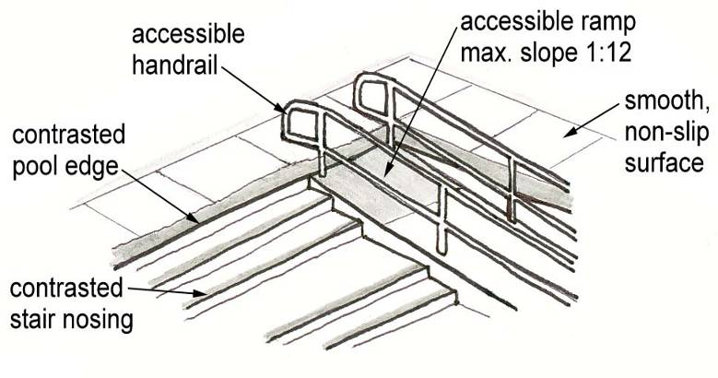
Location
Accessible swimming pools and splash pads should be accessible from a barrier-free route.
criteria
- Accessible swimming and splash pads should be accessible from a barrier-free parking and drop-off area and a barrier-free sidewalk or pathway.

- Barrier-free restrooms and changing areas should be located in close proximity to the accessible pool area (refer to Sections 3.3.4 – Restrooms and 3.3.5 – Changing Areas).

- Swimming pools should include either a hydraulic lift or a ramp for barrier-free access. For an existing pool where a hydraulic lift is present, a portable ramp or portable stairs may also be used to promote independent use of the pool.

- A ramp must have a slip-resistant surface, handrails on both sides and a slope not exceeding 8.3% (1:12). A slope of 6% (1:15) is preferable (Refer to Section 2.4.2 – Ramps). Handrails shall have a height between 800mm (31.5in) and 900mm (35.6in) and run along each side of the ramp running parallel to the slope of the ramp.

Pool with Accessible Ramp

- The pool floor should be slip-resistant yet non-abrasive.

- To assist persons with low vision the pool floor and walls should have a light coloured finish, with depth markings or lettering indicating the SHALLOW END and DEEP END marked in a contrasting colour.

- It is suggested to use different colours on the ceiling to demark pool lanes.

- The surface of a pool deck should be hard, well-drained and slip-resistant with surface joints not exceeding 6mm (1/4in.).

- All skimmers and gutters should be covered with hard plastic or metal grates mounted flush to the pool or deck surface and contain openings no wider than 13mm (1/2in.).

- Pool boundaries should be clearly marked with texture and colour contrasts to both the water surface and the surrounding deck.

- Pool furniture and other pool components, such as lifeguard podiums and diving boards, should contrast with their surroundings and be positioned clear of the accessible route to and from the water.

2.5.3 Accessible Picnic Areas
A portion of each picnic area should be designated and designed with accessible spaces, elements and connecting routes to provide opportunity for participation by individuals with disabilities, including people who have low or no vision or use wheelchairs and other mobility aids.
Location
Accessible picnic areas should be connected to an accessible route and be in close proximity to restrooms and other common facilities.
criteria
a) Accessible picnic areas should be adjacent to a barrier-free route.

b) While it is ideal to evenly distribute accessible picnic areas throughout the site, they should also be located within 180m (590ft.) of universal toilet rooms.

c) The top of an accessible picnic table should be no higher than 865mm (34in.) above the ground.

d) To accommodate a wheelchair or other mobility device, accessible picnic tables should have a clear knee space at least 760mm (30in.) wide, 480mm (19in.) deep and 760mm (30in.) high.

e) Other picnic elements, such as a cooking grill, should be accessible with a height between 610mm (24in.) and 915mm (36in.) from grade.

f) The surface of a barrier-free picnic area should be hard, level and well-drained with at least 2.0m (6ft.6in.) of clear space around all sides of picnic tables and other picnic elements.

g) To improve safety for people who have low or no vision, a change in texture and colour contrast should be used to indicate the location of picnic table areas and other picnic elements.

h) Barrier-free picnic areas should be identified with the Universal Symbol of Accessibility (refer to Section 1.3.2 – Signage).

2.5.4 Accessible Pathways and Trails
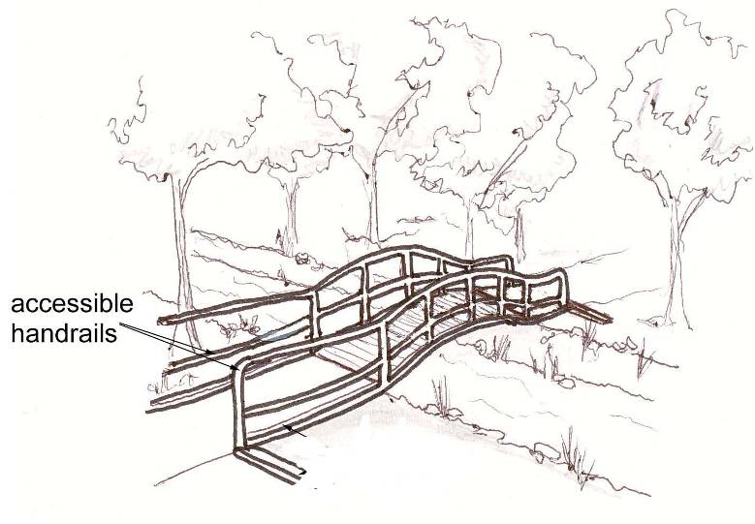
Park pathways and linear multi-use recreational trail systems not only link between destinations, but provide opportunities to experience the natural environment and enjoy outdoor physical activity. While the environmental and geographic constraints preclude all park pathway and trail systems from being totally accessible, where possible, they should be designed to encourage participation from the widest possible range of users.
Location
Barrier-free pathways and trails should be located to encourage participation from the widest possible range of users, while remaining respectful of the existing landform and natural environment.
criteria
a) Accessible paths and trails should connect to accessible site features such as restrooms, playgrounds and picnic areas as well as other common outdoor facilities.

b) All accessible paths and trails may not meet the needs of a diverse range of disabilities. Signage should note the levels of accessibility of the designated paths and trails.

c) Accessible paths and trails should be at least 1.83m (6ft.) in width with level resting areas provided every 30m (98ft.5in.) to 90m (295ft.2in.) depending on the overall length and slope of the route (refer to Section 2.2.1 – Accessible Routes).

d) Bridges should include detectable curbs, rails and accessible handrails.

Accessible Bridge

e) Where provided, accessible viewing areas should be incorporated into the path or trail. Railings should be at least 1.07m (3ft.6in.) in height. Where a railing is higher, the solid portion of the barrier should not exceed 1.07m (3ft.6in.) in height to avoid obstructing views from a seated position.

Accessible Viewing Area
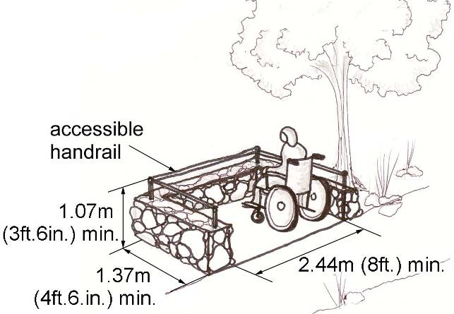

f) Path and trail surfaces should be firm and well-drained. A cross-slope of 2% is recommended.

g) Asphalt, concrete or decking with gaps laid perpendicular to the path of travel are recommended surface treatments for accessible paths and trails (refer to Section 4.9 - Materials and Finishes).

2.5.5 Benches and Street Furniture
Benches and other street furniture such as mail boxes, waste receptacles, lights, bicycle racks and signs should be designed and positioned to maximize safety and utility for all users. For instance, benches installed along barrier-free routes, at entrances and waiting areas, offer a place to rest, which is especially important for the comfort of people with a disability and seniors.
Location
Benches and street furniture should be located along a barrier-free route of travel, but not encroach upon the clear width of the route to avoid potential safety hazards.
criteria
a) Benches and street furniture, such as waste receptacles, mail boxes, light standards, etc. should be cane detectable, colour contrasted to their surroundings, located to one side of an accessible route and not encroach upon the clear width of the route.

b) Benches and street furniture should be stable and firmly anchored to the ground.

c) All waiting and resting areas should include accessible benches and seating.

d) Accessible benches should be constructed with arm and backrests to assist individuals with being seated and rising from the seat.

e) An accessible bench should have a minimum width of 1.2m (4ft.) and a seat height between 460mm (18in.) and 500mm (20in.) from grade.

Accessible Bench Design
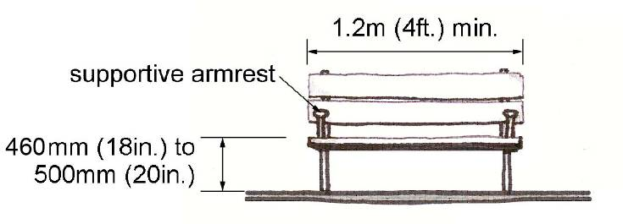

f) To accommodate individuals using service dogs, wheelchairs and other mobility aids, a firm and level surface with a clear space at least 920mm (36in.) wide and 1.37m (4ft.6in.) deep should be located adjacent to an accessible bench or seat.

Accessible Seating Area

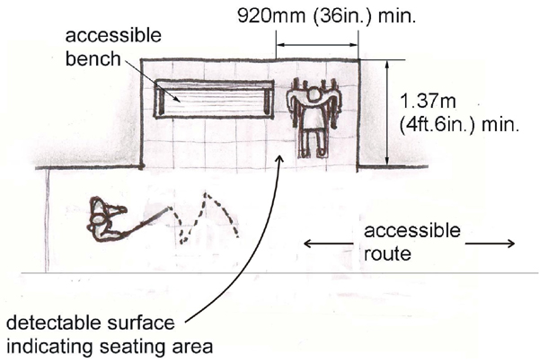

g) A change in surface material or pattern is recommended around amenities, such as seating areas, mail boxes, waste receptacles, etc. to assist persons with low or no vision.

h) Armrests on both sides of a seat are preferable for people who need assistance in transferring to/from the bench.

i) Street furniture, such as mail boxes and waste receptacles, should be securely mounted adjacent to an accessible route.

Amenity Strip on Barrier-free Route
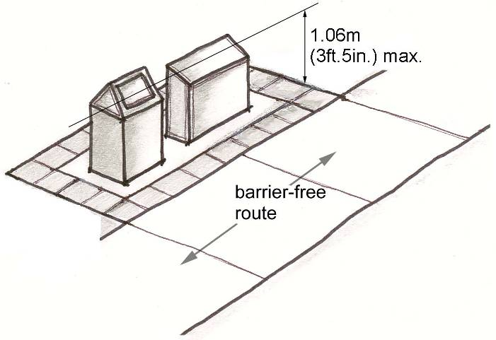

Lids or openings on waste receptacles and other street furniture should be easy to operate with one hand and be no higher than 1.06m (3ft.5in.) from grade.

j) To prevent overflow and potential tripping hazards, waste receptacles should be sufficient in both size and number to contain the anticipated amount of waste for a site.

k) See also Section 2.2.2 – Objects Protruding into Sidewalks and Pathways.

2.5.6 Landscaped Areas
Landscaped areas must be designed with attention given to aesthetics as well as the safety and comfort of a wide variety of users. Natural plant materials may serve to delineate borders and edges, provide pleasing scents and fragrances as well as protect individuals from sun, wind and rain. While providing several benefits, landscaped areas may also present hazards, such as obstructions to a clear path of travel. Suitable materials and regular maintenance should be a priority.
Location
Landscaped areas should be integrated throughout a site to enhance and reinforce barrier-free routes and elements.
criteria
a) Plants and shrubs with a variety of colours and fragrances should be used to provide interest for individuals with low or no vision.

b) Plantings with thorns or heavy berries present a potential hazard and should be pruned back along barrier-free routes or surrounding accessible site features.

c) Contrasting plant material, such as brightly coloured flowers, should be incorporated throughout the site to reinforce borders, edges and landmarks.

d) Plantings may be used as a buffer between street furniture (hydrants or meters) and pedestrians.

e) Trees and shrubs should be used to provide protection from sun, wind and rain particularly along barrier-free routes and around resting areas.

f) Plants or trees that drop large seed pods should not overhang or be positioned near barrier-free routes.

g) Tree branches should be maintained with a vertical clearance of at least 2.03m (6ft.8in.).

h) Edges of a landscaped area should be cane detectable. A curb at least 50mm (2in.) to 75mm (3in.) in height is recommended.

Projections from Landscaped Areas

Accessible planting beds should be raised 460mm (18in.) from grade to accommodate a person with limited mobility, such as an individual in a wheelchair.

i) See also Section 2.2.2 – Objects Protruding into Sidewalks and Pathways.

2.5.7 Balconies, Porches, Terraces and Patios
Where a number of balconies, porches patios or terraces are provided, it is desirable to consider options for different levels of sun and wind protection. This is of benefit to individuals with varying tolerance for sun or heat. Doors to these spaces typically incorporate large expanses of glazing. These should be marked to increase their visibility. Thresholds at balcony doors should be avoided.
Location
Balconies, porches, terraces and patios provided for use by the general public, clients, customers or employees should be accessible via a barrier-free route.
criteria
a) Balconies, porches, terraces and patios shall be located on an accessible route complying with Section 2.2.1.-Accessible Routes and have a minimum depth of 2.44m (8ft.2in.). In a retrofit situation, where providing a depth of 2.44m (8ft.2in.) is technically infeasible, the minimum depth may be reduced to 1.525m (5ft.1in.).

b) Exterior balconies, porches, terraces and patios, where directly accessible from the interior spaces, shall incorporate a threshold, with a rise less than 12mm (1/2in.), in compliance with Section 2.4.1.-Curb Ramps/Cuts.

c) Balcony, porch, terrace and patio surfaces shall comply with Section 2.2.3.-Surface Treatments and be sloped to ensure the removal of water, but not be sloped more than 2%.

d) Railings and guards at balconies, porches, terraces and patios shall comply with the requirements of the Ontario Building Code and be designed to allow clear vision below the rail for persons seated in a wheelchair or scooter. Also, pronounced colour contrast should be incorporated between the railings, guards and the surrounding environment.

- Doors opening out onto the balconies shall be located to open against a side wall or rail.

3

Interior Design

3.1 INTERIOR CIRCULATION
Appropriately sized and designed doorways and corridors are integral to achieve an accessible building interior. If a door or route is too narrow, barrier-free spaces and features adjacent to such components become inaccessible. Similarly, if door hardware is inoperable by persons with physical limitations, entry into a space becomes challenging, if not impossible.

In addition to addressing the space and reach requirements of individuals in wheelchairs, interior circulation design should account for individuals using scooters and other mobility devices, persons with vision disabilities, as well as persons with limited dexterity and strength. The design of corridors and doorways should consider the width of mobility equipment, as well as the clear space required to manoeuvre and negotiate changes in level and direction.

3.1.1 Doors
Doors serve a fundamental function often defining the transition between interior and exterior areas, as well as various interior spaces. To improve access for all users, barrier-free doors, with accessible widths, design and hardware should be included throughout a site.
Location
Barrier-free doors should be located throughout a site, particularly along accessible routes, in order to provide access to barrier-free areas and site features.
criteria
- All barrier-free doors should have a minimum clear width of 860mm (34in.), as measured between the door stop and the edge of the door in the 90 degree open position. Door hardware must not encroach upon the minimum clear width.

- Barrier-free doors should utilize accessible hardware, including levers or D-shaped pulls.

Accessible Door Hardware
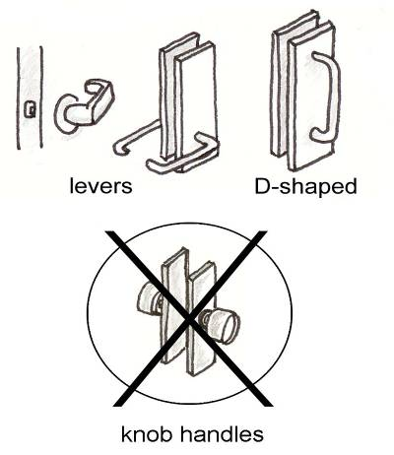

- Door hardware, such as pulls and push plates, shall be mounted between 900mm (35 in.) and 1m (3ft.3in.) from the finished floor.

- Panic hardware should be included where possible, but positioned so it does not interfere with the clear width of the doorway.

- Where panic hardware or other door hardware does encroach upon the clear width of the doorway, the minimum open width should be measured from the panic hardware, rather than the edge of the door.

- To maximize visibility, lever handles, pulls, push plates, and other door hardware should be colour contrasted with the door.

- Thresholds are discouraged, but where required should be less than 13mm (1/2in.) from grade and have a bevelled leading edge to facilitate the passage of wheeled equipment.

- Thresholds should be non-slip and colour, texture or tone contrasted to assist persons with low or no vision.

- Wherever possible doors should not swing into high traffic corridors.

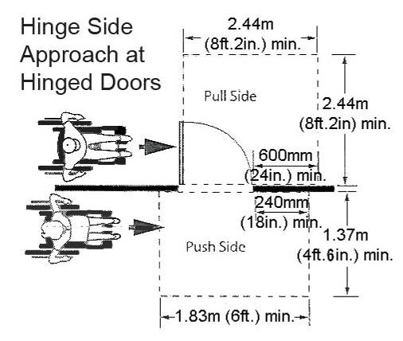
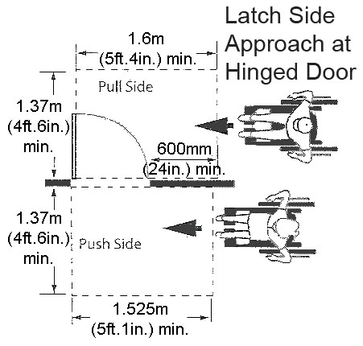
- There should be manoeuvring space on both sides of a door permitting sufficient room for the door to both open and close clear of a mobility aid (refer to Section 2.3.1 – Barrier-Free Entrances).
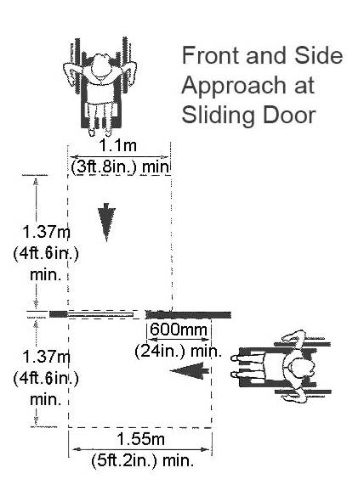
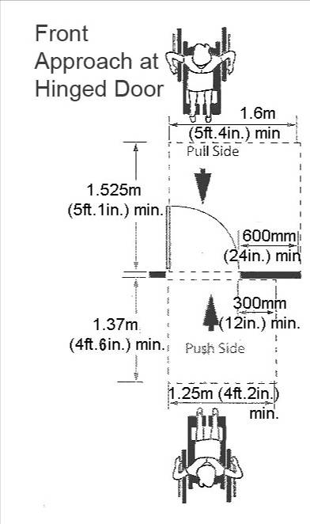

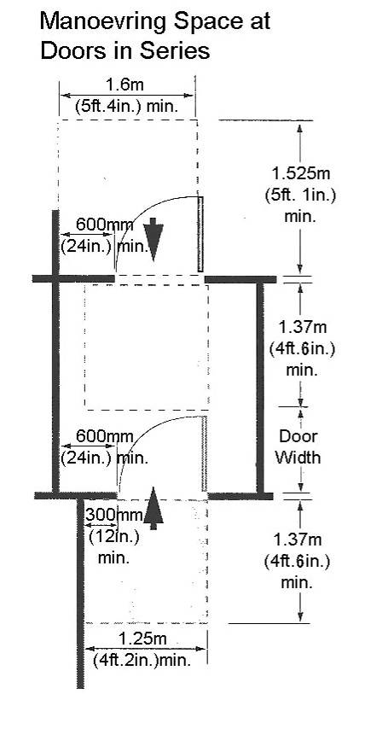
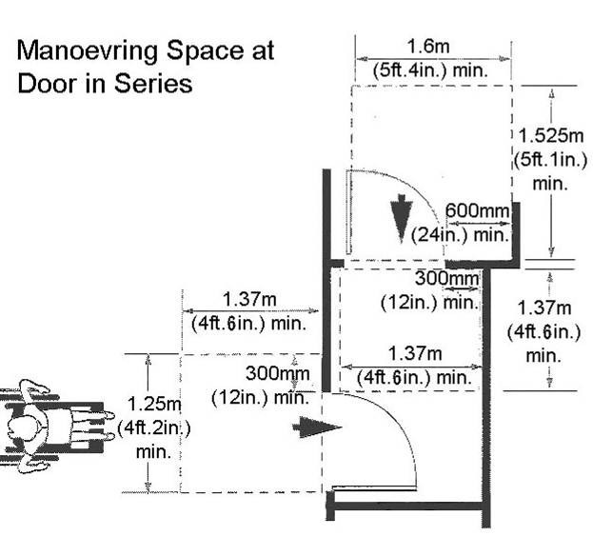
- Where possible, both leaves of double doors, where possible, should be unlocked and operable. This is particularly helpful for service dog users, who need 1.07m (3ft. 6”).

- Where possible, double doors should avoid the use of centre posts.
Manual Doors
- Where a barrier-free door is not equipped with a power door operator, a clear space beyond the latch side at least 600mm (24in.) wide on the pull side of the door or 300mm (12in.) wide on the push side of the door is required.

The force required to open manual doors should not exceed the specifications.

Maximum Force for Door Operation

Door Type | Maximum Force Required to Open
Exterior Swing Door | 38N (8.5 lbs)
Interior Hinged Door | 22N (4.6 lbs)
Sliding/Folding Door | 22N (4.6 lbs)

The sweep period of door closers should be adjusted so that the door will take at least 3 seconds to move from an open position of 90 degrees to a semi-closed position of approximately 12 degrees.
Automatic Doors
n) Barrier-free doors should be equipped with an automatic door operator wherever possible.

All public buildings must be equipped with at least one automatic door at the main entrance.

Automatic doors for accessibility:
1. Sliding doors with a sensing device (most preferred);
2. Swinging doors with a sensing device (second most preferred);
3. Swinging doors with a button opening device (acceptable).

Where a power door operator is installed, the equipment should function for passage in both directions through the door.

The controls for button-operated, out-swinging doors should be mounted outside and in front of the door swing, (toward the latch side if possible), to avoid the situation where an individual using a mobility aid is required to back-up to allow the door to open. This may be achieved in several ways, including wall-mounting or post-mounting the controls.

Where automatic doors open into the path of travel cane detectable rails with at least 300mm (12in.) extensions should be included to protect individuals from the door swing.

Automatic Door Protective Features
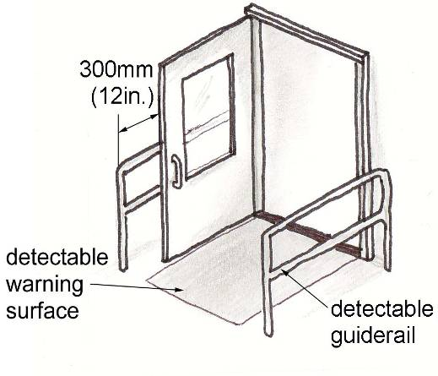

If a guiderail is not present, a colour and texture contrasted surface (or mat) should be installed under the swing pattern of the door and extend at least 300mm (12in.) beyond the door swing to provide a tactile warning surface to aid individuals with low or no vision.

Automatic doors with sensing devices do not require guiderails provided that the sensing device stops or sufficiently slows door movement when there is a pedestrian in the path of the door swing.

Automatic doors should not take less than 3 seconds to move from a closed position to the fully open position.

A force no greater than 66N (13.8 lbs) should be required to stop door movement.

Where automatic doors are installed with a security system ensure the opening mechanism is linked with the electronic board of the security system.

See also Section 2.3.1 – Barrier-free Entrances.

3.1.2 Corridors
Any route of travel should provide a clear width for persons operating wheelchairs or other mobility equipment, pushing strollers or travelling in pairs to easily progress and change directions along the route. Consideration should be given in the design of corridors to accommodate the width and manoeuvrability of various wheeled devices.
Location
Accessible corridors should form a network throughout a building or facility connecting all barrier-free areas and features.
criteria
- An accessible corridor should be at least 1.2m (4ft.) in width. This width permits the comfortable passage of a mobility device and ambulatory person.

Accessible Corridor Width

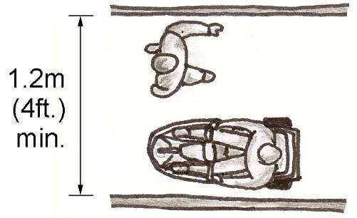

- Where a corridor is less than 1.6m (5ft.3in.) in width, turning spaces at least 1.6m (5ft.3in.) in width and
length should be provided every 20m (65ft.7in.) along the route and at the end of the corridor.

- An accessible corridor should have a minimum vertical clearance of 2.03m (6ft.8in.) with any obstructions or projections, such as the underside of stairs, clearly marked (see also Sections 2.2.2 – Objects Protruding into Sidewalks and Pathways and 2.4.3 – Steps and Stairs).

- Barrier-free corridors should have a slope of 3% (1:33) or less. Areas where the slope exceeds 5% (1:20) should be designed as ramps (refer to Section 2.4.2 – Ramps).

- Changes in level should be avoided along accessible corridors.

- Where changes in level occur, properly designed stairs, ramps and lifts must be included to ensure access for persons with all levels of ability (refer to Section 3.2 – Interior Changes in Level).

- Where there is a change in direction along an accessible corridor and/or the intended destination of the route is not evident, directional signage should be provided (refer to Section 1.3.2 – Signage).

- Distinct colour or texture contrasts should be used throughout accessible corridors to reinforce the location of key elements both within and adjacent to the corridor.

- See also Section 4.7 – Lighting.

3.1.3 Emergency Exits
In order to be accessible to all individuals, emergency exits must include the same accessibility features as other doors specified in Section 2.3.1.-Barrier-Free Entrances. The doors and routes must also be marked in a way that is accessible to all individuals, including those who may have difficulty with literacy, such as children or persons who speak a different language. Persons with low or no vision will need a means of quickly locating exits – audio or talking signs could assist. In the event of a fire, when elevators cannot be used, areas of rescue assistance are an asset to anyone who would have difficulty traversing sets of stairs.
Location
Emergency exits, fire evacuation and areas of rescue assistance should be located as required to be accessible. Accessible means of egress shall be provided in the same number as required for exits by the Ontario Building Code (OBC).
criteria
- Where required exits from a floor level are not accessible, areas of rescue assistance shall be provided on the floor level in a number equal to that of the required exits.

- Every occupied level in non-residential occupancies above or below the first storey (as defined by the OBC) that is accessible, shall be served by an elevator that has protection features, as specified by the OBC or be divided into at least two zones by fire separations, as specified in the OBC.

- In occupiable levels above or below the first storey in residential occupancies, the requirements for protected elevator or two fire zones may be waived, if an appropriate balcony (as specified in the OBC) is provided for each suite.

- Areas of rescue assistance shall comply with this section.

- A horizontal exit meeting the requirements of the OBC shall satisfy the requirements for an area of rescue assistance

- Where emergency warning systems are provided, they shall include both audible and visible alarms. Visual alarms shall comply with Section 4.1.-Visual and Audible Alarms.

- Accessible means of egress shall comply with Section 2.2.1.-Accessible Routes.

- Accessible means of egress shall be identified with signage in compliance with the applicable provisions of Section 1.3.2.-Signage.

- Areas of rescue assistance shall
- Be located on an accessible route complying with Section 2.2.1.-Accessible Route.
- Incorporate the number of rescue spaces in accordance with the following table.
Occupant load of the floor area served by the area of rescue assistance | Minimum number of rescue spaces
1 to 400 | 2
Over 400 | 3 plus 1 for each additional increment of 200 persons in excess of 400 persons
- Be of a size that allows a minimum floor space of 850mm (34in.) x 1.37m (4ft.6in.) per non-ambulatory occupant
- Be separated from the floor area by a fire separation having a fire-resistance rating at least equal to that required for an exit
- Be served by an exit or firefighters’ elevator
- Be designed as an area of rescue assistance for persons with disabilities on the facility
- Be smoke protected in facilities of more than three stories
- Incorporate a 2-way voice communication system for use between each area of rescue assistance and the central alarm and control facility

- Be identified with signage in compliance with the applicable provisions of Section 1.3.2.-Signage, stating “Area of Rescue Assistance” and incorporating the international symbol for accessibility for disabled persons.
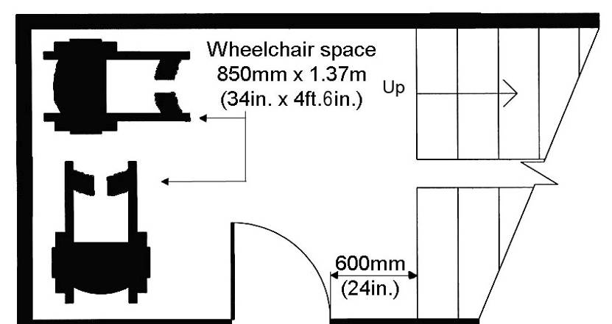
Areas of Rescue Assistance

3.2 Interior Changes in Level
Similar to exterior changes in level, a level change within a building or facility should be navigable by individuals with all levels of ability. Accessible stairs, escalators, ramps, lifts and elevators must be included throughout a multi-level facility to ensure barrier-free access for all users.

Where an accessible route within a building requires steps, escalators or flights of stairs, barrier-free ramps, lifts and/or elevators must be installed to provide access for individuals using wheelchairs and other mobility equipment. All changes in level should be clearly marked with colour or texture contrasts to assist individuals with low or no vision.

3.2.1 Stairs and Escalators
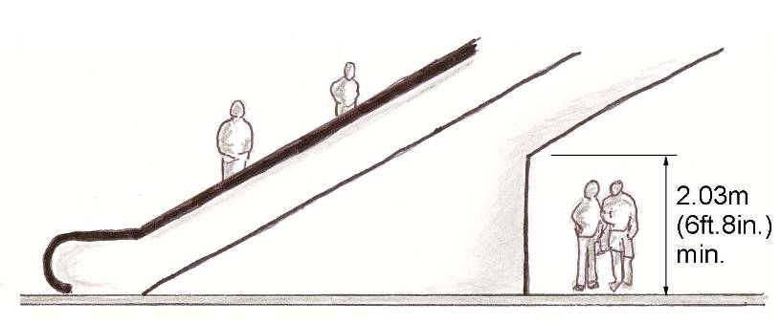
Interior stairs and escalators should be designed to ensure maximum ease and safety particularly for those with mobility difficulties and low or no vision. Safety features, such as detectable warning surfaces and colour contrasts, should be incorporated into stair and escalator design to assist individuals with low or no vision to locate entry and exit points, as well as edges.
Location
Accessible stairs should be located along a barrier-free route, perpendicular to the pedestrian direction of travel. Escalators should be included in high use areas or where flights of stairs are extensive.
criteria
- Refer to Section 2.4.3 – Steps and Stairs for interior step and stair standards.

- Where persons might pass underneath a flight of stairs or an escalator, at least 2.03m (6ft.8in.) of clear headroom should be maintained. Where the underside of a flight of stairs or an escalator is less than 2.03m (6ft.8in.), a cane detectable rail should be installed for the entire length and width of the portion below the required clear height.

Clear Headroom under Escalator or Stairs

Detectable Rail under Open Staircase

- Escalators should include colour contrasted tread edges and nosing to improve visibility while on the stair and assist an individual in estimating the speed of escalator operation from ingress to egress.

- A detectable warning surface, extending at least 915mm (36in.) beyond the head and foot of the escalator should be installed to assist individuals with low or no vision.

- The surface of escalator treads should have a matte, non-slip finish to reduce reflective glare and tripping hazards.

3.2.2 Ramps and Lifts
Interior ramps, platform lifts and stair lifts are important for facility accessibility particularly where elevators are not present.
Location
Accessible ramps and lifts must be located along barrier-free routes where a change in level occurs and an elevator is not present or feasible.
criteria
- Refer to Section 2.4.2.-Ramps for exterior ramp standards.

- Since lifts present space limitations and tend to segregate individuals with disabilities they should be avoided. Wherever possible accessibility for individuals using wheelchairs and other mobility equipment should be provided through the inclusion of properly designed ramps and elevators (see also Section 3.2.3.-Elevators).

- Where ramps and elevators are not practical, due to short horizontal and vertical distances respectively, a lift may be installed to provide access along a barrier-free route.

- Platform lifts should comply with the most recent CSA Standard CAN/CSA-B355 “Lifts for Persons with Physical Disabilities.”

- Platform lifts should be designed to allow for unassisted entry, operation and exit from the lift.

- Platforms should be surrounded by half-walls for safety and stability.

- Platform lifts should include an emergency call system with two-way voice communication.

- Lift activation devices, such as keys or buttons, should be easy to operate by persons with limited dexterity and strength (see also Section 4.3. – Controls and Operating Mechanisms).

- Lifts should be identified by signage displaying the ISA (refer to Section 1.3.2. – Signage).

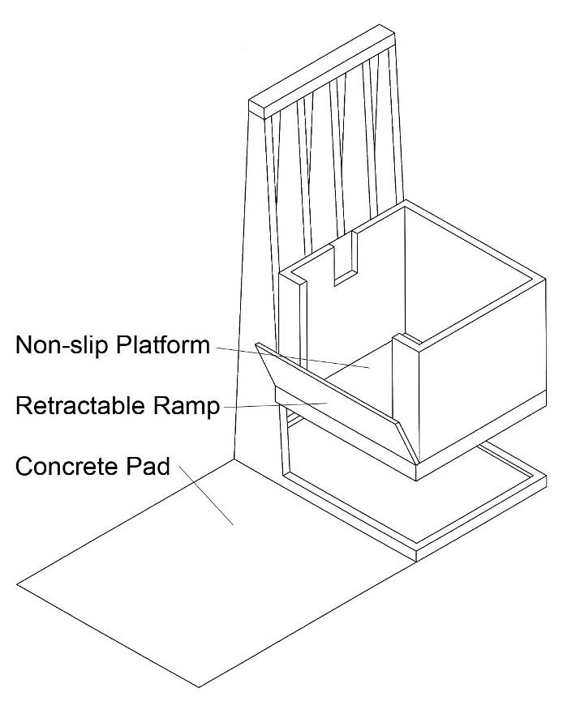
- Ensure that platform lifts and stair lifts do not compromise or eliminate the functionality of a fire egress route. Lifts should not encroach upon required emergency egress widths.

- See also Section 4.7.-Lighting.
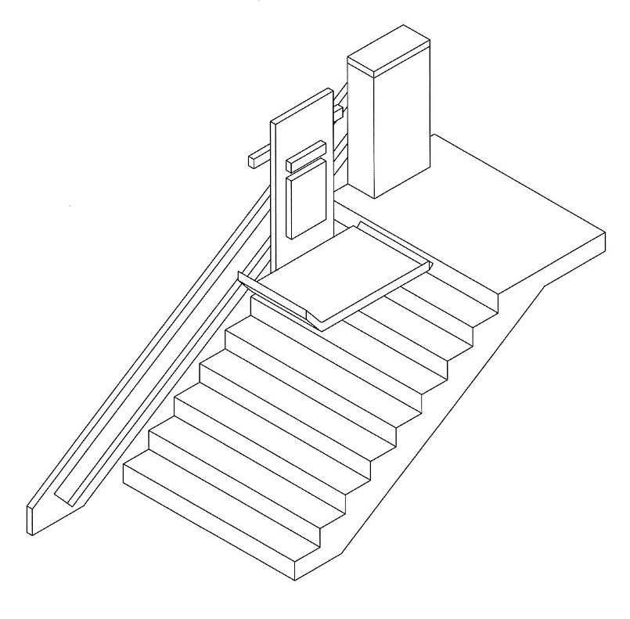

3.2.3 Elevators
In addition to ramps and lifts, elevators are often the only means by which an individual with a physical disability can move from one building floor to another. Every building containing more than one floor not served by a ramp or lift must have an elevator for greater accessibility.
Location
Elevators should be located in close proximity to the main accessible
entrance and accessible parking area (if applicable) and connect with barrier-free corridors and routes throughout the building or facility.
criteria
a) Elevators should comply with the most recent CSA Standards CAN/CSA-B44 “Safety Codes for Elevators” and CAN/CSA-B355 “Lifts for Persons with Physical Disabilities”.

b) The elevator should contain an automatic levelling device which maintains the floor level to ±13mm (1/2in.).

c) An accessible elevator should have a clear space between walls or between wall and doors, at least 1.725m (5ft.8in.) x 1.5m (5ft.) to accommodate people using wheelchairs and other mobility equipment.

d) Elevator doors should have a clear width of at least 915mm (36in.).

Accessible Elevator Dimensions

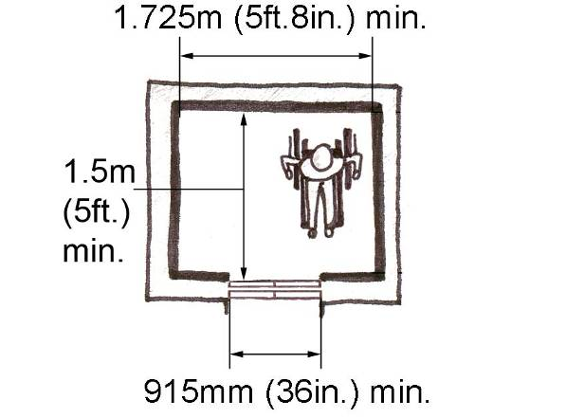

e) Elevator doors should be power-operated and contain an automatic reopening device.

f) A minimum period of 7 seconds should elapse from the time elevator doors begin to open before the doors start to close, for a hall call, and 5 seconds for a floor call. Where an existing condition does not have separate settings, doors should be set for 7 seconds.

g) Doors should contain photoelectric sensors and bumper-type devices capable of sensing and responding to an obstruction in the path of a closing door.

- Photoelectric devices should be positioned 125mm (5in.), with ±25mm (1in.) tolerance, above the floor to detect feet and footrests and 735mm (29in.), with ±25mm (1in.) tolerance, above the floor to detect main body mass.

- Door reopening devices should remain effective for at least 20 seconds to provide sufficient time for a person or object to move clear of the doorway.

- Handrails should be provided on all non-access walls. The top of the gripping surfaces of the handrails shall be at a height of 800mm (31.5in) to 920mm (36in.) from the floor with a space of 35mm (1.5in.) to 45mm (1.75in) between the rail and the wall.

- The interior of elevators should be well illuminated and finished with materials that do not cause glare.

- Illumination for elevator controls and at the landing sill should be at least 100 lux (10 ft. candles) with 200 lux (20 ft. candles) recommended.

- In-car lighting should be provided, with fixtures installed at least 1.83m (6ft.) from the floor.

- The elevator floor and adjacent landings should be firm, slip-resistant and non-glare, to permit easy movement of wheeled devices, as well as to assist individuals with low or no vision. Also, black coloured elevator floors should be avoided.
Elevator Controls and Indicators
- All elevator entrances should have raised pictographs and Braille floor designations mounted with the centreline 1.37m (4ft.6in.) above the floor.

Hall call buttons should be a minimum of 20mm (1in.) in size and mounted one above the other to a centreline of 1.07m (3ft.6in.) from the floor.

Features Outside Elevators
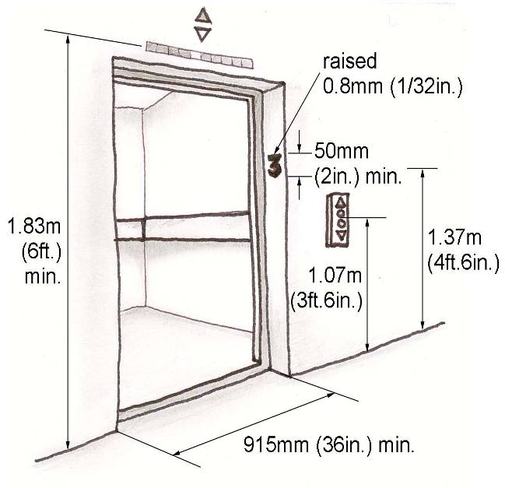

A visual indication should be provided on the hall call button for each registered call which extinguishes when the call is answered.

A visible and audible signal should be provided at each elevator entrance indicating which car is answering the call.

Audible signals should sound once for the up direction and twice for the down direction.

Audible indicators are not recommended for doors that are held open longer than 5 seconds.

All lettering, numbering and control panels in both the elevator and access hallway/lobby should be highly visible and colour contrasted.

Within the elevator, floor buttons should be a minimum of 19mm in size and mounted in series with the centreline of the highest button no higher than 1.2m (4ft.) from the floor.

Controls Within Elevators

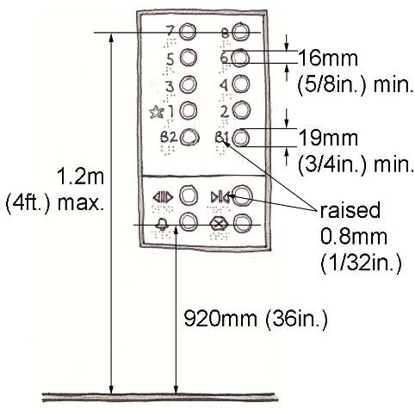
Arabic numerals on a contrasting background, raised pictographs and Braille should be located on the left side adjacent to each floor button or control.

The operating depth of flush or recessed buttons should not exceed 10mm (3/8in.).

Heat sensitive call buttons should not be used.

A visual indication should be provided to show each call registered and a momentary audible indication should be provided when each call is answered.

An audible and visual indication corresponding to the landing at which the car is stopped or passing, should be provided within the elevator to convey the position of the car in the hoist-way.

Where the depth of the elevator cab makes it difficult for persons using mobility aids to turn around, a mirror reflecting the visual floor indicator should be provided on the rear wall.

In case of emergency, elevators should be equipped with a telephone that is capable of two-way communication.

To ensure hearing aid compatibility, emergency telephones must comply with CSA Standard T515, be equipped with a receiver that generates a magnetic field in the area of the receiver cap and include a volume control.

The telephone should be located a maximum of 1.2m (4ft.) from the floor with a minimum cord length of 900mm (35-1/2in.).

If the telephone is in a cabinet ensure that the latch to open the cabinet is accessible e.g. D-pull.

The International Symbols for both telephones and hearing loss should be marked in a contrasting colour on the telephone cabinet (refer to Section 1.3.2 – Signage). The symbols should be at least 38mm high, raised a minimum of 0.8mm (1/32in.).

A push button alarm should be provided for those unable to speak.

Emergency controls and door-operating buttons should be grouped together at the bottom of the control panel.

The centre-line of the alarm and emergency stop buttons should not exceed 920mm (36in.) from the floor.

3.3 Interior Areas
Interior areas, such as reception and information counters, restrooms, offices and meeting rooms are commonly found within public, as well as private facilities. Such areas occur frequently throughout a building and should be accessible to a wide range of users.

Clear floor space for the manoeuvrability of mobility equipment, suitable counter heights for individuals with reach limitations and adequately sized restrooms for families, persons using mobility aids or individuals requiring assistance are examples of the many ways the design of interior areas impacts accessibility within a facility.

3.3.1 Reception Areas
Reception areas should be designed to provide access for individuals with varying levels of ability. Information and service counters should contain sections low enough to serve children, persons of short stature and persons using wheelchairs and other mobility aids.
Location
Accessible reception areas should be located along a barrier-free path of travel in close proximity to the main barrier-free entrance where applicable.
criteria
- Counters for information or service should incorporate at least one accessible section that is located a maximum of 865mm (34in.) above the finished floor and measures at least 915mm (36in.) in width and 480mm (19in.) in depth.

- Accessible sections of information and service counters should incorporate a clear floor space not less than 760mm (30in.) wide and 1.37m (4ft.6in.) deep.

- Where a forward approach is used to access a wheelchair seating space, a clear knee space of at least 760mm (30in.) wide, 480mm (19in.) deep and 760mm (30in.) high should be provided. The clear knee space may overlap the clear floor space by a maximum of 480mm (19in.).

Accessible Information or Service Counter

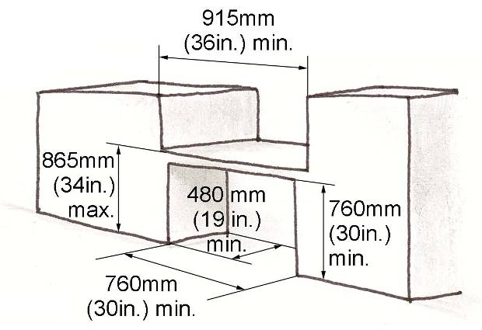

- A variety of counter heights is recommended to provide options for a wide range of people.

- Counter service desks with vertical, backlit panels cause glare and should be avoided (see also Section 4.6 – Glare and Light Sources).

- Where speaking ports are provided at information or service counters, at least one section should have a speaking port no higher than 1.06m (3ft.5in.) above the finished floor.

- Glass, Plexiglas and similar materials used to separate staff from visitors serve as barriers to communication for people with hearing loss or have low or no vision. Such barriers, unless required for safety or security purposes, should be avoided.

- Where appropriate, reception areas should contain accessible seating.

- See also Section 4.7 – Lighting.

3.3.2 Waiting and Queuing Areas
Waiting and queuing areas for passenger pick-up, communication or information, tickets or services should permit safe and convenient access for individuals with disabilities and other limitations.
Location
Waiting and queuing areas should be located along a barrier-free path of travel.
criteria
a) Waiting areas should incorporate sufficient waiting space for at least two persons using wheelchairs, scooters or service dogs (refer to Section 1.3.1 – Space and Reach Requirements).

b) An accessible public telephone should be provided in waiting areas, particularly near main entrances and passenger drop-off zones (refer to Section 3.4.2 – Public Telephones).

c) Accessible seating should be provided in waiting areas to assist people who may experience difficulty standing for an extended duration.

d) To increase visibility, ropes, bars or other solid obstructions defining a waiting or queuing area should be colour contrasted with their background.

e) Cane detectable guiderails should be included in queuing lines to assist individuals with low or no vision.

f) Obstructions in waiting and queuing areas should be laid out in parallel, logical lines, spaced at least 1.06m (3ft.5in.) apart and set clear of the main path of travel.

g) Barriers intended to streamline the movement of people at queuing areas should be firmly mounted to the floor and have rigid rails to provide support for waiting persons.

h) Permanent queuing areas should incorporate clearly defined surface treatments, such as distinct patterns, colours and textures, to aid individuals with low or no vision.

i) Waiting and queuing areas should incorporate clear signage indicating entry and exit points, and other specially designated areas.

3.3.3 Offices, Work Areas and Meeting Rooms
Offices, work areas and meeting rooms providing assistance or programs to the public should be accessible for all users. Additionally, offices, work areas and meeting rooms should be accessible to employees and visitors with varying levels of ability.
Location
All accessible offices, work areas and meeting rooms should be located along a barrier-free route of travel.
criteria
a) All accessible offices, work areas and meeting rooms should include a clear floor space permitting a mobility aid to make a 180-degree turn (refer to Section 1.3.1 – Space and Reach Requirements).

b) A barrier-free route should be provided throughout an accessible office, work area or meeting room such that a person using a wheelchair or other mobility device is not required to travel backwards to enter or exit the space (refer to Section 1.3.1 – Space and Reach Requirements).

c) A barrier-free route should connect the primary activity elements within an accessible office, work area or meeting room. For example, a photocopier, desk, fax machine, boardroom tables, etc.

d) At least 10%, but no less than one fixed or built-in table, counter or work surface should be barrier-free.

- To accommodate an individual in a wheelchair or scooter, desks, tables, counters and other work surfaces should be positioned a maximum of 865mm (34in.) above the finished floor and include a clear floor space at least 760mm (30in.) in width and 1.37m (4ft.6in.) in length.

Clear Floor Space for Work Surfaces
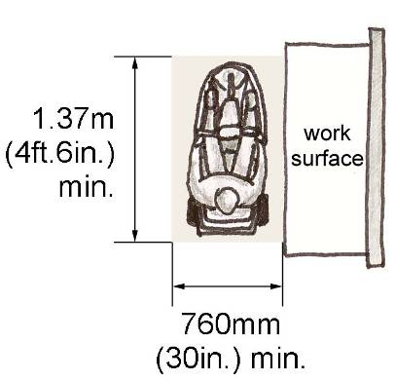

f) To address the knee space requirements of an individual in a wheelchair, tables and other work surfaces must incorporate a clear knee space at least 760mm (30in.) wide, 480mm (19in.) deep and 685mm (27 in.) high.

Clear Knee Space for Work Surfaces
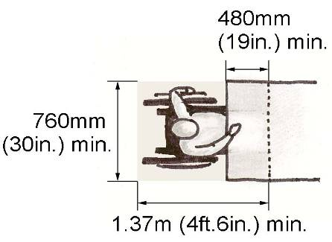

g) Where served by a door, the required clear space of an accessible office, work area or meeting room should not be reduced by the operation of the door (see also Section 3.1.1 – Doors).

h) Storage, shelving or display units should be accessible for use by personnel and visitors (refer to Section 3.4.3 – Lockers, Storage, Shelving and Display Units).
i) A clear floor space, at least 760mm (30in.) x 1.37m (4ft.6in.), should be provided in front of office equipment, such as photocopiers.

j) Natural coloured task lighting, such as that provided by halogen bulbs should be used to improve visibility for individuals with low vision (refer to Section 4.7 – Lighting).

k) In areas where reflective glare may pose a problem, such as adjacent to large expanses of glass, window coverings should be provided and be accessible for adjustment (refer to Section 3.4.4 – Windows, Glazed Screens and Sidelights).

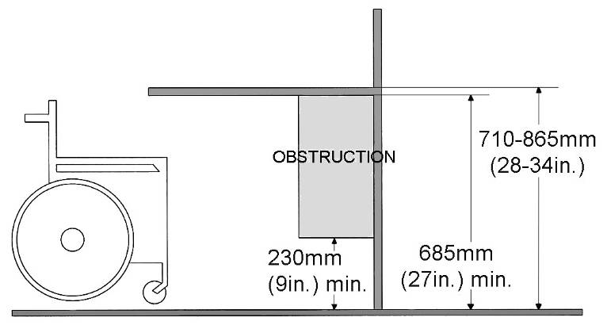
l) Where required, telephone equipment suitable for individuals who are deaf, deafened or hard of hearing should be provided in offices, work areas and meeting rooms.

m) Where required, meeting rooms should be equipped with an assistive listening system. (Refer to Section 4.11 – Assistive Listening System).

n) Accessible reception counters should be a maximum of 865mm (34in.) in height to accommodate individuals with height and reach limitations.

3.3.4 Restrooms

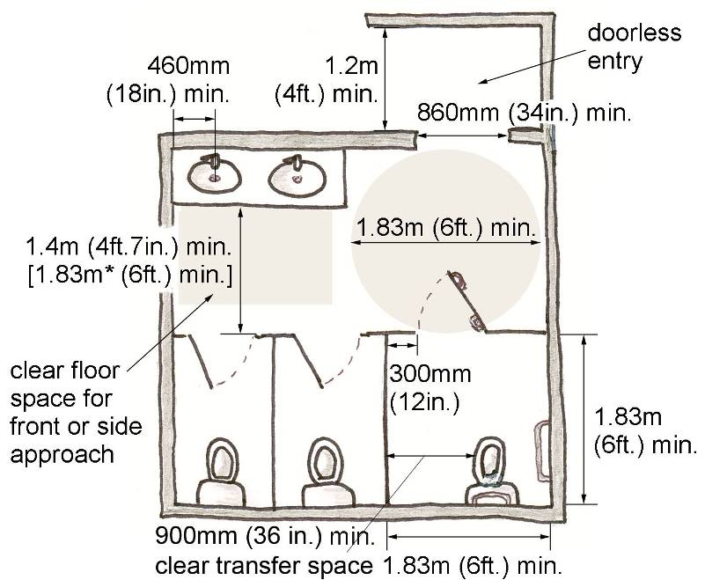
Restroom facilities should be accessible for individuals with physical disabilities. All restrooms should contain accessible stalls or be accompanied by separate universal toilet room. Universal toilet rooms are particularly useful for persons in wheelchairs or scooters, families and individuals requiring assistance.
Location
Universal toilet rooms should be served by a barrier-free path of travel and be located near main areas and activities within the site.
criteria
a) The entrance to universal toilet rooms and public restrooms with accessible stalls should be at least 860mm (34in.) (refer to Section 3.1.1– Doors).

b) Doorless entry is preferred for all restrooms with accessible stalls. Privacy screens with a minimum clear width of 1.2m (4ft.) should be provided between the screen and a door opening.

A minimum clearance of 1.4m (4ft.7in.) should be provided between the outside of the stall face and any wall-mounted fixture or obstruction.

A clear turning space, at least 1.83m (6ft.) in diameter, should be provided outside an accessible stall. The door to the accessible stall may encroach upon this clear space.

Accessible Restroom Dimensions

* Where a lavatory is adjacent to an accessible stall, at least 1.83m (6ft.) of clear space is required [rather than 1.4m (4ft.7in.)] between the outside of the stall face and any obstruction or the swing of an inward swinging stall door.

c) Where doors are used for entry to a universal toilet room, the door should be equipped with an automatic opener.

d) Thresholds are discouraged, but where present should be colour or brightness contrasted, a maximum of 13mm (1/2in.) in height and bevelled to facilitate the passage of wheeled equipment.

- See also Section 3.1.1 – Doors.
Urinals
f) The urinal itself should be wall mounted with an elongated rim located less than 430mm (17 in.) above the finished floor.
The urinal should have grab bars installed on each side, vertically mounted, at least 600mm (24in.) long, and mounted so that each grab bar has the lower end between 600-650mm (2ft.-2ft.2in.) from the floor; and located less than 380mm (15in.) from the centre line of the urinal.
Privacy screens, if provided, shall be at least 920mm (36in.) apart
The centre of the flush lever shall not be more than 1.12m (3ft.9in.) above floor level.
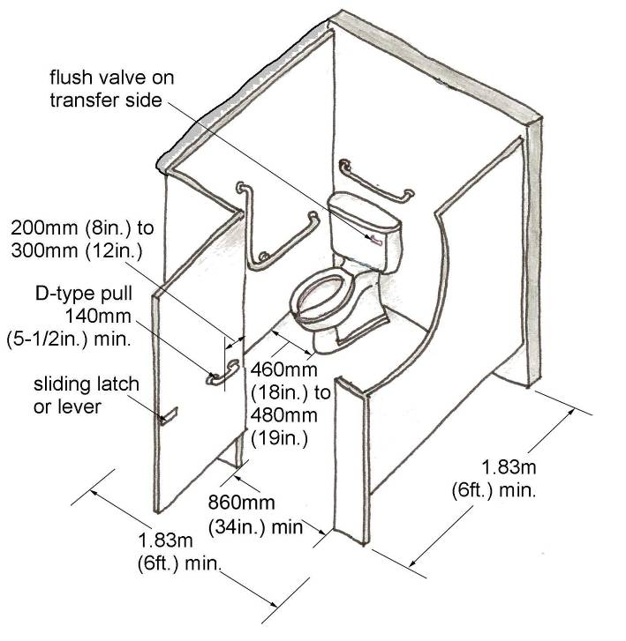
ACCESSIBLE STALLS

- Accessible restroom stalls should have a minimum width and depth of 1.83m (6ft.). These dimensions will be incorporated beside the toilet and excluding accessories in the case that a 1.83m (6ft.) turning radius is not provided outside the stall.

A clear transfer space with a width of at least 900mm (35-1/2 in.) must be provided beside the toilet to facilitate transfer to and from a mobility device. Accessories, such as paper dispensers, sanitary napkin disposals, fold-down shelves, etc., should not obstruct the transfer area.

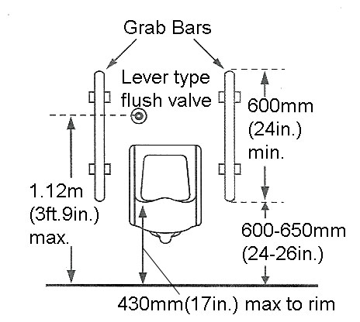
Accessible Restroom Stall
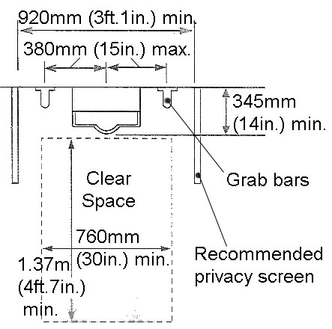
Accessible stall doors must provide a clear opening at least 860mm (34in.) wide and swing outward unless additional space is provided within the stall. This additional space must be 760mm x 1.22m (30in. x 4ft.).
Accessible stalls should include
D-type door pulls with a minimum length of 140mm (5-1/2in.). Door pulls should be positioned on the outside of the door near the latch
and on the inside of the door at a centreline between 200mm (8in.) and 300mm (12in.) from the hinged side.

Locking devices should be located on the inside of the stall door, be operable with one hand (e.g. a sliding bolt or lever) and require a maximum force of 22N. Locking devices should not require tight grasping, pinching or twisting of the wrist.

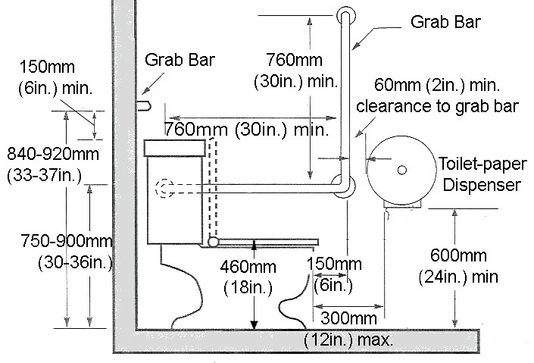
The centreline of the toilet in an accessible stall should be located between 460mm (18in.) and 480mm (19in.) from the adjacent wall.

Baby change tables should not be installed in accessible stalls since they present a potential obstruction and hazard if not closed after use. The only exceptions will be for accessible stalls that exceed the minimum width and depth with the change table in the open position.

h) The top of the toilet seat shall be 460mm (18in.) above the finished floor.

A back support should be provided when there is no toilet seat lid or tank. If a toilet tank lid is present, it should be securely attached.

Grab bars, with a diameter between 30mm (1in.) and 40mm (1-1/2in.) and a slip-resistant gripping surface, must be installed to assist transfer to and from the toilet.

One grab bar, at least 760mm (30 in.) in length, should be horizontally mounted on the wall behind the toilet at a height between 840mm (33in.) and 920mm (36in.) above the finished floor and where a tank is present, at least 150mm (6in.) above the tank.

A reverse L-shaped grab bar should be mounted on the side wall closest to the toilet and positioned between 750-900mm above the finished floor, and project 150mm (6in.) in front of the toilets edge. The inclusion of angled grab bars is not recommended and fold down grab bars are optional.

Accessible Toilet and Grab Bars
Grab bars should have a 40mm (1-1/2in.) clearance between the bar and the wall and be capable of resisting a horizontal and vertical force of at least 1.3kN (300lbs.).

Toilet flush controls should be located on the transfer side of the toilet, above the back rest and be of contrasting colour to their background. Automatic flush controls are preferable.
Toilet paper dispensers should be wall-mounted. The point where the toilet paper is dispensed should be located below the grab bar, and in line with or not more than 300mm (12in.) in front of the toilet seat, not less than 600mm (24in.) above the floor and contrasting in colour to the wall. Alternate options will be considered on an individual basis, as long as functional intent is maintained. In a retrofit situation ensure that the toilet paper dispensers do not interfere with the use of the grab bar and that the above requirements are met as best as possible.
Universal Toilet Rooms
i) Universal Toilet Rooms are preferable to accessible stalls and should be included wherever feasible. A universal toilet room is more spacious for persons using mobility devices and is especially helpful for individuals requiring assistance, e.g. children or seniors, particularly when the assistant is of opposite gender.

Universal Toilet Room
Where a separate universal toilet room is provided, it should be located on the same floor and within 45m (147ft.7in.) of the general public restroom.

A separate universal toilet room should have an internal clear space at least 1.83m (6ft.) in diameter to accommodate the turning radius of a mobility device, such as a scooter. It should also provide a clear transfer space of 1.02m (3ft.5in.) beside the toilet.

The door of a universal toilet room should be lockable from the inside but capable of being released from the outside in case of an emergency.

The door shall be equipped with a power door operator.

An emergency call system should be installed in all Universal Toilet Rooms (refer to Section 4.3 – Controls and Operating Mechanisms for positioning and clearances).

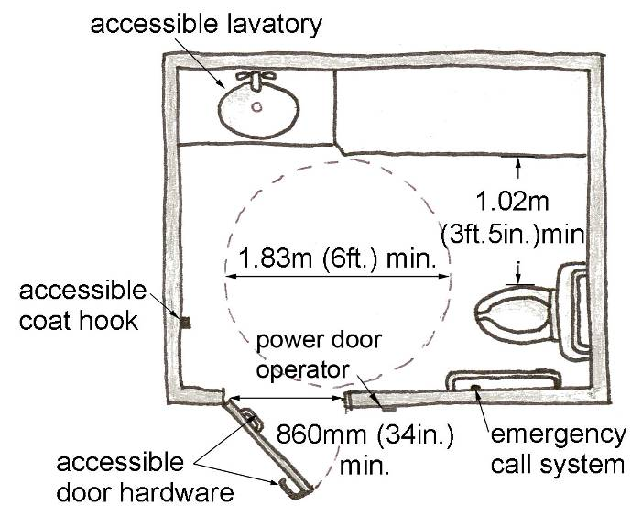
A change table, with a surface no higher than 865mm (34in.), with adjacent clear floor space at least 760mm (30in.) wide and 1.37m (4ft.6in.) long and a design capable of supporting the weight of an adult, may be included in an universal toilet room provided that the required clear transfer and manoeuvring spaces are not reduced when the table is in the open position.

Requirements for toilets, grab bars, dispensers, coat hooks, shelf, door hardware, lavatories and other features should follow the guidelines set out for Accessible Stalls and Lavatories and Accessories found in this section.
Lavatories and Accessories
j) The minimum distance between the centreline of a fixture in a sink or vanity and a sidewall should be 460mm (18in.).

The surface of a sink or vanity should be located between 820mm (32in.) and 840mm (33in.) above the finished floor.

Accessible Sink or Vanity Side View
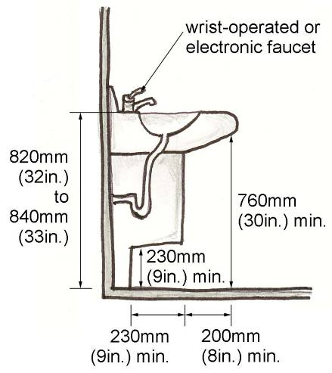

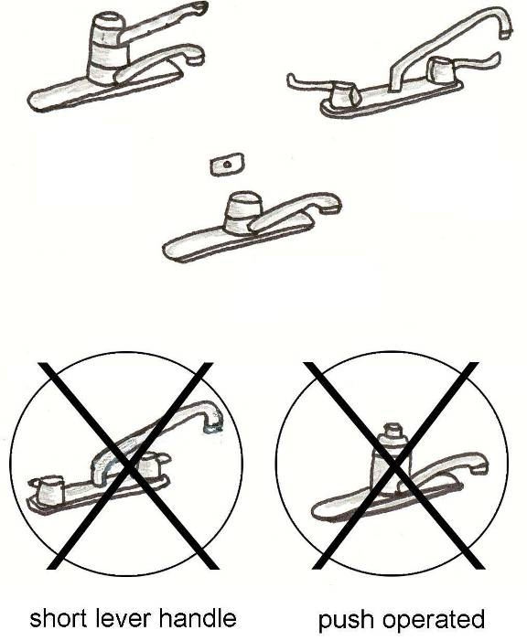
A clear floor space measuring at least 760mm x 1.37m (30in. x 4ft.6in.) should be positioned in front of a lavatory to permit a forward or side approach by a wheelchair or scooter. In the case where there is a wall on both sides of the sink then 460mm is required on either side, making the clear space 920mm wide.

A clear knee space of at least 760mm (30in.) wide and 760mm (30in.) high must be provided under an accessible sink or vanity.

Ensure all drains are offset so sink is accessible. In this way the offset P-trap/drain pipe does not enter into the knee space of someone using a wheelchair. If the drain pipe is located in close proximity to the clear knee space, then it must be insulated.

Accessible Sink or Vanity
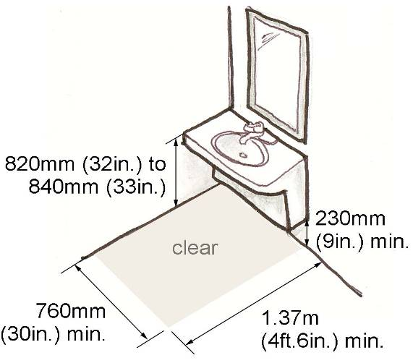

Faucet handles should be a wrist-operated faucet or be electronically controlled (preferred).

Accessible Faucet Handles
Faucet handles and sink accessories should be located a maximum of 300mm (12in.) from the sink edge.

The distance between the centreline of the faucet and edge of the sink basin should not exceed 485mm (19in.).

Washroom accessories and dispensers should be positioned in close proximity to complementary restroom features, such as an accessible sink or toilet stall.

Accessories and dispensers should be mounted with operable controls and dispensing components positioned between 900mm (36in.) and 1.2m (4ft.) above the finished floor. See also Section 4.3 – Controls and Operating Mechanisms.

Accessible Accessories and Dispensers
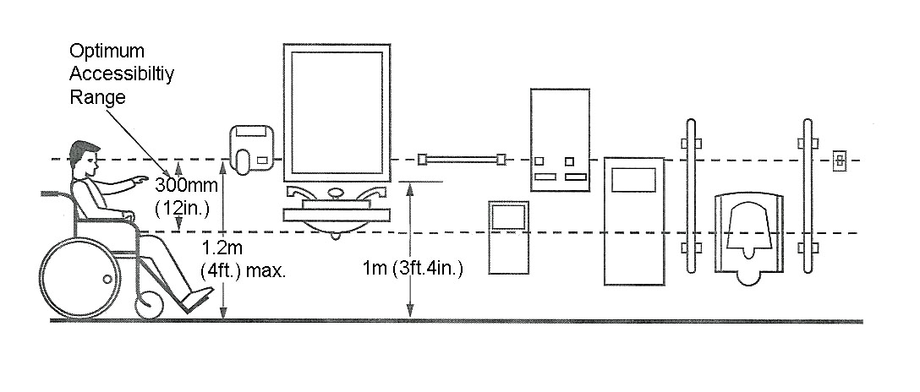
Accessories and dispensers should be operable with one hand and should not require tight grasping, pinching or twisting of the wrist.

Accessories and dispensers should include a clear floor space, at least 760mm (30in.) in width and 1.37m (4ft.6in.) in length, oriented to permit a front or parallel approach in a mobility device.

Accessories and dispensers should not protrude into the barrier-free path of travel and be recessed whenever possible.

Hand dryers, paper towel dispensers and soap dispensers should be installed directly adjacent to an accessible sink, but not encroach upon the required clear space. Dispensers should not be located on the wall behind a sink or vanity.

Restroom mirrors should be installed with a bottom edge no higher than 1m (3ft.4in.) from the finished floor.

A coat hook should be provided in an accessible stall or Universal toilet room, installed no higher than 1.2m (4ft.) from the finished floor, on a side wall and projecting a maximum of 25mm (1in.) from the wall.

A retractable shelf should be provided in an accessible stall or individual restroom not more than 1m (3ft.4in.) above the floor in a location accessible to a person in a wheelchair.

Restroom features such as doorframes and hardware should be colour contrasted to assist persons with vision disabilities.

To assist people with low vision and individuals with literacy concerns, graphic symbols should be used to indicate the location of universal toilet rooms (refer to Section 1.3.2 – Signage).

See also Sections 4.7 – Lighting and 4.9 – Materials and Finishes.

3.3.5 Changing Rooms
Accessible changing rooms should be large enough for a wheelchair or scooter to enter and manoeuvre so that transferring is simple and safe. To accommodate a wide range of users, sufficient space should be provided in accessible changing rooms or sections for at least two people and a mobility device, without interference from seating and other accessories.
Location
Accessible changing rooms must be located along a barrier-free route in close proximity to related activities.
criteria
- Accessible changing areas should include at least one clear space a minimum of 1.83m (6ft.) in width and 1.83m (6ft.) in length to serve as a turning space for individuals using wheelchairs and scooters. Doors should not swing into this turning space.

Accessible Changing Room

Changing rooms should provide access aisles to benches and accessible lockers at least 1.5m (5ft.) in width.

- An accessible changing area should be equipped with a bench at least 610mm (24in.) wide and 1.22m (4ft.) long, mounted with a seat height between 460mm (18in.) and 500mm (20in.) above the finished floor, and designed to carry a minimum load of 1.33kN.

c) A clear floor space, at least 920mm (36in.) wide should be located alongside an accessible bench to permit easy transfer, particularly for individuals using mobility aids, to and from the bench.

d) Where mirrors are provided in accessible changing rooms, a full length mirror, at least 460mm (18in.) wide and 1.37m (4ft.6in.) high should be mounted with the bottom edge no higher than 610mm (24in.) above the finished floor.

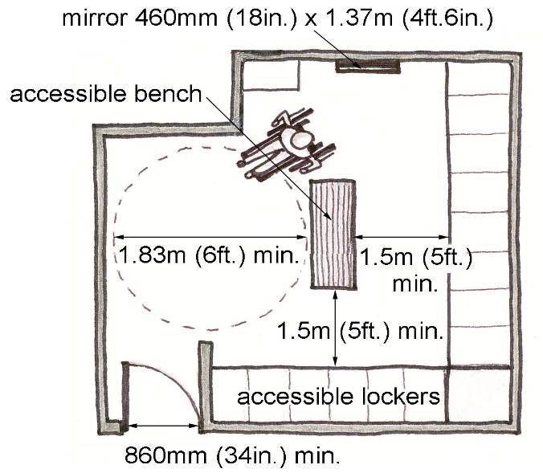
e) Accessible lockers should be provided for individuals using mobility devices such as wheelchairs and scooters (refer to Section 3.4.3 – Lockers Storage, shelving and Display Units).

- Accessible changing areas and features, particularly when in conjunction with showers, swimming pools or other wet locations, must be slip resistant and well-drained.

- Private accessible dressing rooms should be accessed through either a hinged or sliding door, and must not swing into any part of the required 1.83m (6ft.) turning radius within the private accessible dressing room. Turning space is not required within a private accessible dressing room when accessed through a curtained opening of at least 860mm (34in.) wide, if clear floor space, complying with Section 1.3.1.- Space and Reach Requirements, renders the dressing room usable by person in a wheelchair or scooter.

3.3.6 Bathing and Showering Facilities
Bathing and showering facilities should be designed to assist individuals with mobility and vision disabilities. For individuals using wheelchairs, scooters or requiring assistance, a bathing facility with a separate individual shower room and bathroom is preferable to an accessible stall.
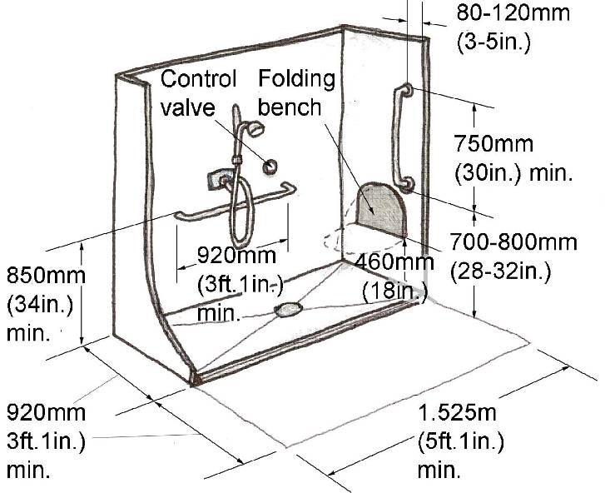
Location
Accessible bathing and showering facilities should be accessible from a barrier-free route and located in close proximity to related activities and changing rooms.
criteria
a) To reduce potential hazards, shower stall, bathtub and other bathing facility surfaces must be well-drained and non-slip.

b) The water system should be equipped with a pressure-equalizing or thermostatic mixing control valve (anti-scalding device) controlled by a wrist-operated lever or other mechanism operable with a closed fist from the seated position.

c) Soap holders should be fully recessed. Dispensers and other fixtures should be fully recessed whenever possible.

d) Grab bars must have a diameter between 30mm (1in.) and 40mm
(1-1/2in.) and a slip-resistant gripping surface.

e) Grab bars must have a 40mm
(1-1/2in.) clearance between the bar and the wall and be capable of resisting a horizontal and vertical force of at least 1.3kN (300lbs.).
Shower Stalls
f) An accessible shower stall should be at least 1.525m (5ft.) wide and 920mm (36in.) deep.

Dimensions for Accessible Shower Stalls

A clear floor space, a minimum of 920mm (36in.) in depth and at least the width of the stall, should be provided at the entrance to an accessible shower.

Fixtures are permitted to project into the clear floor space provided they do not restrict access to the shower.

Accessible showers should have a bevelled threshold not greater than 13mm (1/2in.) above the finished floor.

A horizontal grab bar at least 920mm (36in.) in length should be mounted 850mm (33-1/2in.) from the shower floor and positioned so that at least 300mm (12in.) of its length is reachable from one side of the seat.

A vertical grab bar at least 750mm (29-1/2in.) in length should be mounted between 80mm (3in.) and 120mm (5in.) from the front edge of the stall and begin between 700mm (28in.) and 800mm (32in.) from the finished floor.

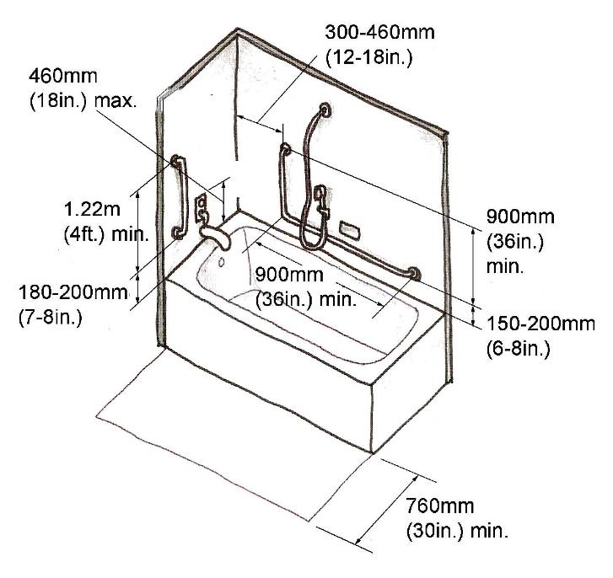
An accessible shower shall include a handheld showerhead with at least 1.525m (5ft.) of flexible hose. The showerhead should be reachable from a seated position and contain a support for operation as a fixed showerhead. The bottom of the handheld shower handle should be installed no higher than 1.2m (4ft.) above the floor.

To be accessible from a seated position all operable components in an accessible shower must be installed no higher than 1.2m (4ft.) above the floor.

An accessible shower stall should be equipped with a wall mounted folding seat that is not spring loaded or make provisions for a portable seat.

An accessible shower seat should be at least 460mm (18in.) wide and 400mm (16in.) deep, installed 460mm (18in.) from the shower floor and be designed to carry a minimum load of 1.33kN.

bathtubs
g) Accessible bathtubs should have a clear floor space at least 760mm (30in.) wide along the length of the tub.

A lavatory may encroach a maximum of 300mm (12in.) into the required clear space in front of the tub provided there is an accessible clear knee and toe space (refer to Section 3.3.4 – Restrooms for lavatory clearances).

A vertical grab bar at least 1.22m (4ft.) long and an L-shaped grab bar at least 900mm (35-1/2in.) long should be installed.

Dimensions for Accessible Bathtubs

Faucet handles should be automatically operable or of a wrist-operated lever-type that is not spring loaded (refer to Section 3.3.4 – Restrooms for accessible faucet handles).
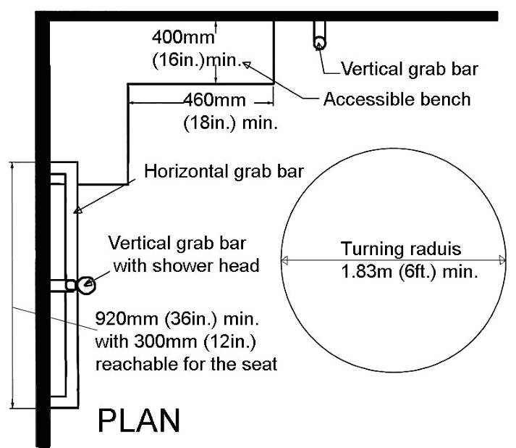
Faucets and other controls should be operable from the seated position and mounted no higher than 460mm (18in.) from the bathtub rim.
multi shower unit
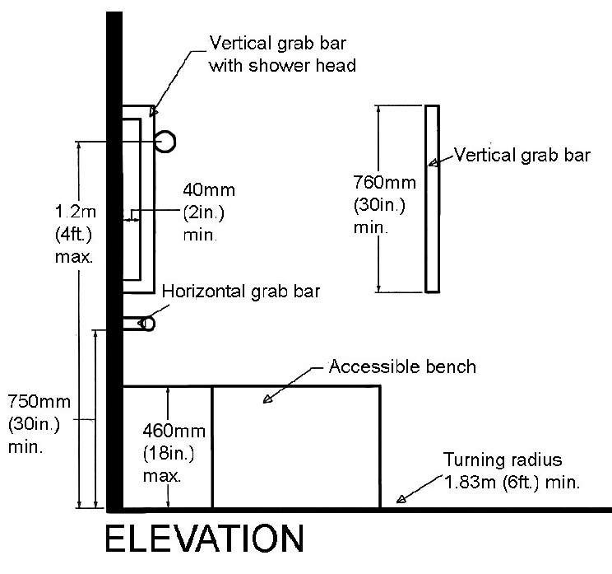
- In a multiple shower unit situation it is recommended that the space allocated for the accessible shower seat be located in the corner of the stall. Horizontal grab bars are to be located across from the seat on both of the side walls to enable transferring from chair to seat. A horizontal grab bar behind the seat is not recommended as it will interfere with the bather’s back when bracing against the wall. A vertical grab bar should be located beside the accessible seat and adjacent to the handheld shower head.

Handheld showerheads and rail must be no further than a 300mm (12 in.) reach in front of the shower seat to comply with reach requirements.

Ensure that shower seats are made of a durable, non-abrasive material (for example solid phenolic).

3.3.7 Saunas and Steam Rooms
Similar to swimming pools, saunas and steam rooms offer therapeutic opportunities and should, therefore, be designed to accommodate and include persons with disabilities.
Location
Saunas and steam rooms should be located along a barrier-free path of travel and in close proximity to universal toilet rooms and changing rooms.
criteria
- Where saunas and steam rooms are clustered, at least 5%, but no less than one of each type should be accessible.

- To accommodate the turning radius of a wheelchair or scooter a clear floor space at least 1.83m (6ft.) diameter should be provided within accessible saunas and steam rooms.

- If necessary, removable benches or seats may locate within the clear floor space.

- If seating is provided, at least one bench should be accessible, with a height between 460mm (18in.) and 500mm (20in.). A supportive armrest or grab bar should be included to facilitate transfer to and from the bench.

- Doors should not swing into any part of the accessible clear floor space or ground space required for accessible benches.

- An emergency call system should be installed in all saunas or steam rooms (refer to Section 4.3 – Controls and Operating Mechanisms for positioning and clearances).

3.3.8 Kitchens
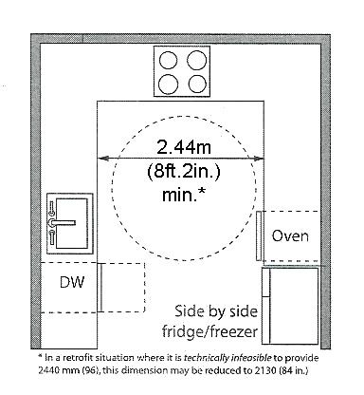
Kitchens and their elements should be accessible to employees, patrons and visitors with disabilities. They should be designed to be accessible for the preparation and the service of food and drink at social gathering facilities such as community centres, banquet halls, restaurants, work places, etc.
location
Accessible kitchens should be located within an accessible environment, including close proximity to barrier-free entrances, and accessible routes.
criteria
- The clearance between counters
and all opposing base cabinets, countertops, appliances, or walls
in accessible kitchens should be
1.1m (3ft.8in.).
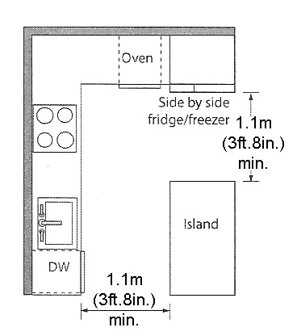
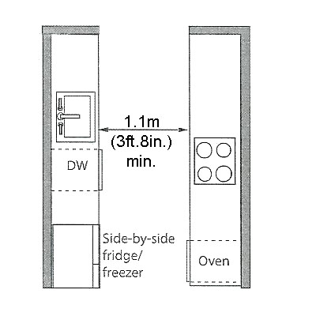

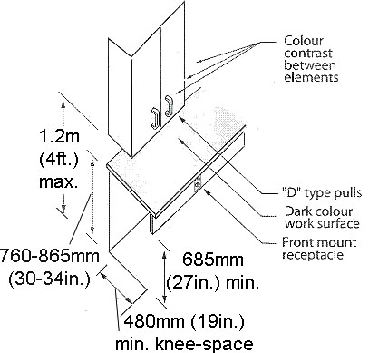
- The work surface should be at least 760mm (30in.) wide, 610mm (24in.) deep and have a height between 760mm (30in.) and 865mm (34in.).

- The work surface should have a centered knee clearance at least 760mm (30in.) wide, 480mm (19in.) deep and 685mm (27 in.) high.

- There should be a clear floor area at least 760mm (30in.) wide and 1.2m (4ft.) deep, which may extend up to 480mm (19in.) beneath the work surface.
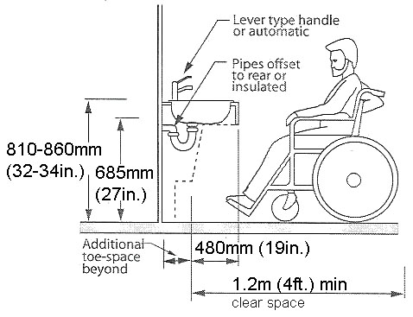
- The work surface should have no sharp or abrasive surfaces under it and have no electrical outlets at the side or the front of it.

- Base cabinets should have a toe space at least 150mm (6in.) deep and 230mm (9in.) high. However, where base cabinets are used for storage, rather than a work surface, the clearance requirements need not be met and a kick plate may be used.

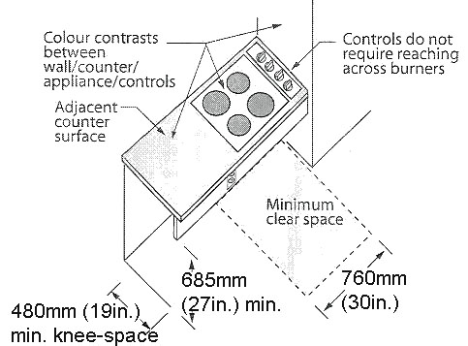
- Sinks should be mounted with the centerline at least 460mm (18in.) from a side wall and have a rim height located between 810mm (32in.) and 860mm (34in.) from the floor.

- Sinks should have a knee clearance, measured from the centre of the sink, of at least 760mm (30in.) in width, 200mm (8in.) in depth and 685mm (27in.) in height, with an additional toe space at least 760mm (30in.) wide and 230mm (9in.) high.

- There should be a clear floor area at least 760mm (30in.) by 1.2m (4ft.), which may extend up to 480mm (19in.) beneath the sink.

- Faucets should have handles of the leaver type or be electronically controlled (preferred).

- Sinks should have no sharp or abrasive surfaces underneath it and have hot water and drain pipes offset to the rear and not abut the clear space. If the hot water and drain pipes abut the clear space, they should be insulated.

- Refrigerators and freezers should be vertical side by side, self defrosting with storage space and controls not more than 1.1m (3ft.8in.) from the floor

.
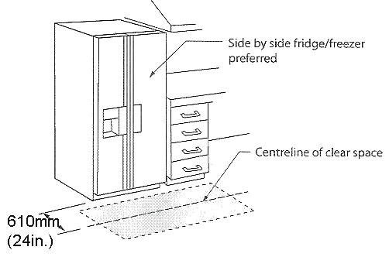

- Cabinets, drawers and self storage areas should have at least one shelf at a height of not more than 1.1m (3ft.8in.) from the floor where it is above a work surface and have “D” type door pull mounted close to the bottom of the upper cabinet doors and top of the base cabinet doors.

3.4 Interior Amenities and Features
While less integral to a person’s ability to access and circulate through a building or facility, several interior amenities and features, if designed as barrier-free, can greatly enhance the comfort, convenience and utility of a site for people with limitations. In turn, items such as accessible drinking fountains, telephones and storage units, can improve the likelihood of full participation by all users within the community.

3.4.1 Drinking Fountains and Eyewash Stations
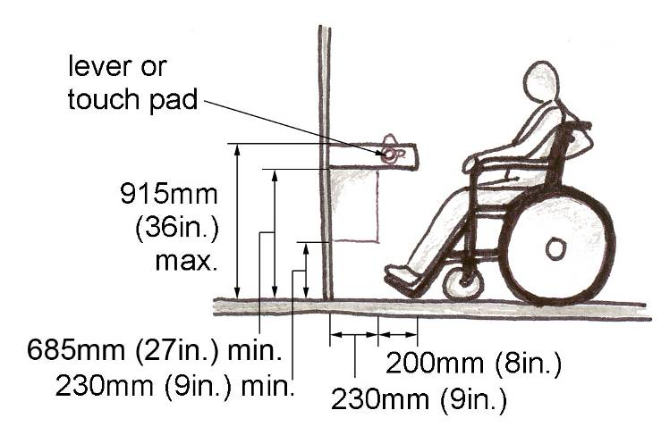
When designing and positioning drinking fountains the limited reach of children, persons of short stature and individuals using wheelchairs or other mobility aids should be accommodated. Water dispensing devices should also consider individuals who experience difficulty bending, have limited hand strength or have coordination difficulties. Additionally, emergency eyewash stations must be accessible in regards to approach and use.
Location
Water dispensing devices, such as drinking fountains and Eyewash stations, should be located along a barrier-free route clear of the path of travel.
criteria
- To accommodate a side approach by wheelchairs and scooters, free-standing or built-in water dispensing devices should have a clear floor space at least 1.37m (4ft.6in.) wide and 760mm (30in.) deep in front of the unit.

Clear Floor Space for Drinking Fountains
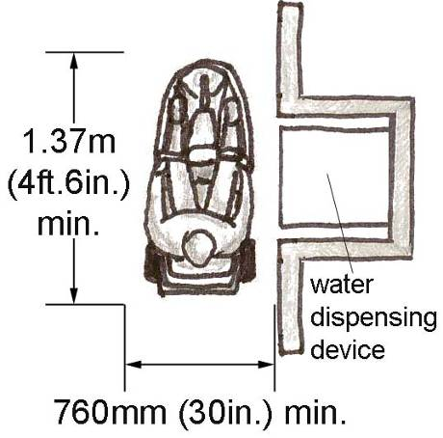

- Drinking fountains should be adjacent to, but clear of a barrier-free route. A unit recessed into the wall or with a cane detectable surface are preferred.

- Cantilevered drinking fountains should have a clear knee space between the bottom of the apron and the floor at least 760mm (30in.) wide, 200mm (8in.) deep and 685mm (27in.) high.

Dimensions for Drinking Fountains

Where an obstruction exists under a cantilevered drinking fountain a clear toe space, at least 760mm (30in.) wide, 230mm (9in.) deep and 230mm (9in.) high, should be provided.

An accessible drinking fountain should have a spout located near the front of the unit raised between 760mm (30in.) and 915mm (36in.) from the finished floor.

The spout should direct the water flow in a trajectory that is parallel or nearly parallel to the front of the unit and provide a flow at least 100mm (4in.) high.

- Controls for a drinking fountain should be automatically operable or be easy to operate from a wheelchair or mobility device, using one hand with a force no greater than 22N (4.9 lbs).

- Drinking fountains should be equipped with lever style controls or touch pads.

- Emergency Eyewash Stations should comply with the knee clearance and table/counter heights, as protruding objects must be considered when positioning/ designing eyewashes and/or combination eyewash-showers. (Refer to Section 2.2.2- Protruding Objects for knee clearance dimensions).

3.4.2 Public Telephones
The design and position of public telephones should address the limited reach of children, persons of short stature and individuals using wheelchairs or other mobility aids. Additionally, public telephones should be accessible to individuals with vision and hearing disabilities.
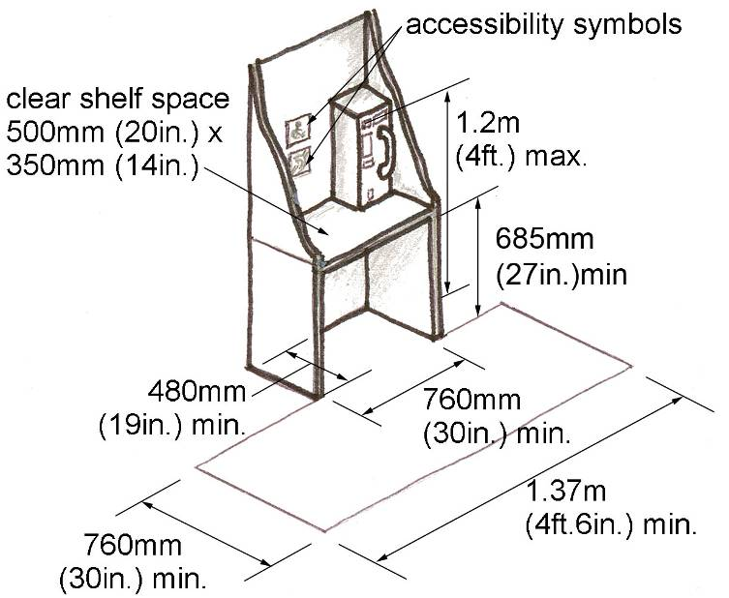
Location
Accessible public telephones should be located adjacent to a barrier-free route, particularly near main entrances and in designated waiting areas.
criteria
- Accessible public telephones should be provided in compliance with the following table.

Accessible Public Telephone Requirements

Total  Public Telephones | Minimum Accessible Public Telephones
1 or more single unit | 1 per floor
1 bank* | 1 per floor
2 or more banks | 1 per bank or 1 single unit in close proximity to each bank

* A bank refers to two or more adjacent public telephones, often installed as a unit.

- Where an interior public pay telephone is provided, at least one interior public text telephone (TTY) should be provided per building, in a public use area.

- Accessible public telephones should be equipped with a volume control.

- To accommodate an individual in a wheelchair or scooter, all accessible public telephones should have a clear floor space at least 760mm (30in.) in width and 1.37m (4ft.6in.) in length in front of the telephone.

Accessible Public Telephone Dimensions

Where a front approach is provided for wheelchair or scooter access, there should be a clear knee space at least 685mm (27in.) high, 480mm (19in.) deep and 760mm (30in.) wide.

Operable portions, such as coin slots and number pads, should have a maximum height of 1.2m (4ft.) from the finished floor.

An accessible telephone should have a flat directory shelf at least 500mm (20in.) wide and 350mm (14in.) deep.

- Telephone directories should not block or hang within the clear knee space under an accessible telephone.
- To facilitate the use of a public telephone by individuals with reach limitations, the handset cord should be at least 1.0m (3ft.4in.) in length.

- The minimum illumination level for accessible telephones should be 200 lux (20 ft. candles).

- Accessible telephones should have push-button controls with characters that are clearly marked in a matte finish. Both the buttons and characters should contrast with their background.

- Text telephones (TTYs) used with pay telephones should be permanently affixed within, or adjacent to the telephone enclosure and signed. If an acoustic coupler is used, the telephone cord should be sufficiently long to allow connection of the TTY and the telephone receiver.

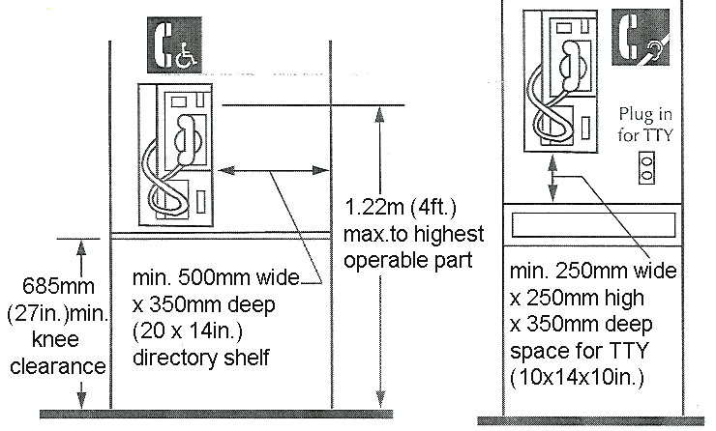
- Additional public telephones designed to accommodate individuals with hearing loss and a portable TTY should comply with CSA Standard T515 “Telephone Terminal Equipment – Acoustic and Magnetic Filed Requirements for Handset Telephones for use by the Hard of Hearing”.
As well as, contain a shelf with a clear space at least 250mm (10in.) wide, 350mm (14in.) deep and 250mm (10in.) high; be equipped with an electrical outlet within or adjacent to the telephone enclosure; and include a handset that is capable of being placed flush on the surface of the shelf.

- All accessible public telephones and directional signs for telephones should include the symbol of accessibility for persons with physical disabilities and/or persons who are hard of hearing (refer to Section 1.3.2 – Signage).

- Telephones projecting from the wall should be designed as cane detectable (refer to Section 2.2.2 – Objects Protruding into Sidewalks and Pathways.

- Where possible, a fold-down seat should be included to assist individuals who experience difficulty standing for extended periods.

- Outdoor telephone booths should be made accessible by mounting the booth flush with the adjacent surface and by utilizing plastic doors which open both in and out.

3.4.3 Lockers, Storage, Shelving and Display Units
In facilities where public and private storage and display units are provided a proportion of that storage or display should be accessible, particularly to individuals with limited reach and/or dexterity.
Location
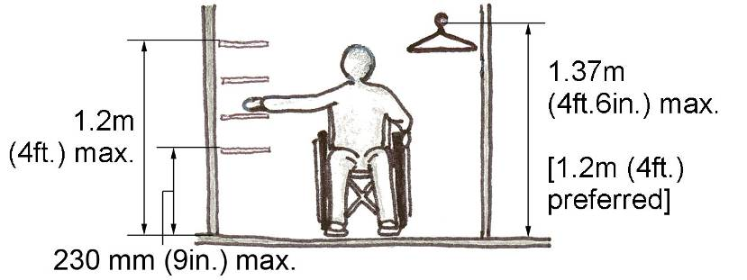
Accessible lockers, storage, shelving and display units should be located adjacent to a barrier-free route.
criteria
- At least one section of every storage area, such as lockers, closets or coat rooms, should be accessible.

- A clear aisle should be provided in front of lockers and other storage units measuring at least 1.5m (5ft.) in depth to permit both the forward and side approach of a mobility device (see also Section 3.3.5 – Changing Rooms).

- Where a storage area is accessed through a doorway, that doorway should comply with Section 3.1.1 – Doors.

- Accessible storage should contain shelving that is between 230mm (9in.) and 1.2m (4ft.) from the finished floor.

Accessible coat racks, rails or hooks should be installed no higher than 1.37m (4ft.6in.) from the finished floor, with a recommended height of 1.2m (4ft.).

Accessible Storage Dimensions

- Locks or other operating mechanisms for accessible storage should be located no higher than 1.06m (3ft.5in.) from the finished floor.

- Numbers or names on lockers and storage units should be in a prominent location, mounted no higher than 1.525m (5ft.) from the finished floor and use legible and clear lettering. Markings should be raised or recessed and be of a highly contrasting colour or tone.

- Accessible lockers should require a maximum force of 22N (4.6 lbs), to open from a fully closed position.

3.4.4 Windows, Glazed Screens and Sidelights
Disabled persons who use wheelchairs and other mobility devices require window views and operating mechanisms accessible from a seated height. Window heights and controls should respect these reach limitations as well as the limited strength or dexterity of individuals with other disabilities.
Location
Accessible windows should be located throughout a building or facility.
Standards
- The sill height of all viewing windows should not exceed 760mm (30in.) above the finished floor.

Accessible Windows

- Where horizontal transoms are incorporated into windows, the transoms should not be located between 1.06m (3ft.5in.) and 1.22m (4ft.) from the finished floor.

- Operable windows should utilize control mechanisms that are operable using one hand, and do not require fine finger control, tight grasping, pinching or twisting of the wrist.

- Window controls should be mounted between 400mm (16in.) and 1.2m (4ft.) from the finished floor.

- Fully glazed sidelights at entrances and vestibules, as well as fully glazed interior screens, should be clearly identified with a horizontal row of decals or continuous stripe at least 50mm (2in.) in width.

- Decals or continuous stripes should be mounted with a centreline between 1.35m (4ft 5in.) and 1.5m (5ft.) above the finished floor.

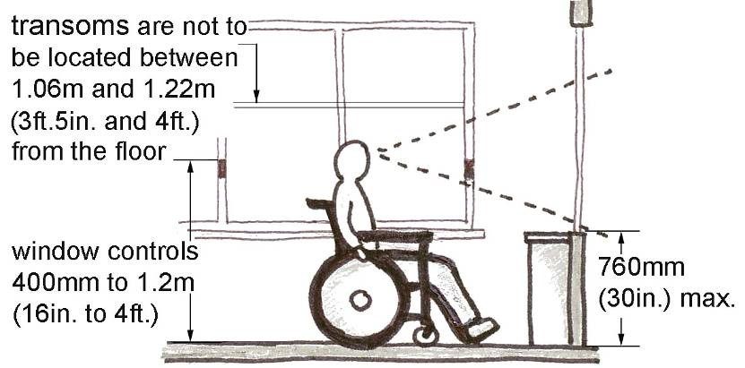
- Where decals are used, each decal should be located a maximum of 150mm (6in.) from the centre of one to the centre of the next.

- Decals may be square, round or of a special design (e.g. a logo) provided that the solid portion provides high colour contrast and is easy to identify by persons with visual disabilities.

- Where etched or patterned glass panels are used, decals or continuous stripes should still be provided.

- Where frameless glass panels are installed, exposed edges should be identified with a vertical safety strip.

3.5 Other Facilities
“Other Facilities” refers to interior areas, such as cafeterias, libraries, places of worship, etc., which are important interior areas, yet are not often found in all buildings. Similar to common interior areas, such as reception counters, restrooms and offices, the design of other interior facilities as barrier-free is integral to the participation of a wide range of individuals within the community.

3.5.1 Cafeterias
Cafeterias provide both the service of food and drink and opportunities for socialization. Tables, chairs and service components should be designed to support persons with physical and vision disabilities. Consideration should also be given for lighting and noise reduction, which may assist individuals with hearing disabilities.
Location
A cafeteria should be accessible from a barrier-free route and located in close proximity to a universal toilet room.
criteria
a) All cafeterias, raised or sunken dining areas and outdoor seating areas should be accessible.

b) Where fixed tables or counters are provided, at least 10%, but no less than one, should be designed as accessible. It is preferable for all fixed installations to be accessible.

c) In buildings where separate areas are provided for smoking and non-smoking, or indoor and outdoor seating, the required number of accessible tables or counters should be evenly distributed between each area(s).

d) Well-illuminated, noise reduced sections should be provided to assist communication among persons with hearing disabilities (refer to Section 4.7 – Lighting).
e) Accessible areas should feature the same level of service and décor as the entire facility.

f) Where food or drink service counters exceed 865mm (34in.) in height and 1.525m (5ft.) in length, a portion of the main counter should be designed as accessible (refer to Section 3.3.1 – Reception Areas for specific requirements).

g) An access aisle at least 1.2m (4ft.) wide should serve all accessible tables, counters, cashier locations and other fixed cafeteria elements.

h) Vending machines, beverage dispensers and other service equipment should be positioned along, but clear of a barrier-free route or access aisle.

i) A clear space at least 760mm (30in.) in width and 1.37m (4ft.6in.) in length should be provided in front of all service machines and dispensing equipment.

j) The operating controls for vending and service machines, as well as the installation height of service shelves, and dispensers for tableware, dishware, condiments, etc., should be located between 400mm (16in.) and 1.2m (4ft.) above the finished floor.

k) In cafeterias or banquet halls with a raised speaker’s podium or head table, the platform and related features should be accessible, e.g. the inclusion of a ramp, wheel stops, protective railings, adjustable lecterns, accessible tables, etc. (refer to Sections 1.3.1 – Space and Reach Requirements, 2 4.2 – Ramps and 2.4.4 – Handrails).

3.5.2 Libraries
Library facilities should be designed to promote accessibility by ensuring that catalogues, display cases and terminals meet the space and reach requirements of as many users as possible and do not obstruct the pedestrian route creating hazards or obstacles for persons with disabilities.
Location
A library should be accessible from a barrier-free route, entrance and parking area.
criteria
- Wherever possible, or upon request, information should be available in multiple formats for example, Braille, large print, audiotape.

- Turnstiles are not accessible for persons using mobility equipment and can be hazardous to ambulatory persons using crutches or canes (refer to Section 2.3.2 – Gates, Turnstiles and Openings).

- Where turnstiles are present, at least one entry and exit gate must be provided for people using wheelchairs, scooters or other mobility aids.

- Accessible gates and turnstiles should be a minimum of 860mm (34in.) in width, installed on level ground, unlocked and operable using one hand.

- Controlled checkout lanes or other restricted passageways must include at least one route at least 920mm (36in.) in width.

- Stack aisles and other access aisles or routes should be at least 1.2m (4ft.) in width (refer to Section 2.2.1 – Accessible Routes).

- A clear floor space at least 1.83m (6ft.) in width and 1.83m (6ft.) in length should be provided periodically within continuous stacks and at aisle termini as a turning space for people using wheelchairs and other mobility aids.

- All work and reading areas, as well as book stacks should be illuminated at least 200 lux (20 ft. candles). At least 5% of work stations should have illumination of 500-700 lux (50-70 ft. candles).

- Changes in lighting level should not exceed a range of 100 lux to 300 lux (10-30 ft. candles) from one space to the next.

- To accommodate the reach limitations of individuals with physical disabilities, a broad sampling of books, information pamphlets and magazines should be stored between 400mm (16in.) and 1.2m (4ft.) from the finished floor. Staff should be available to reach and retrieve material outside this range.

- Computer catalogues and workstations should be accessible with a clear floor space at least 760mm (30in.) wide and 1.37m (4ft.6in.) long and a clear knee space at least 760mm (30in.) wide, 480mm (19in.) deep and 685mm (27in.) high (refer to Section 3.3.3 – Offices, Work Areas and Meeting Rooms).

- The maximum height for a pull handle of book return boxes (interior and exterior) must be 1.2m (4ft.). Ensure the handle is accessible.

- To assist persons with hearing disabilities, acoustic quality in reading and study areas should limit extraneous background noise.

- At least one lane at each check out area should be accessible, with preference for all lanes to be accessible (see also Section 3.3.1 – Reception Areas).

3.5.3 Places of Worship
Places of worship and/or reflection should be accessible to a wide range of individuals. Main areas of worship, meeting rooms, restrooms, coatrooms and offices should be designed as barrier-free to include all members of the community.
Location
Places of worship should be located within a fully accessible environment, following the design standards outlined throughout this document.
criteria
a) All areas of a chapel, place of worship and/or reflection should be accessible for participants, leaders, staff or volunteers with disabilities.

- Entrances, doorways, corridors and all other components and features within a place of worship or reflection should meet the various space, reach and other design requirements set out in this document.

3.5.4 Retail Facilities
All retail facilities and elements thereof should be accessible to employees, patrons and visitors with disabilities.
Location
Retail facilities should be accessible via a barrier-free route of travel.
criteria
- Where service or retail facilities have counters for sales, the distribution of goods and services or for information, at least one of each type of counter should be designed as accessible (refer to Section 3.3.1 – Reception Areas).

- Where counters are dispersed throughout the facility, accessible counters should be equally distributed.

- Accessible checkout aisles, at least 915mm (36in.) in width, with 1.06m (3ft.5in.) recommended, should be provided in accordance with the following table.

Accessible Checkout Aisle Criteria

Total Checkout Aisles of each Design | Minimum Accessible Checkout Aisles  (of each design)
1 to 4 | 1
5 to 8 | 2
9 to 15 | 3
Over 15 | 3 plus 20% of additional aisles

- All accessible sales and service counters should be on a barrier-free route.

- In facilities where counters or teller windows have solid partitions or security glazing, at least one section should provide a method to facilitate voice communication, including grills, slats, talk-through baffles, intercoms, telephone handsets, etc., which is accessible to individuals in wheelchairs or scooters and persons with difficulty bending.

- Accessible sales and service counters should be a maximum of 865mm (34in.) in height to accommodate individuals with height and reach limitations

- Counters with cash registers should include an accessible portion at least 915mm (36in.) in length.

- Where counters without cash registers are present, such as at ticketing counters, teller stations, registration and information counters, box offices and library checkouts, an accessible portion at least 865mm (34in.) in length is required at or adjacent to the main counter.

- Signage identifying accessible checkout aisles shall include the ISA positioned next to the aisle number or aisle type (refer to Section 1.3.2 – Signage).

- Any security features or devices used to prevent the removal of shopping carts should not impede the ingress or egress of an individual using a mobility aid such as a wheelchair or scooter.

3.5.5 Medical Care Facilities
Medical care facilities such as hospitals, clinics and rehabilitation facilities should be designed for a wide range of users. Universal toilet rooms, waiting areas, offices, corridors, doorways, etc. should be provided within medical care facilities to accommodate patients, personnel and visitors with disabilities.
Location
Accessible medical care facilities should be located within an accessible environment, including close proximity to barrier-free entrances, parking areas and drop-off zones.
CRITERIA
- In hospitals and rehabilitation facilities at least 10% of patient rooms and toilets, and all public and common areas should be designed as accessible (refer to Section 3.3 – Interior Areas).

- In hospitals and rehabilitation facilities that specialize in treating conditions affecting mobility all patient rooms and toilets, as well as all public and common areas should be designed as accessible.

- In long term care facilities and nursing homes at least 50% of patient rooms, toilets and bathing rooms, and all public and common areas should be designed as accessible.

- Medical care facilities should be equipped with accessible examining tables in designated accessible examining rooms.

- Medical care facilities should meet the requirements for all corresponding accessible areas and features outlined in this document.

- In facilities where counters or teller windows have solid partitions or security glazing, at least one section should provide a method to facilitate voice communication, including grills, slats, talk-through baffles, intercoms, telephone handsets, etc., which is accessible to individuals in wheelchairs or scooters and persons with difficulty bending.

3.5.6 Transportation Facilities
Transportation facilities serving public and private buses, taxis, trains and airplane arrival and departure should be designed as accessible. Appropriate ramps and lifts, as well as alternative audible and visual communication devices should be available to assist a wide range of users.
Location
Transportation facilities should be accessible via a barrier-free route of travel.
CRITERIA
a) All accessible features and areas within transportation facilities should be identified with the appropriate ISA (refer to Section 1.3.2 – Signage).
Bus Shelters
b) A bus shelter should be positioned on a firm, level pad at a similar elevation to the adjacent sidewalk or pathway.

c) A clear view of oncoming traffic should be provided from within and around a bus shelter.

d) Bus shelters should have a clear space at least 1.22m (4ft.) in width around at least two sides of the shelter, including the landing pad side.

e) All glazed panels surrounding bus shelters should incorporate safety features such as decals or warning strips (refer to Section 3.4.4 – Windows).

f) A bus shelter should include sufficient floor space to accommodate a person using a wheelchair and/or service dog and contain seating designed in accordance with Section 2.5.5 – Benches and Street Furniture.
Bus Stops
g) A bus stop should be positioned on a paved, firm and level surface. Sufficient space should be provided for snow clearance and storage to maintain a barrier-free path around the bus stop.

Benches and street furniture should be installed clear of the barrier-free path required to enter and exit the bus.
Transit Terminals
h) Bus platforms or other boarding platforms shall permit safe access for persons using wheelchairs or other mobility equipment. Where possible a level approach should be provided.

Platform edges should incorporate a continuous detectable warning surface at least 610mm (24in.) wide (refer to Section 4.4 – Detectable Warning Surfaces).

Lighting at all boarding platforms should be at least 100 lux (10ft. candles).

Boarding locations should incorporate both visual and audible warning signals to indicate vehicle approach and departure (refer to Section 4.1 – Visual and Audible Alarms). Audible announcements, such as bus “x” now approaching platform “y,” are preferable to nondescript bells or alarms.

Where special lifting devices are used, appropriate vertical clearance and manoeuvring space for mobility equipment should be included (refer to Section 2.1.2 – Passenger Drop-off Zones)

3.5.7 Theatre Facilities
Designated areas are required for individuals unable to use typical seating. Viewing areas need to provide adequate space to manoeuvre a mobility device as large as a scooter and should not be limited to one location. Designated companion seating should also be provided. Guards placed around a viewing area should not interfere with the line of sight of someone sitting in a wheelchair or scooter. Accessible seating should be available in all price range locations.
Location
Accessible seating should be provided in a theatre or auditorium setting, along a barrier-free route.
CRITERIA
a) In places of assembly with fixed seating, accessible wheelchair/ scooter locations shall be provided in numbers as indicated in the following table.
Numbers of Fixed Seats in Seating Area | Minimum Number of Spaces Required for Wheel Chairs
Up to 100 | 2
101 to 200 | 3
201 to 300 | 4
301 to 400 | 5
401 to 600 | 6
Over 600 | Not less than 1% of the seating capacity

In addition, 1%, but not less than one, of all fixed seats shall be aisle seats with no armrest on the aisle side, or shall have a removable or folding armrest on the aisle side. A sign or marker shall identify each of the seats and signage notifying patrons of the availability of such seats shall be posted at the ticket office.

Accessibility wheelchair/ scooter locations shall adjoin an accessible route complying with Section 2.2.1.-Accessible Routes, without infringing on egress from any row of seating or any aisle requirement.

b) Each accessible wheelchair/ scooter location shall be
- An integral part of any seating plan. Seats shall be distributed in a manner that provides people with physical disabilities a choice of admission prices and line of sight comparable to those for members of the general public.
- Clear and level, or level with removable seats
- If the wheelchair or scooter enters from a side approach, not less than 920mm (36in.) wide and 1.525m (60in.) long space should be provided.
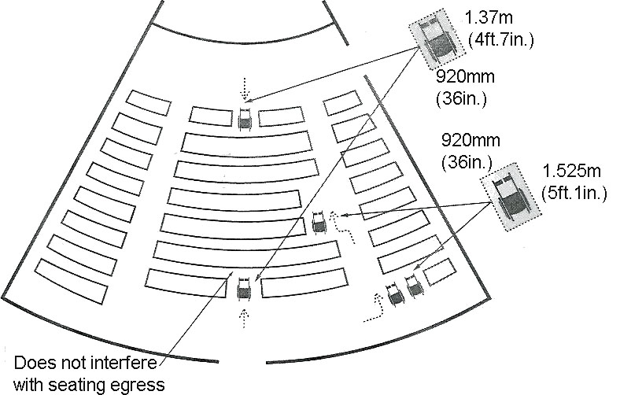
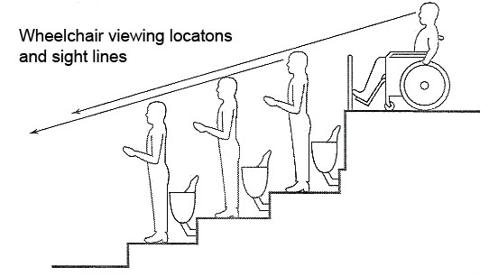
- If the wheelchair/ scooter enters from a front approach, a space not less than 920mm (36in.) wide and 1.37m (54in.) long should be provided.
- Arranged so that at least two designated wheelchair/ scooter locations are side by side
- Arranged so that at least one companion fixed seat is provided next to each wheelchair seating area
- Where the seating capacity exceeds 100, provided in more than one location.

3.5.8 Arenas, Halls and Other Indoor Recreational Facilities
Opportunities for recreation, leisure and active sport participation should be available for all members of the community. Access should be provided to halls, arenas, and other sports facilities, including access to the site, all activity spaces, gymnasia, fitness facilities, lockers, change rooms and showers. Persons with a disability may be active participants, as well as spectators, volunteers and members of staff.
Location
Arenas, halls and other indoor recreational facilities should be completely barrier-free and accessible in reference to manoeuvring in and around the building complex, spectator seating, recreation area itself, and associated change rooms and washrooms.

CRITERIA
- Arenas, halls and other indoor facilities shall have accessible visitors, spectators and/or participant seating options in compliance with Section 3.5.7.-Theatre Facilities

- Incorporate detectable warning surfaces in compliance with Section 4.4.-Detectable Warning Surfaces where seating is accessed by stairs.

- Provide an accessible route in compliance with Section 2.2.1.-Accessible Routes to the arena/facility floor and/or ice surface, including access panels or gates providing at least 860mm (34in.) clear width.

- Where facilities are provided for performances and other events, have a direct accessible route in compliance with Section 2.2.1.-Accessible Routes from the lobby/entrances and viewing locations to all performing areas, including stages, dressing rooms, washrooms, and all other spaces used by performers.

- Where stairs are provided, have stairs that comply with Section 2.4.3.-Steps and Stairs, including appropriate tactile and colour-contrasting features.

- Where dressing facilities are provided for use by the general public, clients, customers, performers or staff, at least 50%, but never less than one, for each type of use in each cluster of dressing facilities should be accessible and in compliance with Section 3.3.5.-Changing Rooms. It is preferable to have all dressing facilities accessible where dressing facilities are provided.

- Where lockers or shelving is provided, have lockers and shelving comply with Section 3.4.3.-Lockers, Storage, Shelving and Display Units.

- Where coat hooks are provided, have at least 10%, but never less than one, within the reach ranges specified in Section 1.3.1.-Space and Reach Requirements.

- Where toilets and bathing facilities are provided, have toilets and bathing facilities comply with Section 3.3.4.-Restrooms.

- Where concessions or other service counters are provided, comply with Section 3.3.1.-Reception Areas and Section 2.2.2.-Protruding Objects.

- Where swimming pool, hot pools or therapy pools are provided, comply with Section 2.5.2.-Accessible Swimming Pools and Splash Pads.

- Where staff accommodations and related support areas, offices or meeting rooms are provided, comply with all relevant section of the Handbook.

- Ensure access to arena floor is barrier-free, including access form the player’s boxes.

.

4

Systems and Controls

4.1 Visual and Audible Alarms
Visual and audible alarms are essential for communicating emergencies or other important information to people who have low or no vision or are hard of hearing. Audible emergency warnings, such as fire alarms or smoke alarms, do not alert persons with hearing disabilities therefore visual devices should be installed to communicate the alarm.
Location
Visual and audible alarm signal devices should be integrated into the facility alarm system throughout the building, particularly in public buildings and places of employment.
CRITERIA
- Visual alarm signals should be installed 2.03m (6ft.8in.) above the finished floor or 152mm (6in.) from the ceiling (whichever is lower).

- In general, a visual alarm device should be within 15m (49ft.2in.) (in a horizontal plane) of all locations within a room, corridor or area.

- In large rooms, exceeding 30m (98ft.5in.) in width, visual alarm devices may be placed around the perimeter positioned a maximum of 30m (98ft.5in.) apart.

- Visual alarm signals should be equipped with a Xenon strobe-type lamp or equivalent bulb.

- A visual alarm should be clear or nominal white light (i.e. unfiltered or clear filtered white light).

- The maximum pulse duration of a visual alarm (the time interval between initial and final points of 10% of maximum signal) should be 0.2 seconds with a maximum duty cycle of 40 percent.

- A visual alarm should have an intensity of at least 75 candelas.

- The flash rate should be between 1Hz and 3Hz.

- To be heard clearly, audible exterior signals, such as a pedestrian crossing signal, should be at least 15 decibels louder than ambient noise.

4.2 Vending and Ticketing Machines
Vending and ticketing machines should be accessible to a variety of users including children, individuals in wheelchairs and scooters and persons with limited mobility and dexterity.
Location
Vending and ticketing machines should be located along, but clear of, a barrier-free route.
CRITERIA
- Vending and ticketing machines should be located along a barrier-free route, but positioned clear of the accessible path of travel (refer to Section 2.2.2 – Objects Protruding into Sidewalks and Pathways).

- To accommodate individuals using mobility aids, children and persons of short stature, operable and dispensing components of vending and ticketing machines should be positioned between 400mm (16in.) and 1.2m (4ft.) above the finished floor or ground (refer to Section 4.3 – Controls and Operating Mechanisms) Where sufficient
clear space is provided for a side approach, the operable components may be installed as high as 1.37m (4ft.6in.) (refer to Section 1.3.1 – Space and Reach Requirements).

- To provide ease of access for individuals in wheelchairs and scooters a clear space, at least 1.37m (4ft.6in.) wide and 760mm (30in.) deep, should be provided in front of all vending and ticketing machines.

- Vending and ticketing machines should be located in close proximity to accessible parking spaces, tables or other site features associated with the function of the machine.

- Signage, with highly contrasting lettering, at least 13mm (1/2in.) in height, should be provided on all vending and ticketing machines.

- All components and mechanisms should be operable with one hand and require minimal strength to assist individuals with young children, a handful of parcels, canes or other mobility aids, or a physical limitation such as arthritis.

- To assist individuals with low and no vision and reduce potential hazards, vending and ticketing machines should be cane detectable and colour contrasted with their surroundings.

- See also Section 4.7 – Lighting.

4.3 Controls and Operating Mechanisms
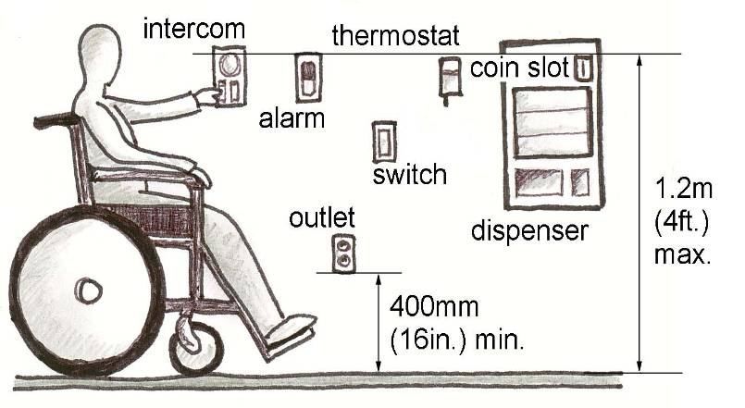
Controls and operating mechanisms should be equally as accessible as the wide range of areas and features to which they apply. For instance, a barrier-free elevator may be inaccessible if the controls and floor calls cannot be reached by a person in a wheelchair or scooter. Accessible controls and operating mechanisms should consider the space and reach requirements of individuals with physical limitations, as well as the needs of people who have low/no vision or have hearing loss.
Location
Controls and operating mechanisms should be accessible from a barrier-free route and positioned to accommodate use from a variety of heights, including a seated position.
CRITERIA
- Controls and operating mechanisms, such as alarms, dispensers, switches and thermostats, should be installed between 900mm (35-1/2in.) and 1.2m (4ft.) from the finished floor or ground. Where sufficient clear space is provided for a side approach, the operable components may be installed as high as 1.37m (4ft.6in.) (refer to Section 1.3.1 – Space and Reach Requirements).

- Electrical outlets shall be installed 400mm (16 in.) above the finished floor.

Accessible Controls and Mechanisms

- A clear floor space, at least 1.37m (4ft.6in.) wide and 760mm (30in.) deep, should be provided in front of all controls and operating mechanisms.

- Where applicable, controls and operating mechanisms should possess both a visual and audible indication (see also Section 3.2.3 – Elevators).

- Flush mounted buttons or touch pads and screens without Braille present difficulty for individuals with low or no vision and should be avoided or accompanied by an accessible alternative.

- Faucets and other such mechanisms should be operable with one hand or be electronically controlled.

- Hand operated controls and mechanisms should require a maximum force of 22N and avoid the need for tight grasping, pinching or twisting of the wrist.

4.4 Detectable Warning Surfaces
Detectable warning surfaces provide important cues for individuals with low or no vision, particularly those using canes or service dogs. A change in surface texture can indicate potential hazards, such as a curb edge or stairs, as well as provide direction for navigation throughout a site.
Location
Detectable warning surfaces should be provided throughout a site and facility, particularly along barrier-free routes and where changes in level or direction occur.
CRITERIA
- Detectable warning surfaces should be colour, tone and/or texture contrasted.

- All textured surfaces used as detectable warning surfaces should be cane detectable and clearly differentiated from the surrounding ground or floor surfaces.

- Interior detectable warning surfaces should differ from adjoining surfaces in resiliency or sound upon cane contact.

- Detectable warning surfaces should be positioned to indicate edges, projections, traffic crossings or other potentially hazardous situations. Also, detectable warning surfaces should be at least 915mm (36in.) in width (see also Sections 2.2.3 – Sidewalk Surface Treatments, 2.4.3 – Steps and Stairs and 2.2.1 – Accessible Routes).

- Grooves, channels, thresholds or other changes in level found within a detectable warning surface should have a maximum depth or height of 13mm (1/2in.).

- Dot-type blocks should be used to provide a warning signal to screen-off obstacles, drop-offs or other hazards. Dots should consist of truncated domes with a diameter of ±23mm (1in.), a height of ±5mm (1/4in.) and centre-to-centre spacing of ±60mm (2in.).

- Line-type blocks should be used to indicate the correct direction of travel. Exterior line-type blocks should consist of parallel grooves or incisions with centre-to-centre spacing of 75mm (3in.) to 100mm (4in.) and a maximum depth of 13mm (1/2in.).

Line-type Cane Detectable Warning Surface
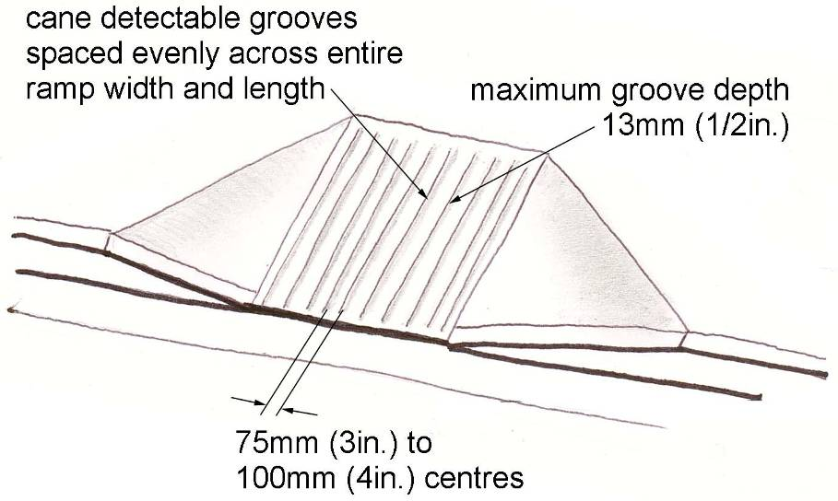

h) Detectable warning surfaces should be used simply, logically and consistently throughout the site so individuals can easily predict and interpret the route layout. A lack of standardization or too many surface changes may cause confusion and weaken the usefulness of the tactile signal.

- Whenever possible, the contrasting material or treatment used to create a detectable warning surface should be integrated into the overall design/décor of the site or facility.

4.5 Card Access, Safety and Security Systems
All systems and components installed for access, safety and security should be appropriate for use by disabled persons, including individuals with reduced manual dexterity and low or no vision.
Location
Card access, safety and security systems should be installed in prominent and accessible locations, such as at the main entrance or other barrier-free entrance to a facility.
criteria
- All card access or encoded entry/exit systems, such as keypads, should be mounted no higher than 1.06m (3ft.5in.) above the finished floor, with an adjacent clear floor space at least 760mm (30in.) wide and 1.37m (4ft.6in.) long.

- Entry or exit card or keypad systems should be positioned on the latch side of the door at a height of 920mm (36in.), clear of the door swing or other operating components of the entry point.

- Card access mechanisms should be operable with one hand, and should not require tight grasping, pinching or twisting of the wrist.

- Operable components of safety or security systems should incorporate raised buttons, numerals, symbols and letters, mounted in a constant array on a clearly differentiated background.

- To accommodate a disabled person requiring assistance a signalling mechanism such as a bell, buzzer or similar device, or a two-way intercom system, should be provided at the primary accessible entrance and in any covered accessible parking area.

- Where Universal Toilet Rooms are provided an emergency call system linked to a central location (main office or switchboard) should be installed (refer to Section 3.3.4 – Restrooms).

- Elevators and platform lifts should incorporate emergency calling devices, including a push button alarm for individuals unable to speak (refer to Sections 3.2.2 – Ramps and Lifts and 3.2.3 – Elevators).

4.6 Glare and Light Sources
Direct or reflected glare off floors, walls or work surfaces presents a significant problem for individuals with low or no vision. Non-reflective materials and finishes, as well as mechanisms to control natural daylight should be integrated throughout a facility.
Location
Glare and light sources potentially impact all areas within a site or facility.
criteria
a) Curtains, blinds or other sun screening systems should be installed at windows and other areas of direct sunlight to minimize and control the level of light and reflective glare.

b) Materials and finishes on horizontal surfaces, such as floors, counters or work surfaces, as well as vertical surfaces, such as walls or columns, should be matte or satin to minimize reflective glare.

c) Extensive high gloss surfaces are not acceptable. High gloss materials and finishes may be incorporated into horizontal and vertical surface details provided they do not result in large reflective surfaces.

d) Light fixtures should be installed with diffusers or lenses or be recessed so they do not produce glare.

e) To minimize potential glare, valance-type lighting or other means of indirect lighting should be used whenever possible. Vertical, backlit panels used as indirect lighting sources may cause glare and are not recommended.

f) Where surface mounted fluorescent fixtures are used, they should have darkened sides (no wrap around lenses) and be positioned perpendicular to the dominant direction of travel.

g) Lighting for key features and direction orienting elements should have upward and downward components only.

h) Changes in lighting level should not exceed a range of 100 lux to 300 lux (10-30 ft. candles) from one space to the next.

i) See also Section 4.7 – Lighting.

4.7 Lighting
Both lighting quality and quantity are important to accessibility, particularly for individuals with low or no vision. To improve access and safety, artificial lighting and natural light sources should provide acceptable, evenly measured light throughout a site or facility.
Location
Ample lighting should be installed throughout a site, particularly at entrances, in work and meeting areas and areas of potential hazard, such as stairs or doorways.
criteria
- All lighting should be evenly distributed to minimize pools of light and cast shadows. Shields, recesses or other features should be used to focus light and minimize reflective glare.

- Changes in lighting level should not exceed a range of 100 lux to 300 lux (10-30 ft. candles) from one space to the next.

- Supplementary lighting should be provided to highlight key signage and orientating landmarks.
Exterior Lighting
- All exterior lighting at public thoroughfares and pedestrian routes should comply with Illuminating Engineering Society of North America (I.E.S.N.A.) Standards, to provide safe access for persons with disabilities from sidewalks, transit stops and parking facilities to nearby facilities and amenities.
Interior Lighting
- Interior light sources and fixtures should be selected and positioned to minimize direct or indirect glare on nearby reflective surfaces.

Where fluorescent or quartz light sources are used provide warmer colours with lower colour temperatures.

To minimize tripping hazards, lighting at steps, stairs, escalators and ramps should be positioned to clearly define leading edges.

Lighting levels for interior accessible routes should be at least 100 lux (10 ft. candles).

All work areas should be illuminated at 200 lux (20 ft. candles) or greater and 5% of work stations should include lighting capable of being adjusted to 500 to 700 lux (70 ft. candles).

Lighting levels in elevator lobbies should be similar to the elevator interior and measure at least 200 lux (20 ft. candles).

Emergency lighting over stairs or ramps, at an exit or along an accessible path of travel should be at least 100 lux (10 ft. candles) measured at the floor.

Lighting for orientating features, over directional or informational signage, at public telephones, information or service counters and card access or keypad security systems should be at least 200 lux (20 ft. candles) measured at the working surface.

Lighting in meeting and assembly areas should be evenly distributed and capable of adjustment (through the use of dimmers or other light control mechanisms).

Lighting at lecterns, podiums, platforms or other speaking locations should be capable of being enhanced even when other lights are dimmed, to assist individuals who are deaf, deafened or hard of hearing read lips or view the hand actions of a signer.

4.8 Texture and colour
The ability of an individual with low or no vision to navigate an environment can be enhanced through the strategic use of colour and texture. Caution is recommended in the selection of heavy or distinct patterns on walls or floors, since these can add visual confusion to settings for persons with low vision. Simple, repetitive, non-directional patterns that feature monochromatic or low-colour contrast are preferred. Changes in material or texture should not necessitate a threshold.
Location
Textural and colour systems should be used in various locations to enhance accessibility.
criteria
- Exterior colour schemes shall incorporate a pronounced colour contrast, to differentiate boundaries of objects, distinguish objects from their background, and to generally enhance spatial orientation. Generally, for seniors and persons with low vision, colours in the warm end of the spectrum (yellow, orange, bright red, etc.) are easier to recognize than those at the cool end of the spectrum.

- Signs shall incorporate pronounced glare-free colour contrast. A sharp contrast of light reflectance is required (a percentage contrast of 70% is recommended). For signs, the most visible colours are white or yellow on black, charcoal or other dark background, such as brown, dark blue, dark green or purple. Black lettering on white is also acceptable, although less readable than the reverse. Unacceptable background colours are light grey and pastel colours. Red lettering on a black background is also unacceptable.

- Colour contrast shall be used as a safety measure to define edges or boundaries of objects (e.g., stair nosing, doors, handrails, etc.). Colour or tone shall be used to visually define the boundaries of a room (i.e., where the wall meets the floor). Baseboards in monochromatic environments shall be highly contrasting with the wall and floor colour, to provide boundary definition.

- Colour shall be used consistently to visually identify distinctive objects (e.g., exit doors).

- Bright colours and/or a highly contrasting tone shall be used to assist with wayfinding. For example, if used as part of a signage band located on walls at eye level, this band is easier to follow than monolithic wall colouring, and can be the visual cue for other essential signs.

- End walls or return walls in long corridors shall be visually defined using highly contrasting colours or tone, to enhance a change of direction or the end of the space.

- Detectable warning surfaces shall be use to define potential hazards.(refer to Section 4.4 .-Detectable Warning Surfaces). All textured surfaces used as detectable warning surfaces shall be clearly detectable, by walking upon, as being different from the surrounding surface. Suitable textures include
- 10mm (3/8 in.) deep saw-cut concrete with regular grooves, positioned no more than 100mm (4 in.) apart, commencing no closer than 100mm (4 in.) from the curb; grooves should be at right angles to the path of travel for exterior textures.
- raised domes, dots or squares, deeply grooved concrete, terrazzo or other stone-like materials, with closely centred grooves at right angles to the path of travel, or applied carborundum or other non-slip strips for interior textures.

- Supplementary textural cues shall also be provided (e.g., by using different floor textures or materials, in major and minor routes).

- Clearly defined boundaries of materials like carpeting or floor tiles shall enhance wayfinding by defining such as the junction between walls and floors, doorway recesses and corridor intersections.

- The same texture shall be used consistently throughout any one site to identify the same type of hazard.

4.9 Materials and Finishes
Materials and finishes used throughout a site or facility are critical to the safety and ease of movement for persons with disabilities, especially individuals using wheelchairs or scooters and those who with low or no vision. Materials or finishes may also contribute to noise and echo, which impacts individuals with hearing disabilities.
Location
Materials and finishes are located throughout a site. Particular attention should be given to those along and within accessible areas.
criteria
a) Stable, firm, slip-resistant materials and finishes should be used wherever possible (refer to CAN/CSA B651 Annex D, “Potential for Slip of Floor and Tread Finishes”).

b) Materials and finishes on horizontal surfaces, such as floors, counters or work surfaces, as well as vertical surfaces, such as walls or columns, should be matte or satin to minimize reflective glare.

c) Surface should be glare-free. Extensive high gloss surfaces are not acceptable. High gloss materials and finishes may be incorporated into horizontal and vertical surface details provided they do not result in large reflective surfaces.

d) Walls and other vertical surfaces adjacent to barrier-free routes and areas should be non-abrasive.

e) Highly patterned floors should be avoided as they can create visual confusion. The use of directional wayfinding within the surface is encouraged.

f) Ground and floor surface materials and transitions between such surface materials should contain variations in level no greater than 13mm (1/2in.) and joints no greater than 6mm (1/4in.) wide.
Exterior Materials and Finishes
- Recommended paving surfaces for accessible exterior routes include concrete, asphalt, brick or decking laid perpendicular to the path of travel. Concrete with a level, brushed surface is most preferred.

Paving stones or interlocking pavers should be avoided for main walking and wheeling surfaces unless installed to minimize the effects of settlement and frost heave, such as over a structural slab.

Wherever possible, gratings and grills must be located clear of a barrier-free route. Where grates and grills are present, the bars should be positioned perpendicular to the main path of travel and contain openings no greater than 13mm (1/2in.) in width.

Exterior surface materials should be well-drained and installed to minimize water and ice accumulation.

See also Section 2. Exterior Design Standards (e.g. Section 2.2.1 – Accessible Routes) for additional exterior surface requirements.
Interior Materials and Finishes
- Where carpet is installed it should be a low-level loop construction, 10- or 12-gauge non-static fibre and glued directly to the subfloor.

Where hard, monolithic materials are used, such as stone, granite, marble or terrazzo, the surface should be non-slip, non-glare and minimize echo.

Wall finishes such as paint, vinyl coverings, stone, marble, wood, metals, plastic laminate etc. should be non-glare and non-abrasive.

Interior floor areas near sources of water, such as pools, shower rooms and restrooms, should be well-drained.

See also Section 3. – Interior Design Standards for additional interior surface requirements.

4.10 Acoustics
Proper acoustics are most important to individuals with low/no vision or hearing loss. The acoustic surroundings of common buildings or spaces should accommodate a hearing or vision disabled person’s need to separate essential sounds from general background noise.
Location
Similar to lighting, acoustics relate to the entirety of a facility or site.
criteria
- Floor finishes, wall surfaces and ceiling treatments should be selected so as not to unduly amplify occasional noise.

- While minimizing amplification to assist individuals with hearing disabilities, surface treatments may include audible differentiation to serve as a cue for changes in location and way finding for people with low or no vision.

- In large facilities where way finding may be problematic for persons with vision disabilities, primary and secondary paths of travel should possess differentiated sound transmission or reflection characteristics.

- Ceiling design should minimize echo.

- Public address and call systems should be capable of focusing in key areas, rather than blanketing the whole facility at all times.

- In meeting rooms and assembly areas where audio communication is the primary mode, all unnecessary background noise (mechanical equipment, air diffusers, fans etc.) should be dampened and/or the room should be equipped with sufficient sound insulation.

- Meeting rooms and assembly areas should have the necessary wiring installed for devices that assist persons with hearing disabilities.

- Public or common spaces, such as library reading rooms or cafeterias, should provide noise reduced sections to assist communication among persons with hearing disabilities.

4.11 Assistive listening system
The provision of assistive listening devices is important for the range of individuals who may have difficulty hearing. Assistive Listening Systems amplify audible communication when a sound system is present, and can be used by persons who are hard of hearing, with or without hearing aids. Each system will consist of a Transmitter and a Receiver listening device (beltpack). They do not interfere with the listening enjoyment of people without a hearing loss.
Location
In buildings of assembly occupancy, all classrooms, auditoria, meeting rooms and theatres with an area of more than 100 sq. m (1080 sq. ft.) and an occupant load of more than 75 shall be equipped with assistive listening systems (ALS) encompassing the entire seating area.
criteria
- Signage that incorporates the Symbol of Accessibility for persons who are hard of hearing (Section 1.3.3 – Universal Symbols of Accessibility) and complies with applicable provisions of Section 1.3.2.-Signage, shall be installed to notify patrons of the availability of a permanently installed ALS.
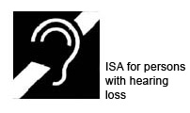
- Adequate and controllable lighting is required for persons who lip-read, or those who require increased task lighting, due to a low vision.

- In the cases listed above a Permanently Installed Sound System is required. Therefore, only certain rooms will have this ability if the room was deemed as needing a sound system in the first place. A permanently installed sound system must be present in the room and outfitted with a permanently installed Assistive Listening Device Transmitter. Sound is transmitted into the listening area into the user’s assistive Listening Device provided by the facility to the requestor.

While the Ontario Building Code (OBC) does not mention the minimum number of receiver listening devices (beltpacks) required for potential users – we will provide a minimum of 2 units per facility. For example, if the facility has 5 rooms with sound systems that require Assistive Listening Systems, only one device would be installed per room. However, we will ensure that the system will be designed with channel selectable units. This will ensure that any of the 5 room devices can be switched to match any of the 5 rooms. Therefore, you can have up to 5 devices in one room. The system will also be outfitted with two different comfort options to the user – standard headset or inductive loop necklace. For hygienic reasons, earbud sets will not be an option.

Most systems installed shall be FM (frequency- modulated) models ensuring the best coverage by using radio waves that use a section of the FM radio band that has been set aside by the government for hearing assistance and educational purposes. Alternatively, in pre-designed and pre-determined venues that may deal with highly sensitive or secure information (ie. City Court House, Council Chambers) the IR (infrared) models shall be installed that transmit an audio signal via infrared light instead of FM radio waves. Since IR does not penetrate walls, this will ensure the listening user is within the room and the sensitive or secure information will not be obtained from outside the room with any other listening devices. Also, it is important to remember that IR can travel through windows and the transmission may pass through if the blinds are not drawn etc. IR’s inability to penetrate walls, bookshelves, people, etc. means that in order for IR transmission to work well, an infrared receiver must be in direct line of sight of the transmitter within the room. It is important to remember that the IR units chosen shall not be interfered with by sunlight or fluorescent lighting.

Receiver listening devices (beltpacks), shall be rechargeable units to ensure the lack of fresh batteries will not be an issue. These units shall be rechargeable within the sound rack drawer, in a rack chosen by the facility. In the case where the units had not been charged, the unit shall be able to use regular batteries as backup.

- Some venues and locations of choice may not have Assistive Listening Systems installed due to the fact that the room either did not warrant a permanent sound system or the room’s sound system did not require an Assistive Listening System as per OBC. However, a small Portable Sound System may still be required by the City Staff Department in charge of the meeting or event. This system can be reserved, by City Staff, through the City’s AV Technical Services department.

- If a small portable sound system is deemed as not being adequate enough (i.e. Canada Day Event), then a larger Temporary Sound System may be required. This temporary sound system will include an Assistive Listening Kit that will be outfitted with a Transmitter and 2 Receiver listening devices (beltpack) and outfitted with 2 different comfort options to the user- Standard Headset or Inductive Loop necklace.
.

Appendices
5

5.1 Universal Design Principles
The Principles

The authors, a working group of architects, product designers, engineers and environmental design researchers, collaborated to establish the following Principles of Universal Design to guide a wide range of design disciplines including environments, products, and communications. These seven principles may be applied to evaluate existing designs, guide the design process and educate both designers and consumers about the characteristics of more usable products and environments.

How The Principles Are Formatted:

- Name of the principle (a concise statement of the key concept embodied in the principle).

- Definition of the principle (brief description of the principle’s primary directive for design).

- Guidelines (list of the key elements that should be present in a design which adheres to the principle).

- Images (photographic samples of the principles applied).

Universal Design:

The design of products and environments to be usable by all people, to the greatest extent possible, without the need for adaptation or specialized design.

Principle One: Equitable Use  The design is useful and marketable to people with diverse abilities.  Guidelines:  - Provide the same means of use for all users: identical whenever possible; equivalent when not.  - Avoid segregating or stigmatizing any users.  - Provisions for privacy, security, and safety should be equally available to all users.  - Make the design appealing to all users. | 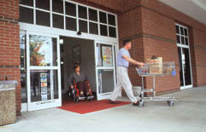
Principle Two: Flexibility In Use  The design accommodates a wide range of individual preferences and abilities.  Guidelines:  - Provide choice in methods of use.  - Accommodate right-or left-handed access and use.  - Facilitate the user’s accuracy and precision.  - Provide adaptability to the user’s pace. | 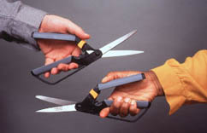

Principle Three: Simple and Intuitive  Use of the design is easy to understand, regardless of the user’s experience, knowledge, language skills, or current concentration level.  Guidelines:  - Eliminate unnecessary complexity.  - Be consistent with user expectations and intuition.  - Accommodate a wide range of literacy and language skills.  - Arrange information consistent with its importance.  - Provide effective prompting and feedback during and after task completion. | 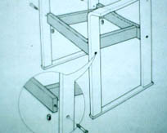
Principle Four: Perceptible  Information  The design communicates necessary information effectively to the user, regardless of ambient conditions or the user’s sensory abilities.  Guidelines:  - Use different modes (pictorial, verbal, tactile) for redundant presentation of essential information.  - Provide adequate contrast between essential information and its surroundings.  - Maximize “legibility” of essential information.  - Differentiate elements in ways that can be described (i.e., make it easy to give instructions or directions).  - Provide compatibility with a variety of techniques or devices used by people with sensory limitations. | 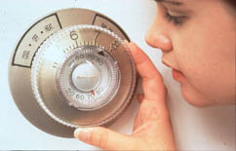
Principle Five: Tolerance for Error  The design minimizes hazards and the adverse consequences of accidental or unintended actions.  Guidelines:  - Arrange elements to minimize hazards and errors: most used elements, most accessible; hazardous elements eliminated, isolated or shielded.  - Provide warnings of hazards and errors.  - Provide fail safe features.  - Discourage unconscious action in tasks that require vigilance. | 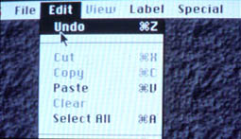
Principle Six: Low Physical Effort  The design can be used efficiently and comfortably and with a minimum of fatigue.  Guidelines:  - Allow user to maintain a neutral body position.  - Use reasonable operating forces.  - Minimize repetitive actions.  - Minimize sustained physical effort. | 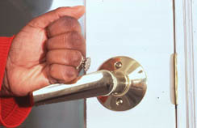

Principle Seven: Size and Space for Approach and Use
- Appropriate size and space is provided for approach, reach, manipulation, and use regardless of user’s body size, posture, or mobility.

Guidelines:

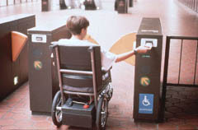
- Provide a clear line of sight to important elements for any seated or standing user.
- Make reach to all components comfortable for any seated or standing user.
- Accommodate variations in hand and grip size.
- Provide adequate space for the use of assistive devices or personal assistance.

5.2 DEFINITIONS
Access Aisle
An accessible pedestrian space between elements, such as parking spaces, seating, and desks that provides clearances appropriate for use of the elements.
Accessible (Barrier-free)
Describes a site, building, facility, or portion thereof that complies with these guidelines.
Accessible Element
An element specified by these guidelines (for example, telephone, controls, and the like).
Accessible Route
A continuous unobstructed path connecting all accessible elements and spaces of a building or facility. Interior accessible routes may include corridors, floors, ramps, elevators, lifts, and clear floor space at fixtures. Exterior accessible routes may include parking access aisles, curb ramps, crosswalks at vehicular ways, walks, ramps, and lifts.
Accessible Space
Space that complies with the accessibility guidelines.
Adaptability
The ability of certain building spaces and elements, such as kitchen counters, sinks, and grab bars, to be added or altered so as to accommodate the needs of individuals with or without disabilities or to accommodate the needs of persons with different types or degrees of disability.
Addition
An expansion, extension, or increase in the gross floor area of a building or facility.
Administrative Authority
A governmental agency that adopts or enforces regulations and guidelines for the design, construction, or alteration of buildings and facilities.
Alteration
An alteration is a change to a building or facility that affects or could affect the usability of the building or facility or part thereof. Alterations include, but are not limited to, remodelling, renovation, rehabilitation, reconstruction, historic restoration, resurfacing of circulation paths or vehicular ways, changes or rearrangement of the structural parts or elements, and changes or rearrangement in the plan configuration of walls and full-height partitions. Normal maintenance, re-roofing, painting or wallpapering, or changes to mechanical and electrical systems are not alterations unless they affect the usability of the building or facility.
Area of Rescue Assistance
An area, which has direct access to an exit, where people who are unable to use stairs may remain temporarily in safety to await further instructions or assistance during emergency evacuation.

Assembly Area
A room or space accommodating a group of individuals for recreational, educational, political, social, civic, or amusement purposes, or for the consumption of food and drink.
Automatic Door
A door equipped with a power-operated mechanism and controls that open and close the door automatically upon receipt of a momentary actuating signal. The switch that begins the automatic cycle may be a photoelectric device, floor mat, or manual switch (see power-assisted door).
Boarding Pier
A portion of a pier where a boat is temporarily secured for the purpose of embarking or disembarking.
Boat Launch Ramp
A sloped surface designed for launching and retrieving trailered boats and other water craft to and from a body of water.
Boat Slip
That portion of a pier, main pier, finger pier, or float where a boat is moored for the purpose of berthing, embarking, or disembarking.
Building
Any structure used and intended for supporting or sheltering any use or occupancy.
Circulation Path
An exterior or interior way of passage from one place to another for pedestrians, including, but not limited to, walks, hallways, courtyards, stairways, and stair landings.
Clear
Unobstructed.
Clear Floor Space
The minimum unobstructed floor or ground space required to accommodate a single, stationary wheelchair and occupant.
Closed Circuit Telephone
A telephone with dedicated line(s) such as a house phone, courtesy phone or phone that must be used to gain entrance to a facility.
Common Use
Refers to those interior and exterior rooms, spaces, or elements that are made available for the use of a restricted group of people (for example, occupants of a homeless shelter, the occupants of an office building, or the guests of such occupants).
Cross Slope
The slope that is perpendicular to the direction of travel (see running slope).
Curb Ramp
A short ramp cutting through a curb or built up to it.

Detectable Warning
A standardized surface feature built in or applied to walking surfaces or other elements to warn people who have low or no vision of hazards on a circulation path.
Dwelling Unit
A single unit which provides a kitchen or food preparation area, in addition to rooms and spaces for living, bathing, sleeping, and the like. Dwelling units include a single family home or a townhouse used as a transient group home; an apartment building used as a shelter; guestrooms in a hotel that provide sleeping accommodations and food preparation areas; and other similar facilities used on a transient basis. For the purposes of these guidelines, use of the term "Dwelling Unit" does not imply the unit is used as a residence.
Egress, Means of
A continuous and unobstructed way of exit travel from any point in a building or facility to a public way. A means of egress comprises vertical and horizontal travel and may include intervening room spaces, doorways, hallways, corridors, passageways, balconies, ramps, stairs, enclosures, lobbies, horizontal exits, courts and yards. An accessible means of egress is one that complies with these guidelines and does not include stairs, steps, or escalators. Areas of rescue assistance or evacuation elevators may be included as part of accessible means of egress.
Element
An architectural or mechanical component of a building, facility, space, or site, e.g., telephone, curb ramp, door, drinking fountain, seating, or water closet.
Elevated Play Component
A play component that is approached above or below grade and that is part of a composite play structure consisting of two or more play components attached or functionally linked to create an integrated unit providing more than one play activity.
Entrance
Any access point to a building or portion of a building or facility used for the purpose of entering. An entrance includes the approach walk, the vertical access leading to the entrance platform, the entrance platform itself, vestibules if provided, the entry door(s) or gate(s), and the hardware of the entry door(s) or gate(s).
Facility
All or any portion of buildings, structures, site improvements, complexes, equipment, roads, walks, passageways, parking lots, or other real or personal property located on a site.
Gangway
A variable-sloped pedestrian walkway that links a fixed structure or land with a floating structure. Gangways which connect to vessels are not included.

Ground Floor
Any occupiable floor less than one story above or below grade with direct access to grade. A building or facility always has at least one ground floor and may have more than one ground floor as where a split level entrance has been provided or where a building is built into a hillside.
Ground Level Play Component
A play component that is approached and exited at the ground level.
Mezzanine or Mezzanine Floor
That portion of a story which is an intermediate floor level placed within the story and having occupiable space above and below its floor.
Marked Crossing
A crosswalk or other identified path intended for pedestrian use in crossing a vehicular way.
Multifamily Dwelling
Any building containing more than two dwelling units.
Occupiable
A room or enclosed space designed for human occupancy in which individuals congregate for amusement, educational or similar purposes, or in which occupants are engaged at labour, and which is equipped with means of egress, light, and ventilation.
Operable Part
A part of a piece of equipment or appliance used to insert or withdraw objects, or to activate, deactivate, or adjust the equipment or appliance (for example, coin slot, pushbutton, handle).
Play Area
A portion of a site containing play components designed and constructed for children.
Play Component
An element intended to generate specific opportunities for play, socialization, or learning. Play components may be manufactured or natural, and may be stand alone or part of a composite play structure.
Power-Assisted Door
A door used for human passage with a mechanism that helps to open the door, or relieves the opening resistance of a door, upon the activation of a switch or a continued force applied to the door itself.
Ramp
A walking surface which has a running slope greater than 1:20.
Running Slope
The slope that is parallel to the direction of travel (see cross slope).
Service Entrance
An entrance intended primarily for delivery of goods or services.
Signage
Displayed verbal, symbolic, tactile, and pictorial information.

Site
A parcel of land bounded by a property line or a designated portion of a public right-of-way.
Site Improvement
Landscaping, paving for pedestrian and vehicular ways, outdoor lighting, recreational facilities, and the like, added to a site.
Space
A definable area, e.g., room, toilet room, hall, assembly area, entrance, storage room, alcove, courtyard, or lobby.
Storey
That portion of a building included between the upper surface of a floor and upper surface of the floor or roof next above. If such portion of a building does not include occupiable space, it is not considered a storey for purposes of these guidelines. There may be more than one floor level within a storey as in the case of a mezzanine or mezzanines.
Structural Frame
The structural frame shall be considered to be the columns and the girders, beams, trusses and spandrels having direct connections to the columns and all other members which are essential to the stability of the building as a whole.
TDD (Telecommunication Devices for the Deaf)
See text telephone.
TTY (Tele-Typewriter)
See text telephone.
Tactile
Describes an object that can be perceived using the sense of touch.
Text Telephone (TTY)
Machinery or equipment that employs interactive text based communications through the transmission of coded signals across the standard telephone network. Text telephones can include, for example, devices known as TDDs (telecommunication display devices or telecommunication devices for deaf persons) or computers with special modems. Text telephones are also called TTYs, an abbreviation for Tele-typewriter.
Transfer Device
Equipment designed to facilitate the transfer of a person from a wheelchair or other mobility device to and from an amusement ride seat.
Vehicular Way
A route intended for vehicular traffic, such as a street, driveway, or parking lot.
Walk
An exterior pathway with a prepared surface intended for pedestrian use, including general pedestrian areas such as plazas and courts.

Taken from: ADA Accessibility Guidelines for Buildings and Facilities (ADAAG)

5.3 BIBLIOGRAPHY AND WEB RESOURCES
This broad list summarizes the sources used or considered when creating the design criteria presented in this document.
BIBLIOGRAPHY
- City of London, Facility Accessibility Design Standards, 2006
- City of Burlington, Accessibility Design Guidelines, 2003.
- City of Ottawa, Accessibility Technical Guidelines Draft, 2003.
- City of Toronto, Accessibility Design Guidelines, 2004.
- City of Brampton, Accessibility Technical Standards.
- Ontario Building Code, 2006.
- Job Accommodation Network, "The Economics of Disability" (Washington, DC), p. 1.
- Hopkins, Kevin R., Susan L. Nestelroth, and Clint Bolick, Help Wanted: How Companies Can Survive and Thrive in the Coming Worker Shortage (McGraw-Hill, New York, 1991), p. 19. See also Workers 45+: Today and Tomorrow (American Association of Retired Persons, 1986), p. 1.
- The Architectural and Transportation Barriers Compliance Board, "The Americans with Disabilities Act in Brief" (U. S. Government Printing Office, Washington, DC).
- Levy, Howard Adam, "Barrier-Free Design," Professional Office Design (November/December 1989), p. 45.
- Clearing Our Path, CNIB, 1998.
- Playability Toolkit, Ontario Parks Association.
- CAN/CSA Standard B651-95 and CAN/CSA B651-04 Accessible Design for the Built Environment.
- CAN/CS A-Z614-07 Children’s Play Spaces and Equipment.
WEB RESOURCES
http://www1.city.peterborough.on.ca/CITYdocs/cityofpeterboro_2/planningbuildin_/accessplan/accessplan.pdf
http://www.city.london.on.ca/Planning/fads_2001.pdf
http://www.peasedev.org/web/engineering/vehicle_parking_and_loading.htm
http://ci.alexandria.va.us/city/zoningdigest/zd_plreqs.html
http://www.metrokc.gov/dias/ocre/signage.htm
http://www.beneficialdesigns.com/trails/access.html
http://www.gov.on.ca/citizenship/accessibility/english/parkingbylaw.htm
http://www1.oecd.org/cem/pub/pubpdf/TPHguideE.pdf
http://www.gov.on.ca/citizenship/accessibility/english/act2001.htm
http://www.dhh12s.com/signage.htm
http://www.dhh12s.com/aameetingsblind.htm
http://www.ski.org/Rehab/WCrandall/AusOpt/AOintro.html
http://www.ada.gov/adastd94.pdf
http://www.accessign.com/
http://www.oakville.ca/Media_Files/AccessPlan2004.pdf
http://www.garaventa.ca/dsgn/index.html
http://www.cityofkingston.ca/pdf/accessibility/2003_AccessibilityPlan.doc
http://www.equalopportunity.on.ca/eng_g/subject/index.asp?action=search_7&dir_id=1657&file_id=24166
http://www1.oecd.org/cem/topics/handicaps/pdf/TPH0010Fe.pdf
http://www.gwbarrierfree.org/advisory.htm
http://www.design.ncsu.edu/cud/univ_design/princ_overview.htm

Disability Organizations such as The Canadian Hearing Society www.chs.ca and
The Canadian National Institute for the Blind www.cnib.ca can assist with the purchase and installation of equipment to serve people with disabilities.

For further information on universal design principles refer to Section 5. – Appendices

