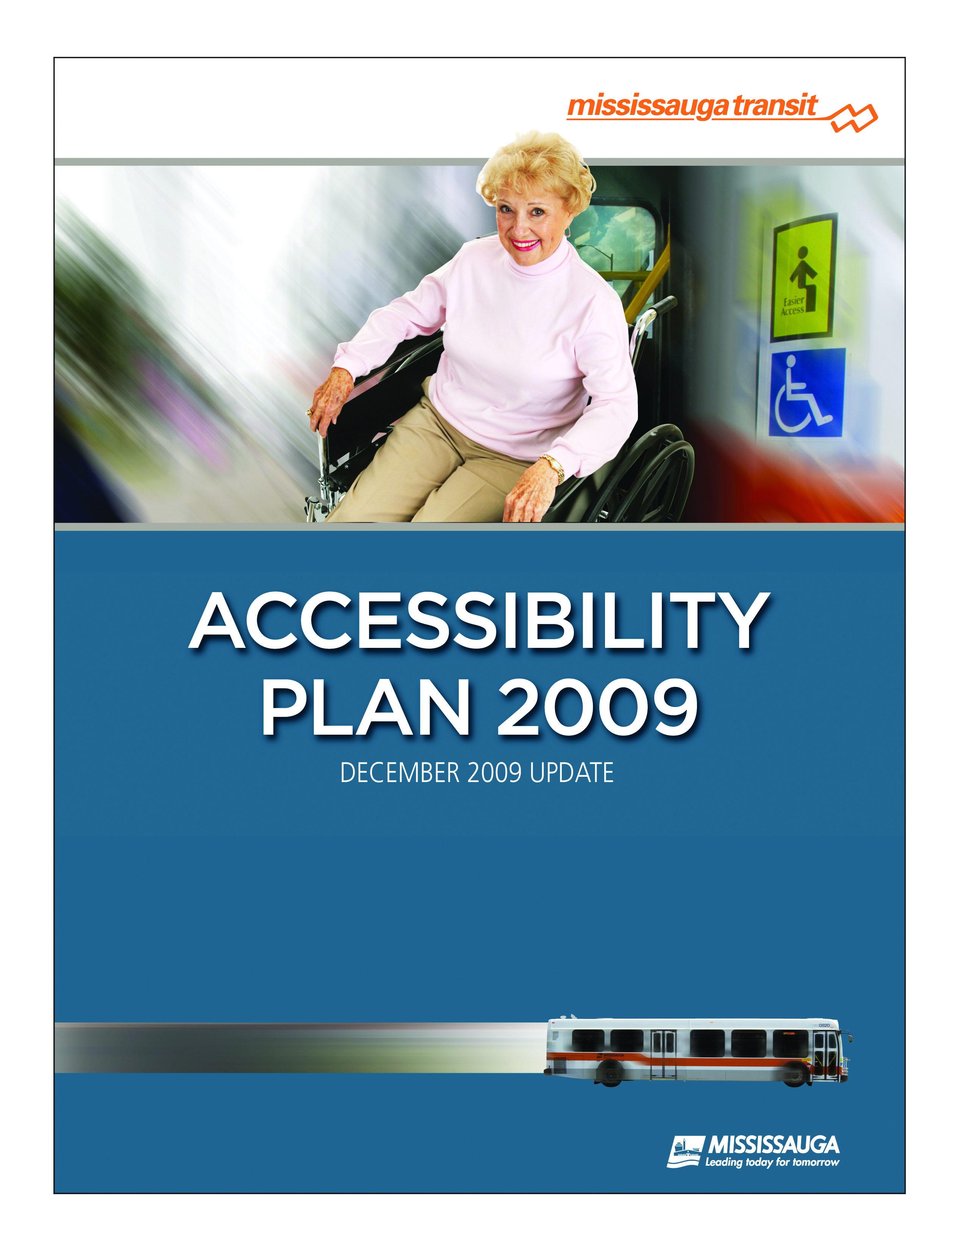
Table of Contents

Executive Summary 3
Introduction 4
Legislative Framework 4
Background 5
What is Disability? 5
Mississauga Transit’s Accessibility Policy 6
Mississauga Transit: Service Profile 7
Mississauga Transit: Accessible Services Map 9
Specific 2008 Initiatives and Achievements 10
Accessible Routes 10
Buses 10
Transit Infrastructure 10
Respectful Workplace Training 11
AODA Customer Service Standard 11
‘May I Help You? Understanding Accessible Customer Service’ 12
Unanticipated Service Disruptions 12
Ongoing Initiatives 13
Announcing of Bus Stops 13
Audio and Visual Annunciation Systems 13
PRESTO System 13
Support Persons 14
Customer Service/Sensitivity and Awareness Training 14
Customer Contact System (CCS) 14
Information 15
Mississauga’s Bus Rapid Transit (BRT) System 16
Project Overview 16
Project Status 17
Design Status 17
Plan Approval and Communication Strategy 18
Conclusion and Last Steps 18
Mississauga Transit: General Information 19

Executive Summary
This report provides an update on activities Mississauga Transit has undertaken between January 2009 and December 2009 to meet the goal of improving accessibility in all its services and facilities. Mississauga Transit’s Accessibility Plan - 2009 is in conformance with the requirements of the Ontarians with Disabilities Act (“ODA”) and serves as an annual report on the progress made to date with respect to the Mississauga Transit’s Accessibility Plan direction.

As demonstrated, Mississauga Transit is committed to:

- the continuous improvement of accessible transit services;

- working toward ensuring its facilities and premises are barrier free;

- ensuring employment and employment opportunities are barrier free; and,

- implementing communication services that respect the abilities of all customers, employees and the public at large.

The development of the Accessibility Plan documents the extensive planning and implementation activities undertaken by Mississauga Transit in 2009 that reflect the continued progress made in improving accessibility in all its services and facilities.

Introduction
The “Ontarians with Disabilities Act (ODA), 2001” and the “Accessibility for Ontarians with Disabilities Act (AODA), 2005”, requires that public transportation agencies, such as Mississauga Transit, develop an annual Accessibility Plan and consult with people with disabilities and others in preparing the plan.

Mississauga Transit’s Accessibility Plan provides an update on activities Mississauga Transit has undertaken to improve accessibility in all its services and operations. This Plan summarizes the results, to date, of the extensive planning and implementation activities Mississauga Transit has undertaken to make the system more accessible.

Fulfillment of Mississauga Transit’s corporate direction is achieved and sustained through operational policy and regulations, and through staff training and awareness programs implemented throughout the organization.

Mississauga Transit has committed to producing and updating this annual status report on an ongoing basis.

Legislative Framework
The Ontarians with Disabilities Act sets out the following requirements for public transportation organizations:

Section 14 of the Act requires public transportation organizations to:

- prepare an Accessibility Plan; and

- consult people with disabilities and others when it prepares its Plan.
- Ontarians with Disabilities Act, 2001

According to the Act, the contents of the Plan must include the following:

- a report on the measures the organization has taken to identify, remove and prevent barriers to persons with disabilities;

- the measures in place to ensure that the organization assesses its proposals for by-laws, policies, programs, practices and services to determine their effect on accessibility for persons with disabilities;

- a list of the by-laws, policies, programs, practices and services that the organization will review in the coming year in order to identify barriers to persons with disabilities; and,

- the measures that the organization intends to take in the coming year to identify, remove and prevent barriers to persons with disabilities.
- Ontarians with Disabilities Act, 2001

Background
The Ontarians with Disabilities Act, 2001 (ODA) outlines accessibility planning requirements for governments, municipalities and the broader public sector. In June 2005, the Province of Ontario’s Accessibility for Ontarians with Disabilities Act, 2005 (AODA), came into effect. The legislation provides for the development of accessibility standards that will lead to accessible services and facilities being in place by 2025.

The purpose of the AODA is to:

- develop, implement and enforce accessibility standards in order to achieve accessibility for Ontarians with disabilities with respect to goods, services, facilities, accommodation, employment, buildings, structures and premises by January 1, 2025

- provide for the involvement of persons with disabilities, the government of Ontario and representatives of industries and of various sectors of the economy in the development of accessibility standards.
- Accessibility for Ontarians with Disabilities Act, 2005

What is a Disability?

The ODA and AODA cover the same broad range of disabilities as the Ontario Human Rights Code. These include physical, sensory, cognitive, developmental and mental disabilities, and brain injury.

The ODA and AODA define "disability" as:

a. Any degree of physical disability, infirmity, malformation or disfigurement that is caused by bodily injury, birth defect or illness and, without limiting the generality of the foregoing, includes diabetes mellitus, epilepsy, a brain injury, any degree of paralysis, amputation, lack of physical co-ordination, blindness or visual impediment, deafness or hearing impediment, muteness or speech impediment, or physical reliance on a guide dog or other animal or on a wheelchair or other remedial appliance or device.

b. A condition of mental impairment or a developmental disability.

c. A learning disability or a dysfunction in one or more of the processes involved in understanding or using symbols or spoken language.

- A mental disorder.

- An injury or disability for which benefits were claimed or received under the insurance plan established under the Workplace Safety and Insurance Act, 1997; ("handicap").
- Ontarians with Disabilities Act, 2001

Mississauga Transit’s Accessibility Policy
Mississauga Transit is fully committed to providing a transportation system that ensures its services and operations are accessible to everyone.

Under the ODA, municipalities have a legal obligation to prepare annual accessibility plans. Hence, the City of Mississauga’s first Accessibility Plan was issued in 2003. The Plan describes the progress that the City has made to improve accessibility, and remove barriers to persons with disabilities. The Annual Accessibility Plan is developed by the Accessibility Staff Working Group in conjunction with the City of Mississauga Accessibility Advisory Committee (AAC). The Accessibility vision is:

“To create a fully accessible community utilizing universal design principles resulting in improved attitudes and full inclusion.”

Mississauga Transit is committed to achieving an accessible transit system within the City of Mississauga. To meet the principles and goals outlined in the Accessibility for Ontarians with Disabilities Act (AODA), Mississauga Transit will ensure that:

- its services are provided in a way that maintains and respects the dignity and independence of all customers;

- all infrastructure and services related to transit are developed with accessibility in mind; and,

- that policies, procedures and protocols are implemented that work towards identifying, removing and preventing barriers to people with disabilities.

Mississauga Transit’s Service Profile
Mississauga Transit operates conventional, fixed route transit service within the boundaries of the City of Mississauga, with service integration into neighbouring municipalities, like the City of Brampton, the Town of Oakville, and the City of Toronto.

Mississauga Transit has made substantial progress in achieving its goal of fully-accessible service. Approximately 93% (14 of 15) of our terminals/transit hubs within the City of Mississauga are fully accessible, along with approximately 92% of the entire bus fleet. Mississauga Transit’s plans, as outlined in this document, will result in all services and facilities being accessible before the accessibility goal of 2025, as established by the AODA. An accessible transit system, including vehicle fleet and infrastructure, is forecasted to be in effect by the year 2012.

Conventional Services – 2009 Service Profile

Types of Services Conventional fixed route transit service.

School Routes - Trips to and from local secondary schools within the Mississauga to supplement conventional transit service.

Service Area Primarily within the City of Mississauga boundaries with service integration into neighbouring municipalities

Hours of Service Day: Time:
Monday to Friday: 3:53 AM to 3:19 AM
Saturday: 4:41 AM to 2:50 AM
Sunday: 6:52 AM to 2:09 AM
Statutory Holidays: 6:52 AM to 2:09 AM

Annual Revenue Passenger Trips 29.2 Million

Annual Service Hours 1.27 Million

Annual Revenue Kilometres 28.0 Million

Number of Routes 83 Routes plus 21 school routes (2009)

Fleet Composition 92% of fleet is comprised of low floor fully accessible buses (approx. 388 of 422)

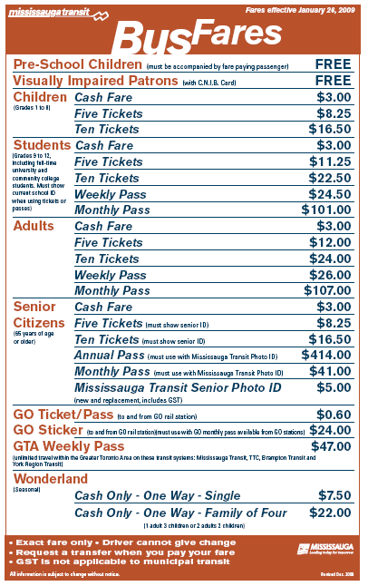
Fare Structure

Mississauga Transit’s Accessible Routes (as of Dec.7th, 2009)
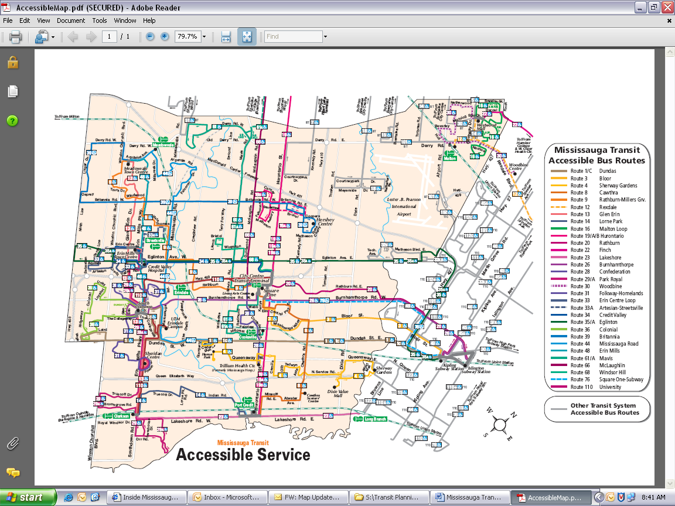
Specific 2009 Initiatives and Achievements
Designated Accessible Routes:

Every year, Mississauga Transit conducts a review of existing service with a view towards adding to our list of designated accessible routes. When evaluating potential routes, consideration is given to routes with the largest volume of ridership, greatest number of requests, connections to major destinations/transfer points, and availability of accessible buses. Mississauga Transit is committed to ensuring an accessible transit system by 2012.

In order for Mississauga Transit to designate a route as being fully accessible, two major factors need to be in place:

- Buses used along the route must be fully accessible, low floor buses; and
- Transit infrastructure along the route must be fully accessible, i.e. bus stop pads must be installed at every stop (where feasible) and must connect with the existing sidewalk network

In 2009, Mississauga Transit designated the following 2 routes as accessible:

- Route 39: Britannia
- Route 66: Confederation

Taking into consideration the above mentioned routes, Mississauga Transit now has 36 of 83 routes that are accessible, that’s approximately 43% of all our routes (excluding school routes).

Since September 2007, Mississauga Transit’s Central Parkway campus has been undergoing a vast expansion which has resulted in major operational changes. The campus expansion resulted in a delay in designating additional routes as accessible in 2009. However, upon the completion of the expansion project by the end of the year, Mississauga Transit will be designating the following routes as being accessible for January 2010:

- Route 5/5B: Dixie
- Route 42: Derry
- Route 7: Airport
- Route 11/11A/11B: Westwood
- Route 109: Meadowvale Express

The addition of these routes will result in approximately 53% of existing routes being accessible, bringing our total up to 44 of 83 routes.

Buses:

In 2009, Mississauga Transit continued to replace its high floor buses with fully accessible low floor vehicles. By the end of 2009, approximately 92% (approx. 388 of 422) of the fleet will consist of low floor buses. Mississauga Transit is committed to replacing all its old high-floor buses with accessible buses by 2012.

Transit Infrastructure:

A fundamental aspect of the expansion of accessible conventional services within Mississauga's existing transit system is the ongoing upgrade of stops, shelters, bus pads and sidewalk connections. Almost all of the bus shelters in Mississauga have been replaced with newly designed, accessible shelters. As of the end of 2009 the City will have 930 accessible bus shelters. This year alone, Mississauga Transit has installed 360 new bus pads throughout the city to make access to transit more convenient and accessible. As mentioned above, in order for a route to be considered fully accessible, in addition to buses, all transit infrastructure along the route must also be accessible, i.e. bus stop pads installed at every stop (if feasible) and must connect with the existing sidewalk network where possible. The programming of sidewalks is being co-ordinated between Transit Infrastructure Management and the Transportation & Infrastructure Planning Division in support of transit accessibility. The timing for these works is undetermined and is subject to Transportation & Infrastructure Planning priority schedule, budget availability and Council approval. As such, a limited number of stops along accessible routes may not be deemed as accessible due to the absence of sidewalks and sufficient road right-of-way. Mississauga Transit has set a goal of creating a fully accessible system by 2012 by which all routes and stops within the boundary of the City of Mississauga (to the extent possible) will be accessible. As progress is made and sidewalks constructed to improve pedestrian linkages, Mississauga Transit will continue to install the necessary infrastructure to improve accessibility throughout our system.

Respectful Workplace Training:

As an Employer of Choice and municipal leader, the City of Mississauga makes it a priority to create and provide its employees with a positive and respectful working environment. The City’s goal is to create a workplace that encourages and strengthens a safe and healthy environment that preserves equal dignity and supports an individual’s well-being.

To ensure that all employees understand their part in creating and maintaining this type of work environment, the City has developed and implemented the Respectful Workplace training. This City-wide initiative was approved by City Council and makes the training mandatory for all employees. The purpose of the training is to ensure understanding and mutual respect for the dignity, worth, and well-being of each individual.

All Mississauga Transit employees have undergone this training by taking either the one hour Respectful Workplace Employee Training e-learning course or by a face-to-face respectful workplace employee training session.

AODA Customer Service Standard:

As previously mentioned, the Accessibility for Ontarians with Disabilities Act, 2005 (AODA) was passed by the Ontario legislature. The goal was to create a set of standards/guidelines that would improve accessibility across the province in areas such as Transportation, Built Environment, Employment, Information and Communication, and Customer Service. Currently, the AODA Customer Service Standard has been developed, and made law.

The Customer Service Standard requires that the City of Mississauga:

- Establish policies, practices and procedures on providing goods or services to people with disabilities.
- Train staff, volunteers, contractors, people who are involved in developing your policies, practices and procedures and any other people who interact with the public or other third parties on your behalf, on a number of topics, as outlined in the customer service standard.
- Establish a process for people to provide feedback on how you provide goods or services to people with disabilities and how you will respond to any feedback and take action on any complaints.
- Provide notice when facilities or services that people with disabilities rely on to access or use your goods or services are temporarily disrupted.
- Source: ‘May I Help You? Understanding Accessible Customer Service’ Participant Guide

In response to the AODA Customer Service Standard, the City of Mississauga developed the ‘May I help you? Understanding Accessible Customer Service’ training course to ensure all staff are aware of the key requirements in delivering services to customers with disabilities.

‘May I help you? Understanding Accessible Customer Service’:

Beginning July 13th, 2009 the May I Help You? Understanding Accessible Customer Service e-learning course was made available to all City of Mississauga employees. Every person who provides goods and services to members of the public on behalf of the City must undergo this training. There are several key requirements from this standard that are addressed through the training:

- the purpose of the AODA and requirements of the Customer Service Regulation;
- how to interact and communicate with persons with various types of disabilities;
- how to interact with persons with disabilities who use assistive devices, or require the assistance of a service animal or support person;
- what to do if a person with a disability is having difficultly accessing our goods and/or services; and,
- how to use equipment that is available on the premises that may help in the provision of goods or services.
- Source: ‘May I Help You? Understanding Accessible Customer Service’ Participants Guide

All staff, contractors, volunteers, third party agents, and others who provide service on behalf of the City of Mississauga must meet the requirements of Ontario Regulation 429/07, by completing the customer service training. Currently more than half of all employees of the City have completed this training either through face-to-face training sessions or via the e-learning training course. This training is to be completed by the end of 2009.

Unanticipated Service Disruptions:

Mississauga Transit is currently in the process of making improvements to its process of notifying passengers of unanticipated service disruptions (detours, bus stop relocations, etc.).

An Unanticipated Disruption is any disruption that is known less than 2 business days before its occurrence. In the event of a service disruption to scheduled service (changes to routing, stop locations, and service frequency), Mississauga Transit will notify the public via an announcement on CityLink (Mississauga Transit’s Automated Information System), a notice on the City of Mississauga’s Website and a notice posted at the out-of-service stops or affected transit terminals.

Mississauga Transit has recently created consistent ‘Service Disruption’ templates that all notices must follow in order to ensure all necessary information pertaining to the date of disruption, the type of change, duration, and alternatives are provided for our transit users.

Ongoing Initiatives
Announcing of Bus Stops:

Presently Mississauga Transit buses are not equipped with automated stop announcement systems. Until such time as an automated system is fully functional, Mississauga Transit Operators are required to manually announce bus stop locations in the following manner:

- Every Operator will continue to announce bus stop locations on request by any customer, for any reason;
- Operators will continue to announce all bus stops located at major intersections and terminals;
- Operators will announce all bus stop locations permitted by their memory;
- Operators will announce all bus stop locations where there is a next stop, bus stop sign installed when the bus has stopped to either pick up or drop off passengers; and,
- Every operator will commit to learn as many stops as possible so that bus stop locations can be announced.
- Source: Mississauga Transit – Standard Practice Instruction (SPI)

To assist the operators in the manual announcing of all bus stop locations, Mississauga Transit has installed next stop, bus stop signs at every Mississauga Transit bus stop. The next stop, bus stop signs provide transit operators with a tool they can safely and effectively use to assist them in announcing the next bus stop location in advance of the bus stop. In addition to facilitating the manual announcing of bus stops, a secondary benefit to installing the next stop, bus stop signs is assisting passengers on board the bus in identifying the next approaching transit stop.

Audio and Visual Annunciation Systems:

Mississauga Transit is currently working towards implementing Audio and Visual Annunciation Systems throughout all our vehicles. This system complies with the AODA proposed Transportation Standard requirement to provide automated aural and visual next stop announcement to passengers.

The Voice and Visual Annunciation Systems announce and display pre-recorded route and stop information, just prior to arriving and upon arriving at the stop. The recorded messages contain information about bus stops. In addition to the automated announcements of this information, the information is played automatically over on-board display signs where passengers see the message scroll as it is announced.

Mississauga Transit is currently in the process of deploying this system on all vehicles with a plan to equip the entire fleet by the end of 2010.

PRESTO System:

The PRESTO System is an initiative to implement an easy to use smart-card based fare system in the Greater Toronto Area (GTA). This fare card will allow users to travel on and between various transit systems using the same fare card that deducts the respective fare each time you travel. The Ministry of Transportation Ontario is developing this PRESTO fare system with the following service providers: Brampton Transit, Durham Regional Transit, GO Transit, Burlington Transit, Durham Regional Transit, The Hamilton Street Railway Corporation, Mississauga Transit, Oakville Transit, and York Regional Transit.

With the Ontarians with Disabilities Act, 2001 and the Accessibility for Ontarians with Disabilities Act (AODA), 2005 developing and implementing a set of standards to remove the barriers faced by persons with disabilities, a PRESTO Accessibility Plan is in the process of being developed to account for the measures that have been taken to comply with the AODA Standards and to identify areas where future improvements may be required. The PRESTO System has been designed to allow transit users with disabilities to use the PRESTO System with independence and dignity.

Support Persons:

Support Persons accompanying passengers with disabilities, regardless of the nature of their disabilities, are permitted to travel at no charge. Disabilities include visible and non-visible disabilities such as physical, intellectual/developmental, learning or cognitive, mental health, speech/language and visual disabilities. One personal care attendant per customer with a disability will travel at no charge.

If able, the customer with a disability will inform the Transit Operator upon boarding that they have a disability and request that their accompanying support person ride at no charge. A support person can be a paid professional, a family member, a friend, or a volunteer. A support person can assist with communication, mobility (such as getting on and off the bus), personal care (such as eating), medical needs or other travel assistance such as following directions.

This process has been in effect since February 7th, 2007 and is consistent with the requirements of the Ontario Human Rights Code.

Customer Service/Sensitivity and Awareness Training:

Mississauga Transit makes it mandatory for all transit operators to receive Accessibility Training, on a three year training cycle. Training includes the safe operation of the ramp and securement of wheelchairs and scooters, as well sensitivity training on the provision of service to persons with disabilities. In addition, at the present time, Mississauga Transit also incorporates members of the Accessibility Advisory Committee into the new operator training sessions to visit classes to speak on their experiences, and provide insight into key issues revolving around accessibility.

In accordance with Ontario Regulation 429-07, Accessibility Standards for Customer Service, Mississauga Transit’s Operations section will be providing AODA Customer Service & Assisted Equipment training to all transit operators, route & operations supervisors, and other front-line staff. The training ensures all operators are aware of the key components of the Customer Service Standard, the requirements for assisting customers with disabilities, and ensuring that they know how to correctly operate the equipment when boarding or de-boarding customers using wheelchairs or scooters. This AODA Customer Service Training will be included as part of the three year training cycle that all operators receive.

In addition, Mississauga Transit’s Operations section are continually reviewing the content, format, and delivery method of its sensitivity, disability, and diversity training programs with a view to: improving their impact and effectiveness, and integrating improvements into its regular new and existing employee training programs.

Customer Contact System (CCS):

Mississauga Transit utilizes a Customer Contact System (CCS) that allows customers to provide feedback with regards to our system. Customers can either call our call centre, visit the information booth at the City Centre Transit Terminal or email our customer service section directly to forward their comments and/or questions.

Our Customer Service Representatives are adept to assisting customers develop routing plans that meet their individual needs as well as answer any general inquiries customers may have about our services.
Inquiries about a specific request or complaint is logged and forwarded to the appropriate department for comment and follow up. Issues related to accessibility or our accessible services are forwarded to our Service Development Department for action. Customer requests related to a particular route being designated fully accessible are recorded and used to determine our accessible route priority list for the following year.

Information:

Mississauga Transit has developed an online trip planner on their website (www.mississaugatransit.com) called “Click n’ Ride”. This tool continues to make conventional transit more user-friendly for all customers. The trip planner allows customers to limit search results to accessible routes only so that passengers can be assured that their entire trip plan will include all accessible routes and stops.

In addition, Customer Information Representatives (905-615-INFO) are available seven days a week to provide assistance in trip planning and relaying information on our services. A TTY (TeleTypewriter) Phone (905-615-3886) is available for patrons who are deaf or hard of hearing. CityLink, Mississauga Transit's Automated Information System, is scheduled to become accessible through TDD (Telecommunication Devices for the Deaf) by 2010. The system will be available 24 hours a day, 7 days a week. Customers will have access to the schedule information and stop lookup feature through their TTY.

Mississauga Transit produces an “Accessible Transit Rider’s Guide” that outlines step by step information on Mississauga Transit’s policies and procedures for boarding the bus as well as information on safety and the Law. This Guide is updated and improved on an annual basis with the updated version being released in October/November of each year.

Mississauga’s Bus Rapid Transit (BRT)

Project Overview:
The City of Mississauga in partnership with the Federal Government, the Province of Ontario, and GO Transit is constructing a segment of the Bus Rapid Transit System through Mississauga, a high efficiency transit corridor (a two lane, bus-only roadway) and service. This segment will cover 18 kilometres of the 100 kilometre Oakville to Pickering planned GO Transit Inter-Regional Bus Rapid Transit System from Winston Churchill Boulevard to Renforth Drive, running along the Highway 403, Eastgate Parkway and Eglinton Avenue corridors via the dedicated bus bypass shoulders along on Highway 403 between Erin Mills Parkway and Mavis Road.

The BRT system will consist of a dedicated right-of-way for buses using dedicated roads and buses, making it faster and easier to travel through Mississauga and the Greater Toronto Area (GTA).

Designated stations (12 stations in Mississauga) will act as key transfer/connection points with several stations having passenger pick up and drop off and/or park-and-ride facilities.

The following map illustrates the BRT system in Mississauga and 12 stations proposed between Winston Churchill Boulevard and Renforth Drive. The BRT will connect and complement local transit service as well as inter-regional transit and subway systems.

Bus Rapid Transit (BRT): Transit way in Mississauga
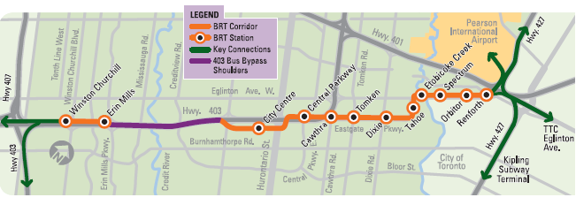
- Source: ‘RAPID – Mississauga Bus Rapid Transit News’
Fall 2008, Vol. 2 Newsletter

Project Status:
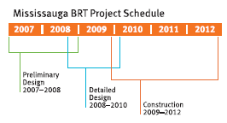
At the beginning of 2009, the BRT Project started the detailed design phase of the project which is the final phase before the start of construction.

The construction of the proposed busway will be built in two parts:
- Between Winston Churchill Boulevard and Erin Mills Parkway (on the north side of Highway 403); and,
- Source: ‘RAPID – Mississauga Bus Rapid Transit News’
Fall 2008, Vol. 2 Newsletter

- Between Hurontario Street (Mississauga City Centre) and Renforth Drive (along Eastgate Parkway and Eglinton Avenue).

Both segments will be connected via Highway 403 and Centre View Drive. Construction of the proposed BRT System is planned to begin in the spring of 2010 and is expected to be completed by late fall of 2012.

Design Status:

Designs of the future BRT structures and facilities have utilized Universal Design Principles and support the guidelines and objectives set out within the City of Mississauga’s Accessibility Plan and the City of Mississauga Accessibility Design Handbook.

On September 24th 2009, the BRT Project Team presented the Intermediate Designs for the Bus Rapid Transit system to the Facility Accessibility Design Sub-Committee (part of the City of Mississauga’s Accessibility Advisory Committee) and provided information on the status of the project thus far and addressed key issues that pertained to accessibility. The BRT Project Team provided information on such issues as sufficient colour contrasts at dangerous areas for persons with visual disabilities, relocation of street furniture to an amenity zone, the use of colour contrast decals to help identify glass walls, and tactile guiding paths that are currently being considered.

These Intermediate Designs for the future Bus Rapid Transit system were accepted by members of the Facility Accessibility Design Sub-Committee and the Accessibility Advisory Committee with no major concerns.

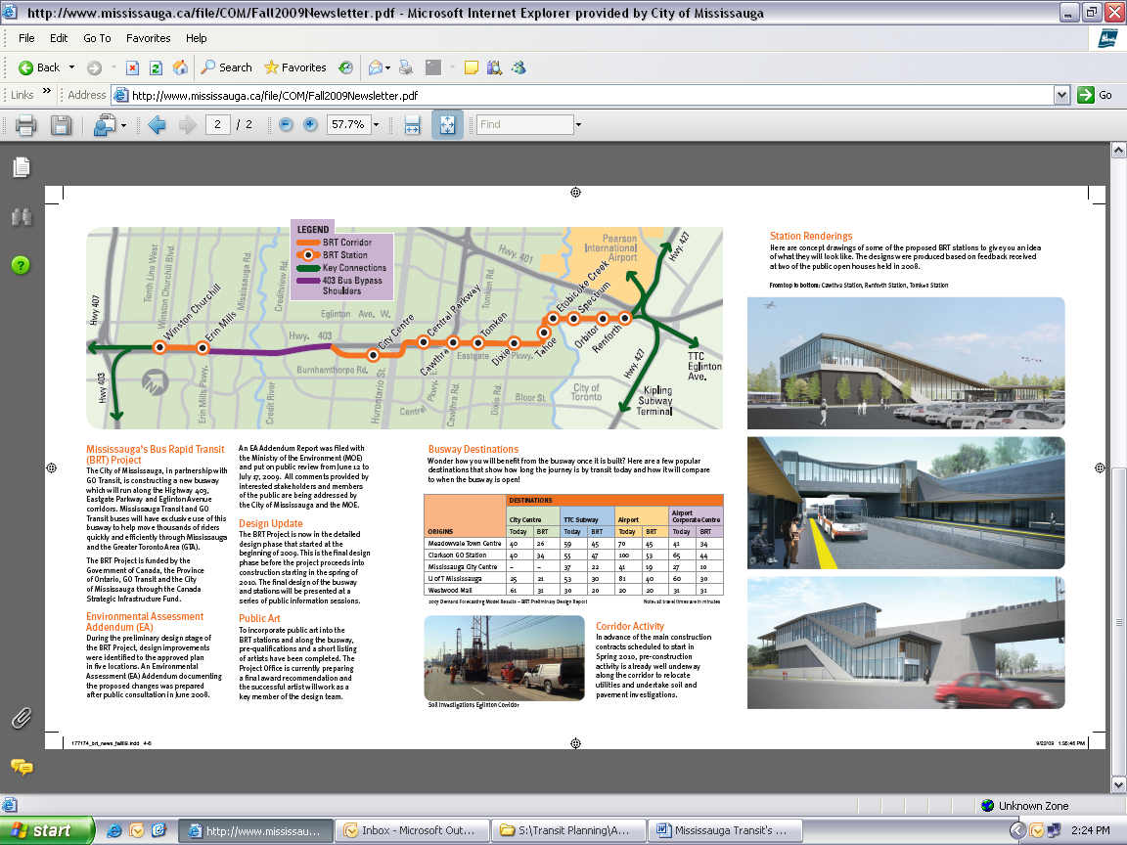

- Source: ‘RAPID – Mississauga Bus Rapid Transit News’
Fall 2008, Vol. 2 Newsletter

Plan Approval and Communication Strategy
Transit Management Team approved the Accessibility Plan at its December 15th, 2009 meeting. The required communication of the plan will include the following:

- release of the approved report to the City of Mississauga’s Accessibility Advisory Committee

- inclusion of the approved report in the City of Mississauga’s Accessibility Plan

- inclusion of the approved report on Mississauga Transit’s website (www.mississaugatransit.com)

- notification of the availability of the approved report in the “In Transit” Brochure and Mississauga Transit’s “eNews” newsletter.

- notification of the availability of the approved report in the ‘Accessibility Guide’ Brochure

Conclusion and Next Steps…

Mississauga Transit has made great strides in achieving its goal of fully accessible transit for all City of Mississauga residents.

Mississauga Transit’s Accessibility Plan provides an update on activities Mississauga Transit has undertaken to improve accessibility to all of its services and facilities. This Plan summarises the results, to date, of the extensive planning and implementation activities Mississauga Transit has undertaken over the years to make the system more accessible.

Current plans call for the fleet to be fully accessible by 2012 and we are working towards being able to designate the routes accessible at that time. Where feasible, Mississauga Transit is incorporating Universal Design Principles into the design of our system and the supporting infrastructure. By adopting these Principles we are confident that in time the services offered by Mississauga Transit will accommodate the needs of not just the accessible community but the greater population as well.
For More Information…
Questions or comments about Mississauga Transit’s Accessibility Plan or general inquiries on our Accessible Services are always welcome.

For Travel Times & Route Planning Assistance, Information Representatives are available:

Weekdays: 7:00 am to 6:55 pm
Weekends/Holidays: 8:00 am to 5:55 pm
Email: transit.info@mississauga.ca

To Provide Customer Feedback, Customer Service Representatives are available:

Weekdays: 8:30 am to 4:25 pm
Weekends/Holidays: Closed
Email: mtcustomer.service@mississauga.ca

TTY Phone: 905-615-3886

Teletypewriter phone for persons who are deaf, deafened or hard of hearing.
Weekdays: 7:00 am to 6:55 pm
Weekends/Holidays: 8:00 am to 5:55 pm

Mississauga Transit’s Website: www.mississaugatransit.com

Mississauga Transit’s Mailing Address: Mississauga Transit
3484 Semenyk Court Mississauga, Ontario L5C 4R1



