2015 Reporting on Living Green Master Plan

Living Green Master Plan (LGMP)
The LGMP is Mississauga’s 10-year action plan for doing business and providing services in an environmentally sustainable way. It was adopted by City Council in 2012.

2015 Progress in a Snap Shot
2015 was the fourth year implementing the LGMP.
At the end of 2015, 42 of the 49 LGMP actions (86%) were on-target.
- 72% underway
- 14% complete
- 14% scheduled for future
View the status of all 49 LGMP actions. (pdf)

Putting Our Priorities into Action
Excellent progress has been made to deliver on Mississauga’s environmental priorities. The following stories highlight Mississauga’s 2015 environmental accomplishments in sustainable transportation, natural heritage and urban forest, stormwater management, waste, energy, environmental education and outreach and food security.
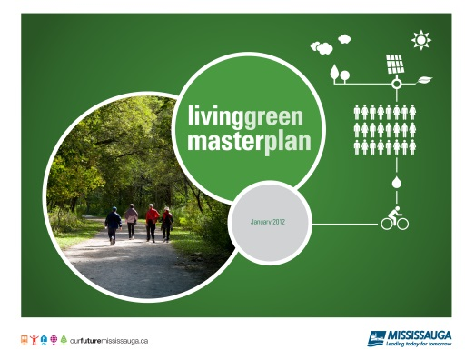
Living Green Master Plan document cover

Sustainable Transportation

Mississauga Transitway
The Mississauga Transitway is the first dedicated bus corridor to be built in the Greater Toronto and Hamilton Area and is a key component of a dedicated bus corridor across the Greater Toronto Area. As of February 2016, six stations are open along the Mississauga Transitway. Upon completion in 2017, the 18 kilometre Transitway will have 12 stations from Winston Churchill to Renforth Drive.
  - From November 2014 to October 2015 there was a 42% ridership increase on the Transitway
  - This avoided 500 tonnes of CO2 emissions = 100 cars off the road
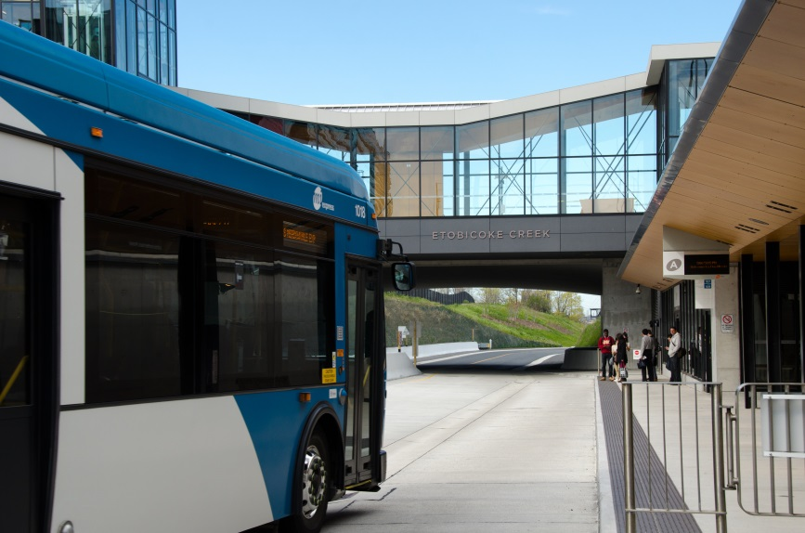
Mississauga Transitway station
Bus driving on traffic-free Transitway next to traffic jam on roadway

Natural Heritage and Urban Forest

One Million Trees
One Million Trees Mississauga is a tree planting program to help conserve and enhance Mississauga’s open spaces and natural areas. Launched in 2013, the goal is to add one million trees on both public and private property by 2032. By the end of 2015, 178,062 trees were planted. Trees are important to quality of life in our city because they help filter harmful pollutants in the air, release oxygen, provide habitat for birds and wildlife, and much more. To join a tree planting event, visit onemilliontrees.ca.
- 178,062 trees planted since the launch in 2013
- The goal is 1 million trees by 2032
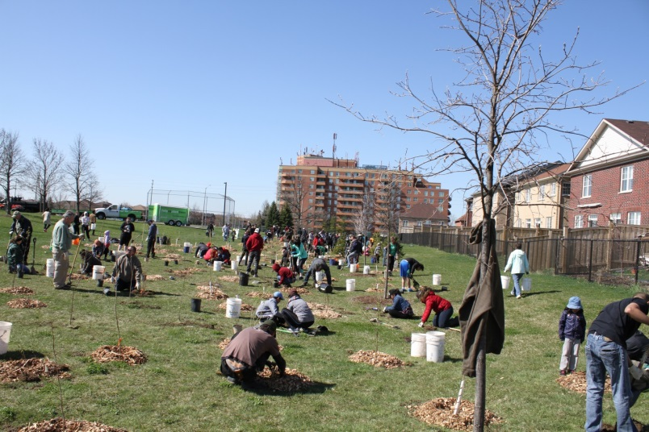
Tree planting event

Stormwater Management

Low Impact Development
The Central Parkway Rain Garden allows rainwater to filter through the soil and captures it in underground units. The cleaned water is then soaked into the roots of the trees. Rain Gardens imitate natural processes and help ensure our streams, rivers and Lake Ontario, the source of Mississauga’s drinking water, are clean.
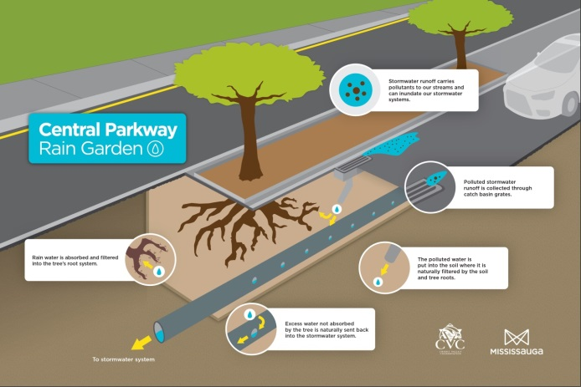
How the Central Parkway Rain Garden works
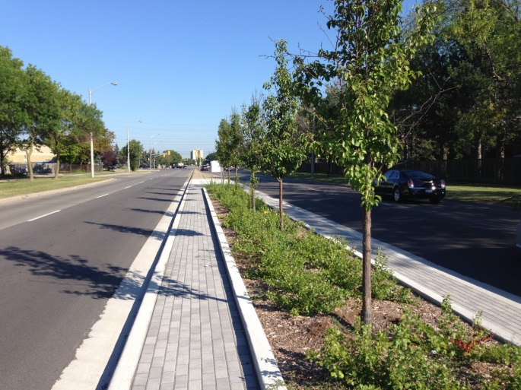
Street view of Central Parkway Rain Garden

Waste

Mississauga Celebration Square Waste Management
Mississauga Celebration Square has new waste and recycling bins and signage which have reduced the amount of waste going to landfill. 97 percent of Mississauga Celebration Square visitors surveyed find waste disposal easier since the launch of the waste program in July 2015.
  - 17% increase in waste diversion from landfill
  - 39% decrease in waste generation per visitor
  - 93% decrease in contamination of recycling
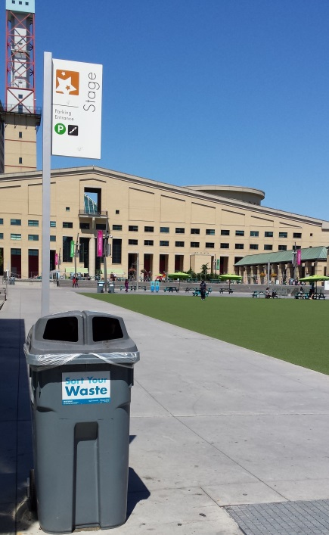
Waste container on Celebration Square
with Sort Your Waste sign and receptacles for garbage and recycling

Energy

LED Street lighting
The City’s LED Street Lighting Conversion Project to convert 50,000 street lights to LED light bulbs is near completion. The City saved $3.6 million (25 million kWh of energy) from January 2013 to December 2015 through the use of LED street lights. This is equivalent to the total electricity consumed by City arenas and community centres in 2015. LED street lights also increase safety, visibility and reduce light pollution in the sky.
Reduced Greenhouse Gas emissions over three years by 1085 tonnes of CO2 = 217 cars off the road
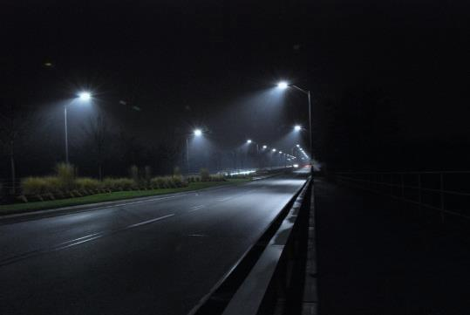
LED street lights casting bright lights on roadway
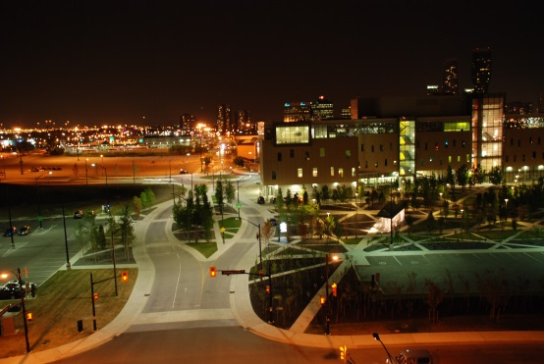
Night scene in downtown Mississauga with LED street lights

Environmental Education and Outreach

Earth Markets
Earth Markets are fun and interactive community events providing residents an opportunity to learn and engage in environmental activities. In 2015, over 800 visitors attended two Earth Markets held in partnership with One Million Trees Mississauga and The Backyard Farm and Market at Erin Mills. Earth Markets featured educational workshops, interactive displays, environmental vendors, documentary screenings, healthy food and live music. For more information, visit mississauga.ca/earthmarket.
  - Over 800 people attended two Earth Markets in 2015
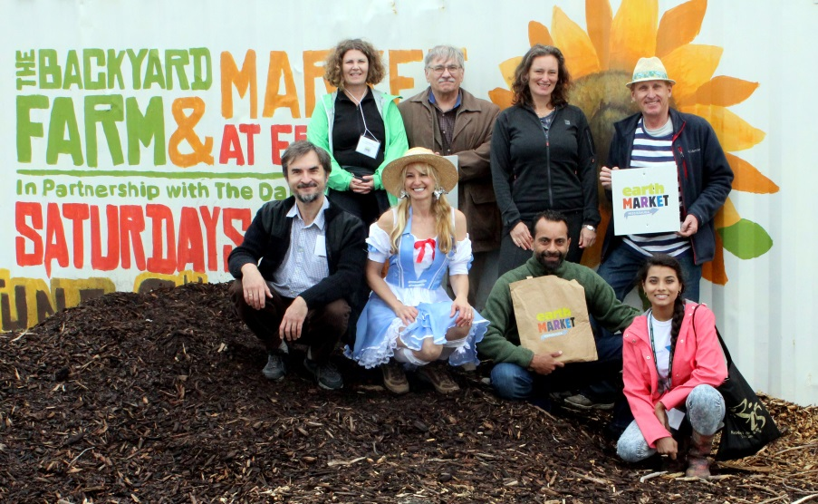
Participants and entertainers at Earth Market
Little girl at Earth Market

Food Security

Environmental Community Grant supporting Community Gardens
The City of Mississauga grants $75,000 annually to Ecosource to develop and program community gardens. Started in 2014, three new community gardens are developed each year for 5 years. Community gardens use organic growing practices, empower residents in environmental protection and raise awareness about the healthy food and healthy environments.
  - The 2015 Community Gardens and Urban Agriculture program engaged 4,472 participants in learning about community food growing and preserving ecosystem health
  - Volunteers contributed over 6,300 hours to community food growing and park stewardship
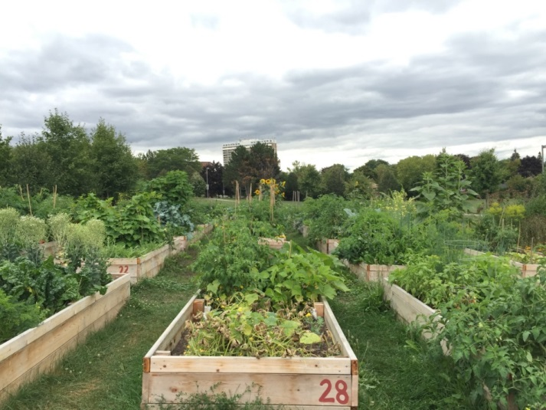
Community Garden plots
photo credit: Ecosource

For more information:
Environment Division, City of Mississauga
201 City Centre Drive, Suite 900
Mississauga, ON L5B 2T4
TTY: 905-896-5151
Email: living.green@mississauga.ca
Mississauga.ca/environment
Twitter @MiLivingGreen
Facebook @SaugaGreen

