In Person and Virtual Public Meeting

RECOMMENDATION REPORT NOTICE

Meeting Date and Time:
Tuesday, June 25, 2024 at 6:00 p.m.

Meeting Place:
Mississauga Civic Centre, Council Chamber, 300 City Centre Drive

Applicant's Proposal:
1667 Sunningdale Bend, east side of Sunningdale Bend, west of Meadow Wood Road
Application submitted by: 2272061 Ontario Ltd.
File: OZ 21-19 W2

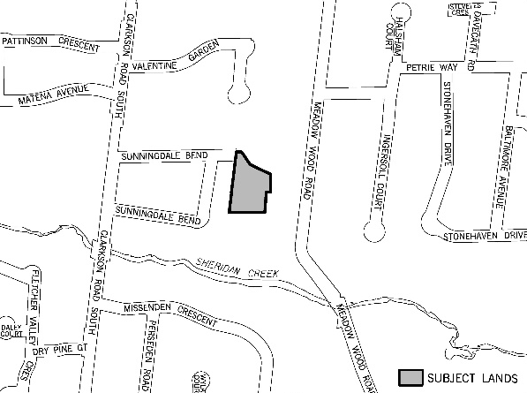
Location of the Proposal

Proposed Site Plan
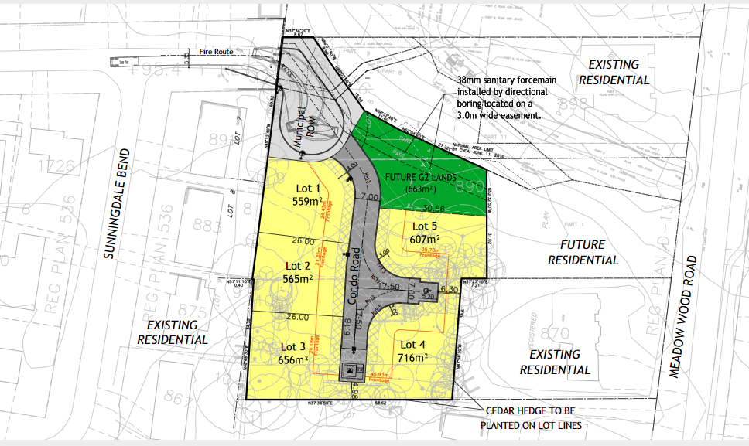

The applicant is proposing to change the zoning to permit five detached dwellings on a common element condominium (CEC) road and the extension of Sunningdale Bend.
The remediation of potential on-site contamination will be evaluated through the review of this application and addressed in the Corporate Report.

Meeting Details:
This meeting will be held in person and online. Advance registration is required to make a verbal submission at the meeting virtually. Advance registration is preferred to make a verbal submission at the meeting in person. The proceedings will be streamed live online for the public to view at the following link: http://www.mississauga.ca/portal/cityhall/council-and-committee-videos. If you wish to phone in to listen to the meeting only, please call 905-615-3200, ext. 5423 for instructions.
Options for participating in the meeting are outlined below.

Purpose of Meeting:
The City held a Public Meeting on May 30, 2022. At the upcoming meeting, Planning and Building staff will present a report addressing issues raised and will provide a recommendation on the proposal. Planning and Development Committee will make a decision about this project at this meeting.
The report will be available on-line one week prior to the meeting at: http://www.mississauga.ca/portal/cityhall/planninganddevelopment


For detailed information contact:
City Planner Lucas Petricca at 905-615-3200 ext. 5733 or lucas.petricca@mississauga.ca

If you would like to share your views and/or you wish to be notified of further meetings or be added to the mailing list, please contact the Planning and Building Department by Friday at 4:00 p.m. prior to the meeting date:
- by mail to 300 City Centre Drive, Development and Design Division, Mississauga ON L5B 3C1
- by email to application.info@mississauga.ca
- please include your name, your address, and application number or address of the property you are providing comments on

Written Comments:
In order to be received by Committee at the public meeting, written comments must be received no later than Friday at 4:00 p.m. prior to the meeting date. Submissions are accepted by email at deputations.presentations@mississauga.ca or by mailing the Planning and Development Committee, 300 City Centre Drive, 2nd Floor, Mississauga, ON L5B 3C1. Please include your name, your address, and application number or address of the property you are providing comments on. Written comments received before, during or after a public meeting but before a by-law is passed receive the same consideration as verbal comments made during a public meeting.

How to participate in a public meeting if you wish to make verbal submissions:

Participate Virtually
Advance registration is required to participate and/or make comment virtually at the public meeting. Please email deputations.presentations@mississauga.ca no later than Friday at 4:00 p.m. prior to the meeting date. Any materials you wish to show the Committee during your presentation must be provided as an attachment to the email. Links to cloud services will not be accepted. You will be provided with directions on how to participate from Clerks' staff.
Residents without access to the internet can participate and/or make comment in the meeting via telephone. To register, please call Angie Melo at 905-615-3200 ext. 5423 no later than Friday at 4:00 p.m. prior to the meeting date. You must provide your name, phone number, and application number if you wish to speak to the Committee. You will be provided with directions on how to participate from Clerks' staff.

Participate In Person
To make a verbal submission in person, advance registration is preferred. Please email deputations.presentations@mississauga.ca no later than Friday at 4:00 p.m. prior to the meeting date.
If you are a landlord, please post a copy of this notice where your tenants can see it. We want to make sure they have a chance to take part.

Background Studies:
Planning documents and background material available at: http://www.mississauga.ca/portal/residents/development-applications.
Contact the city planner noted above for more information.

Personal Information:
Individuals should be aware that any personal information in their verbal or written communication will become part of the public record, unless the individual expressly requests the City to remove the personal information. Questions about the collection of this information may be directed to application.info@mississauga.ca or in writing to the Planning and Building Department at 300 City Centre Drive, Mississauga ON L5B 3C1.

Information about Appeals:
If a person or public body does not make oral submissions at a public meeting or make written submissions to the City before the by-law is passed, the person or public body is not entitled to appeal the decision of City Council to the Ontario Land Tribunal, or be added as a party to an appeal of the decision to the Tribunal.
The proposed Official Plan amendment is exempt from approval by the Region of Peel. The decision of City Council is final if a notice of appeal is not received on or before the last day for filing a notice of appeal.
Date of Notice: May 30, 2024

