Please be informed of a proposed development in your neighbourhood
5100 Erin Mills Parkway
Northeast corner of Eglinton Avenue West and Metcalfe Avenue
Applicant's Proposal: To change the use of these lands to permit a convenience restaurant use with a drive-through
Application submitted by: EMTC Holdings Inc.
File: OZ 26-4 W9

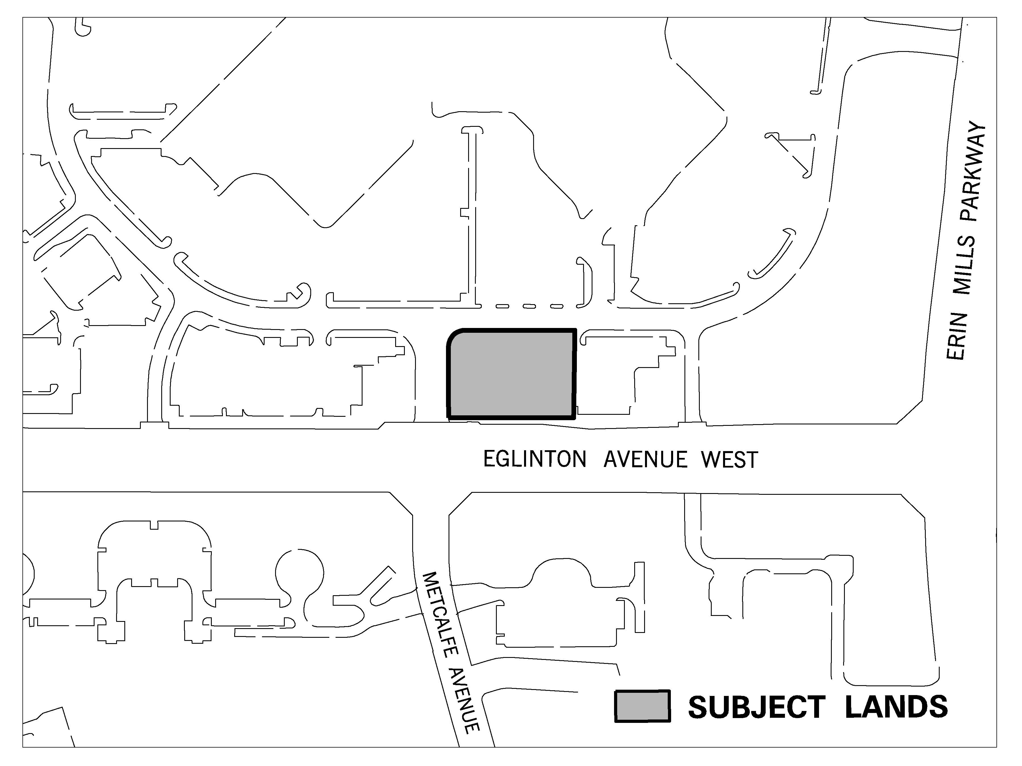
Location of the Proposal

Applicant's Rendering
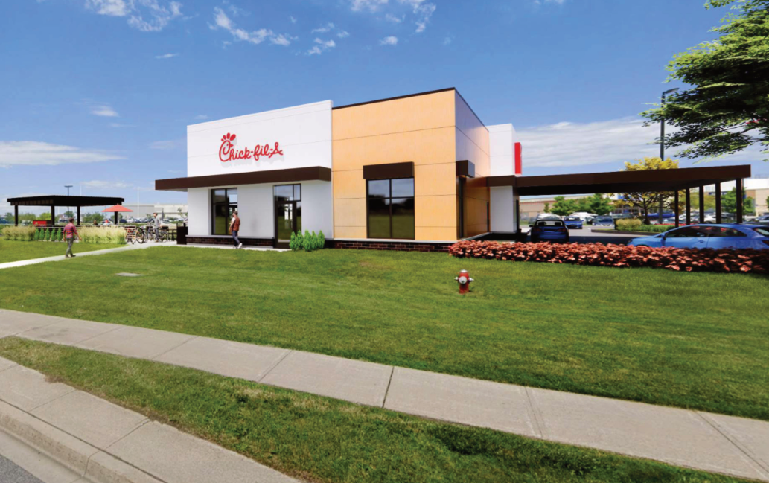

In Person and Virtual Public Meeting

Meeting Date and Time:
Monday, June 22, 2026 at 1:30 p.m.

Meeting Place:
Mississauga Civic Centre, Council Chamber, 300 City Centre Drive

The applicant is proposing to change the zoning to permit a convenience restaurant use with a drive-through.

Meeting Details:
This meeting will be held in person and online. Advance registration is required to make a verbal submission at the meeting either virtually or in person Friday at 12:00 p.m. prior to the meeting date. The proceedings will be streamed live online for the public to view at the following link: http://www.mississauga.ca/portal/cityhall/council-and-committee-videos. If you wish to phone in to listen to the meeting only, please call 905-615-3200, ext. 8437 for instructions.
Options for participating in the meeting are outlined below.

Purpose of Meeting:
- For people to ask questions and share their views about the proposal
- For Planning and Development Committee to receive a report that provides information on the project, addresses issues and provides a recommendation on the proposal
- For Planning and Development Committee to make a decision about this project
The report will be available on-line one week prior to the meeting at: http://www.mississauga.ca/portal/cityhall/planninganddevelopment


For detailed information contact:
City Planner Connor Di Pietro at 905-615-3200 ext. 8711 or connor.dipietro@mississauga.ca

If you would like to share your views and/or be added to the official record, please contact the Planning and Building Department by Friday at 12:00 p.m. prior to the meeting date:
- by mail to 300 City Centre Drive, Development and Design Division, Mississauga ON L5B 3C1
- by email to application.info@mississauga.ca
- by visiting the following link: https://www.mississauga.ca/services-and-programs/planning-and-development/development-applications/active-development-applications/5100-erin-mills-parkway-oz-26-4-w9/

Please include your name, your address, and application number or address of the property you are providing comments on.

Written Comments:
In order to be received by Committee at the public meeting, written comments must be received no later than Friday at 12:00 p.m. prior to the meeting date. Submissions are accepted by email at deputations.presentations@mississauga.ca or by mailing the Planning and Development Committee, City Clerks Office, 300 City Centre Drive, Mississauga, ON L5B 3C1. Please include your name, your address, and application number or address of the property you are providing comments on. Written comments received before, during or after a public meeting but before a by-law is passed receive the same consideration as verbal comments made during a public meeting.
If you wish to be notified of the decision on the proposed zoning by-law amendment and/or proposed official plan amendment, you must make a written request.

How to participate in a public meeting if you wish to make verbal submissions:

Participate Virtually
Advance registration is required to participate and/or make comment virtually at the public meeting. Please email deputations.presentations@mississauga.ca no later than Friday at 12:00 p.m. prior to the meeting date. Any materials you wish to show the Committee during your presentation must be provided as an attachment to the email. Links to cloud services will not be accepted. You will be provided with directions on how to participate from Clerks' staff.
Residents without access to the internet can participate and/or make comment in the meeting via telephone. To register, please call Ani Grigoryan at 905-615-3200 ext. 8437 no later than Friday at 12:00 p.m. prior to the meeting date. You must provide your name, address, phone number, and application number if you wish to speak to the Committee. You will be provided with directions on how to participate from Clerks' staff.

Participate In Person
To make a verbal submission in person, advance registration is preferred. Please email deputations.presentations@mississauga.ca no later than Friday at 12:00 p.m. prior to the meeting date.
If you are a landlord, please post a copy of this notice where your tenants can see it. We want to make sure they have a chance to take part.

Background Studies:
Planning documents and background material submitted in support of this application are available for review at: https://www.mississauga.ca/services-and-programs/planning-and-development/development-applications/active-development-applications/5100-erin-mills-parkway-oz-26-4-w9/
Contact the city planner noted above for more information.

Planning Act Requirements:
The City will be processing the applications in accordance with the Provincial Planning Act which requires that all complete applications be processed.
The application is now being circulated to City Departments and Agencies for technical review.
A report summarizing the development and the comments received will be prepared by Planning staff and presented at the Public Meeting listed in this Notice.

Personal Information:
Individuals should be aware that any personal information in their verbal or written communication will become part of the public record, unless the individual expressly requests the City to remove the personal information. Questions about the collection of this information may be directed to application.info@mississauga.ca or in writing to the Planning and Building Department at 300 City Centre Drive, Mississauga ON L5B 3C1.

Information about Appeals:
Application decisions can be appealed through the Ontario Land Tribunal. The applicant, a specified person, a public body, or the Minister, or those who own land subject to the application can appeal. A person who otherwise would have an ability to appeal but the person or public body does not make oral submissions at a public meeting or make written submissions to the City of Mississauga before the proposed zoning by-law is passed and the proposed official plan amendment is adopted is not entitled to appeal the decision and may not be added as a party to the hearing of an appeal before the Ontario Land Tribunal.

General Information:
Visit Mississauga’s online Guide to City Planning and Development to learn more. It’s organized around topics we get asked most – such as What is City Planning, How Land Gets Developed and Ways to Get Involved. Visit www.mississauga.ca/city-planning-guide.

Date of Notice: April 29, 2026
K:\PLAN\DEVCONTL\GROUP\WPDATA\CORPORATE REPORTS TO PDC\2. North Reports\OZ 26-4 W9 - 5100 Erin Mills Parkway - Connor\Notice\OZ 26-4 notice-complete application and public-pdc-Meeting In Person Virtual (Bill 185) n3.docx

