Information about the construction
The City of Mississauga is planning restoration works for the Applewood Creek corridor within the Lakeview Golf Course. In order to accommodate the natural channel restoration, improvements to the golf course are also required.

What are the planned improvements?
- Construction of the creek into a more natural winding alignment
- Replacement of cart path bridges over the creek
- Adjustment to the tees, greens, fairways and cart paths adjacent to the creek:
  - Hole 1 – rebuild tees, with the new elevated tees similar to the original 1921 design
  - Hole 5 – increased presence of Applewood Creek to the left of the landing area and restored bunkers
  - Hole 8 – regraded fairways
  - Hole 16 – reconfigured fairway and expanded green, as well as relocated cart path
  - Hole 17 – restoration of the upper hole to its original 1921 Herbert Strong design, including an enlarged green and bunkers, as well as removal of the alternate lower hole and irrigation pond
  - Hole 18 – relocated tees and reconfigured fairway, while preserving the original 1921 elevated tee location

What are the benefits of this remediation work on Applewood Creek?
The benefits of this remediation work include:
- Improved stability and environmental health of the watercourse
- Improves fish habitat and fish passage
- Maintains or improves the hydraulic capacity of the creek, and protect nearby property and infrastructure
- Enhance the golf course layout, improve playability, while maintaining or enhancing the heritage characteristics of the course.

Will the golf course close, and if so, when?
For the 2021 season, Lakeview Golf Course closed in November. This allowed construction of the creek restoration and golf course improvements to begin while shortening the disruption to the 2022 golf season.

When will the golf course re-open?
We will re-open as a 9-hole course on June 20th, 2022 (weather permitting).
We anticipate that we will be able to open all 18-holes and operate our full golf course by July 15th, 2022 (weather permitting).

What will the new creek look like?
Currently, the creek is channelized and its banks are lined with stone-filled gabion baskets that were installed 30 to 40 years ago over the entire 1.3 km length through the golf course. These stoned filled baskets will be removed and the creek will be restored to a more naturalized, meandering form.
The main goal of this project is to mitigate the existing erosion problems and ensure long-term stability of the creek using natural design techniques, where feasible, while also protecting or enhancing the existing environmental resources within the study area.

Where can I find more information about this restoration?
More information about the Applewood Creek restoration can be found online on the project website: https://www.mississauga.ca/projects-and-strategies/environmental-assessments/applewood-creek-erosion-control-lakeview-golf-course/
Hole 17 restoration

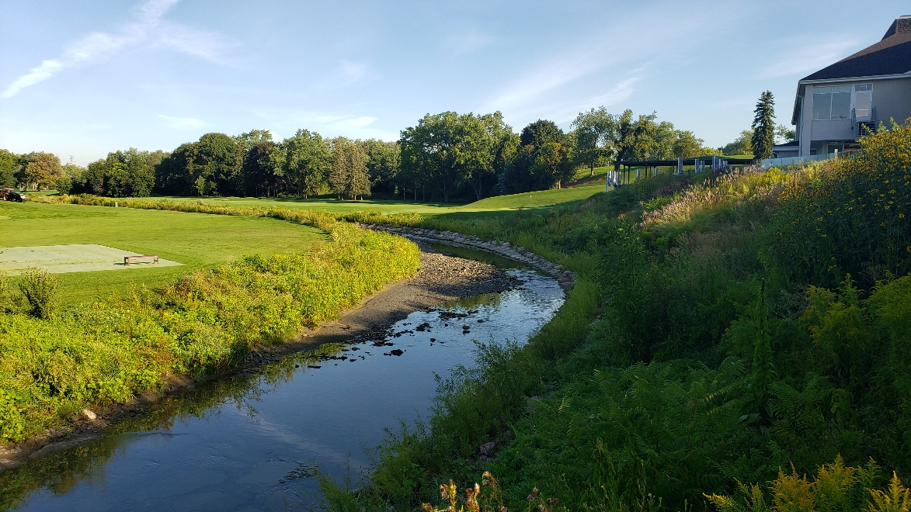
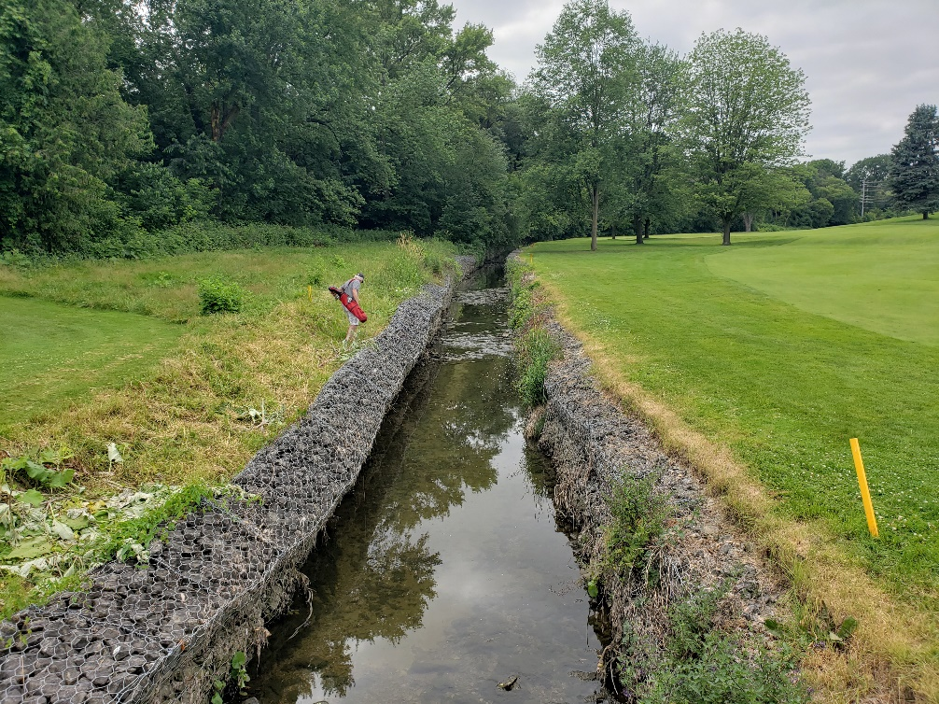
Proposed creek concept
Existing creek
